A seven-week prayer curriculum為期七週的禱告課程

Journey Through
The Alliance Vision Prayer

為宣道會異象同行禱告

Vision Prayer 異象禱告

O God, with all our hearts, we long for You. Come, transform us to be Christ-centred, Spirit-empowered, Mission-focused people, multiplying disciples everywhere. 上帝啊，我們全心全意渴慕袮。來吧，改變我們，使我們以基督為中心，靠聖靈得權能，由宣教作主導，在各處建立門徒。
Jasper, AB 賈斯珀, 艾伯塔省

Week 1 第一週

O God, with all our hearts, we long for You. Come, transform us to be Christ-centred, Spirit-empowered, Mission-focused people, multiplying disciples everywhere.

上帝啊，我們全心全意渴慕袮。來吧，改變我們，使我們以基督為中心，靠聖靈得權能，由宣教作主導， 在各處建立門徒。

Vancouver Island, BC溫哥華島, 卑詩省

Day 1 第一天

BIBLE READINGS 讀經:
Psalm 42; Psalm 84
詩篇 42篇; 詩篇 84篇

REFLECTION QUESTIONS 思考問題
- When was the last time you wept in longing for the presence of God?
你上次因渴想神的同在而感到哀慟是什麼時候？
- In what ways are you pouring out your soul before God these days? Is your soul downcast because it feels like He is absent?
你是如何將自己的心靈完全交付給上帝？ 你的靈有否因為感到祂的缺席而感到沮喪？
- Is dwelling close to God the greatest longing of your soul? Would you trade 1000 days doing something else for a single chance to be with Him?
親近上帝是你心靈的最大渴望嗎？ 你願意捨棄一千天做別的事情來換取一次與祂同在的機會嗎？

PRAYER PROMPTS 禱告事項:
- That God would increase the intensity of our longing for Him —so much that we would physically feel it.
祈求上帝使我們的心切慕祂，甚至在肉體上都能感受到這份渴慕。
- That we would do everything we can to be close to His presence.
願我們盡己所能去親近祂。
- That our trust and pursuit of God would be strong even when our souls are downcast, and grief overwhelms us.
即使我們的靈魂沮喪，悲傷淹沒我們，我們對上帝的信任和追求也會堅定不移。
- If even the sparrow can find a home near God’s presence, how much more the Yazidis? Pray that Jesus would reveal Himself to them.
如果連麻雀也能在上帝面前找著房屋，更何況是雅茲迪人(Yazidis)呢？ 祈求主耶穌向雅茲迪人顯明祂的同在。

LISTENING PRAYER 靜默禱告:
- Jesus, are there any griefs that are keeping me from dwelling in your presence?
主耶穌，我心中有沒有悲傷使我無法住在袮的同在裡面呢？
- How do you want to meet me in my grief today?
今天在我的悲傷中，袮會怎樣動工？

Day 2 第二天

BIBLE READINGS 讀經:
Genesis 32:22–32; Colossians 2:1–3; 4:12
創世記 32:22-32； 歌羅西書 2:1-3; 4:12

REFLECTION QUESTIONS 思考問題:
- How could you cultivate more longing for God?
你如何培養深深渴慕神的心？
- In what ways does your prayer life reflect a struggle on behalf of others?
你在禱告中如何為他人竭力的祈求？
- How much wrestling with God are you willing to do to receive His blessing and multiply disciples who are firm in obeying His will?
你會否和神摔跤以爭取祂賜的祝福，並去建立更多堅定順從祂旨意的門徒？

PRAYER PROMPTS 禱告事項:
- That we would long for God’s blessing as much as Jacob did.
祈求我們會像雅各一樣渴望上帝的祝福。
- That we would be relentless in seeking God on behalf of the disciples He has called us to make.
祈求我們會回應祂的呼召去建立門徒，並在過程中不懈地尋求祂。
- That we would have perseverance in prayer until He blesses our disciples and us. 願我們堅持不懈地禱告，直到祂祝福我們和我們的門徒。
- That God would give us His longing for the Arab Diaspora to become disciples. 祈求上帝改變我們像祂一樣，渴望散居在外的阿拉伯人成為祂的門徒。

LISTENING PRAYER 靜默禱告:
- Jesus, am I longing and wrestling for the right things?
主耶穌，我是否正渴望著正確的事情而為之奮鬥？
- What do You want me to contend for in prayer until You answer?
在袮回應我的禱告前，袮想我反思什麼？

Day 3 第三天

BIBLE READINGS 讀經:
Psalm 63; Isaiah 55:1–6
詩篇 63篇; 以賽亞書 55:1-6

REFLECTION QUESTIONS 思考問題:
- How thirsty are you for God’s presence? In what ways has His presence been satisfying your soul?
你對上帝的同在有多渴望？ 祂的同在如何滿足你的靈魂？
- How are you enjoying God’s love that is better than life?
你如何享受上帝給予我們這份比生命更美好的愛？
- What connection might there be between us accepting God’s invitation to come to the waters and us summoning the nations as those who are endowed with splendour?
神邀請一切乾渴的都當就近水來; 祂也召來祂已榮耀的國民，這兩個邀請有什麼關連?

PRAYER PROMPTS 禱告事項:
- That God would increase our thirst for His presence.
祈求上帝增加我們對祂同在的渴望。
- That we would experience and behold the love, power, and glory of God daily.
祈求我們每天都經歷到和見證到上帝的愛、大能和榮耀。
- That we would be so endowed with the splendour of Jesus so that the nations would be attracted to God in us.
祈求我們同樣地被祂榮耀，讓萬國看到住在我們裡面的神, 而被祂所吸引。
- That our international workers would effectively reveal the beauty of Jesus to Sasak.
祈求我們的國際同工向薩薩克(Sasak)展示耶穌的榮美。

LISTENING PRAYER 靜默禱告:
- Jesus, what good and beautiful gift do you have for me as I seek after You today?
主耶穌，我今天來尋求袮，袮準備了什麼美好的禮物給我？

Day 4 第四天

BIBLE READINGS 讀經:
Joel 2:12–27; Acts 2:36–41
約珥書 2:12-27; 使徒行傳 2:36-41

REFLECTION QUESTIONS 思考問題:
- Does your hunger/longing for God lead you to mourn over the sin that keeps you from His presence?
我們的罪會驅使我們遠離祂。那麼，你對上帝的渴慕會否因為你的罪而令你感到悲傷？
- Do you fast, pray and repent of sin?
你有禁食、祈禱和悔改的習慣嗎？
- How sensitive is your heart to the conviction of the Spirit?
你的心對聖靈的提醒有多敏感？
- How does fasting help you express your longing for God’s presence? 禁食如何幫助你表達對上帝同在的渴望？

PRAYER PROMPTS 禱告事項:
- That we would immediately recognize when we are out of step with the Spirit and quickly repent. 祈求我們與聖靈脫節的時候，我們會立即意識到並迅速悔改。
- That we would be quick to radically repent from the heart, not just with religious words. 我們會迅速從心裡面徹底悔改，而不是僅用宗教儀式或言語來隱藏。
- That in God’s kindness, He would grant the gift of repentance and faith to the Minnan.
祈求恩慈的上帝將信心和悔改的心賜給閩南人(Minnan)。

LISTENING PRAYER 靜默禱告:
- Jesus, please show me any places where my heart has become insensitive to the conviction of Your Spirit. 主耶穌，在我的生命裡，請提醒我任何與聖靈脫節的地方。
- Are there any specific ways you call me to show my longing for more of Your presence? 主啊，有沒有特別的方式能幫助我去表達對袮同在的渴望？

Day 5 第五天

BIBLE READINGS 讀經:
Genesis 3:1–10; Daniel 9:1–19; Phil.4:8
創世記 3:1-10； 但以理書 9:1-19； 腓4:8

REFLECTION QUESTIONS 思考問題:
- What do you find to be pleasing to the eye and most desirable these days? Is your greatest longing: All Things Jesus?
在你的生活裡，有什麼東西「也悅人的眼目，且是可喜愛的」？ 你最大的渴望是「凡事唯獨耶穌」嗎？
- Does your shame cause you to hide from God or pursue Him through repentance with fasting and tears?
你會否因為自身的羞辱而使你躲避神? 抑或你會籍著禁食流淚和悔改來尋求祂？
- How does your longing for the glory of God and His reputation among the nations motivate your prayers?
你渴望神在萬國中的名和榮耀得以稱頌嗎? 此渴望怎樣鼓勵你的個人祈禱生活呢？

PRAYER PROMPTS 禱告事項
- That ‘All Things Jesus’ would be the most desirable longing of our lives and that all other longings would pale in comparison.
祈求「凡事唯獨耶穌」是我們一生中的最大渴望，所有其他渴望都將相形見絀。
- That our hearts would be quick to repent to restore intimacy with God rather than to hide in shame. 祈求我們的心會迅速悔改去恢復與神的親密關係，而不是隱藏在羞恥之中。
- That we would humbly plead with God for His forgiveness and that He would use us to reveal His Name to the nations. 我們會謙卑地祈求上帝的寬恕，祈求祂使用我們，向萬國顯明自己的名字。
- That the Fulani in Senegal would see Jesus in our international workers.
塞內加爾的富拉尼人(Fulani in Senegal)會在我們的國際同工身上看到主耶穌基督。

LISTENING PRAYER 靜默禱告:
- Jesus, in what ways have the eyes of my heart drifted to desire other things more than You?
主耶穌，我的心是否正渴望除袮以外的東西？

Day 6 第六天

BIBLE READINGS讀經:
Isaiah 60:1–5; Ephesians 5:1–20
以賽亞書 60:1-5; 以弗所書 5:1-20

REFLECTION QUESTIONS思考問題:
- Is your greatest longing for the glory of the Lord to rise upon you and to light up our world? What difference will it make for you when He satisfies that longing?
你最大的渴望是祂的榮耀現在你身上並照耀我們的世界嗎？ 當祂滿足你的渴望時，你的生命會有什麼改變？
- Is there any hint of immorality or greed in your life? Any darkness?
你的生活中有任何污穢、貪婪或黑暗嗎？
- What earthly longings do you need to release to create more space to long for God?
你的心需要捨下哪些屬世的渴望來修復更多的空間來渴望上帝呢？

PRAYER PROMPTS禱告事項:
- That God would awaken our hearts with deep longing and ravenous hunger for more of Him.
祈求上帝喚醒我們內心深處對祂的一份深層和無盡的渴望。
- That our hearts would be filled with joy as the glory of God descends upon us.
當神的榮耀現在我們身上時，我們的心會充滿喜樂。
- That all dark desires would be banished from our hearts and that we would wholeheartedly long for the beauty of God.
祈求所有黑暗的慾望從我們心中消失，讓我們能夠全心全意地渴望上帝的榮美。
- That each people group we’ve prayed for this week (Yazidi, Arab Diaspora, Sasak, Minnan, and Fulani in Senegal) would see the glory of God revealed in Christ and be rescued from the thick darkness that oppresses them.
祈求本週我們為之代禱（雅茲迪人、散居阿拉伯人、薩薩克人、米南人和塞內加爾的富拉尼人）的每個族群都能看到上帝在基督身上彰顯的榮耀，並從壓迫他們的黑暗中得到拯救。

LISTENING PRAYER靜默禱告:
- Jesus, are there any self-centred longings that need to die and be replaced with Christ-centred ones?
主耶穌，我心中是否有任何以自我為中心的渴望需要捨下, 並以基督為中心？

Week 2 第二週

O God, with all our hearts, we long for You. Come, transform us to be Christ-centred,
Spirit-empowered, Mission-focused people, multiplying disciples everywhere.

上帝啊，我們全心全意渴慕袮。來吧，改變我們，使我們以基督為中心，靠聖靈得權能，由宣教作主導，在各處建立門徒。

Montréal, QC 魁北克省蒙特利尔

Day 1 第一天

BIBLE READINGS 讀經:
Nehemiah 2:11–18
尼希米記 2:11-18

REFLECTION QUESTIONS 思考問題:
- How open is your heart to the coming of God and His Kingdom? Is there any part of you that is not ready to invite His presence?
你的心巳準備好迎接上帝和祂的國度來臨嗎？ 你生命中有沒有什麼地方還未準備好邀請祂的同在？
- How might the Lord want you to pray, and where might He want you to step into someone’s story?
主想你如何禱告? 祂希望你如何籍著禱告幫助他人？

PRAYER PROMPTS 禱告事項:
- That the Spirit would show you where He wants you to intercede for your family, your church, and our country.
祈求聖靈引導你，去為你的家人、教會和國家代禱。
- Invite God into the brokenness that He’s identified to you to do the redeeming, restoring work only He can do. Invite Him to be more present in your thoughts and choices today so you can be more present to others.
邀請上帝進入祂向你顯明的破碎之處，去成就只有祂能作的救贖大工。 邀請祂的同在降臨在你的想法和選擇之中，讓你更有能力幫助別人。
- That the North Africans in Spain would recognize their spiritual brokenness and invite Jesus to come into their story. 祈求西班牙的北非人察覺到他們屬靈的破碎，並邀請耶穌進入他們的故事。

LISTENING PRAYER 靜默禱告:
- Jesus, how do You want to come into my story? How do you want to use me to bring your presence into the story of someone else? 主耶穌，袮會如何在我的故事作工？ 袮想我怎樣把袮的同在帶到別人的故事裡？

Day 2 第二天

BIBLE READINGS 讀經:
2 Samuel 6:12–23; 2 Timothy 4:6–8
撒母耳記下6:12-23; 提摩太後書 4:6-8

REFLECTION QUESTIONS 思考問題:
- How are you inviting the presence of God to come daily in your life and ministry?
你如何邀請上帝的同在每天來到你的生活和事工當中？
- How are you fighting the good fight in such a way that shows your longing for His appearance?
你正如何打美好的仗去表達你對祂同在的渴望？
- Does the joy of God’s presence cause you to celebrate?
你的心有因上帝與你同在而感到喜悅嗎？

PRAYER PROMPTS 禱告事項:
- That we would sacrifice whatever it takes not to hinder the presence of God from dwelling among us.
祈求我們願意不惜一切代價，讓上帝的同在住在我們中間。
- That our longing for the Coming King to appear would compel us to sacrificial action on behalf of others.
祈求我們渴望迎接即將來臨的君王，並願意為他人作出犧牲。
- That we would pour out our lives to prepare the nations including the Tajik, for His coming.
祈求我們願意付出自己的生命，去幫助各國(包括塔吉克人)迎接主的再來。
- That we would regularly experience His coming among us in such a way that would fill us with great joy.
祈求我們不斷經歷祂降臨在我們中間，使我們充滿喜樂。

LISTENING PRAYER 靜默禱告:
- Jesus, are there any sacrifices you are calling me to make to prepare the way for Your coming?
主耶穌，袮正呼召我去作什麼犧牲，來為袮的再來預備道路？
- What is one step that you are calling me to take today?
你今天要我踏出的一步是什麼？

Day 3 第三天

BIBLE READINGS 讀經:
Ezekiel 37:1–14; John 20:19–23
以西結書 37:1-14; 約翰福音 20:19-23

REFLECTION QUESTIONS 思考問題:
- What are the dry bones in your life, or church, that need a fresh visitation of the breath of the Spirit? What might your role be in prophesying to the breath? 在你的生活或教會裡，有什麼「枯乾的骸骨」需要氣息的進入？ 在為那些骸骨說預言的事上，你正扮演著什麼角色？
- Are there places of fear in your life that need to experience the peace of Jesus?
在你的生活中，你有沒有什麼恐懼需要經歷到主耶穌賜的平安？
- Who might Jesus be sending you as the Father sent Him?
如同天父差祂的兒子一樣，耶穌正差遣你去幫助誰呢？

PRAYER PROMPTS 禱告事項:
- That the presence of Jesus would bring us great peace, even when we face fearful circumstances.
即使我們身處可怕的境地，祈求耶穌的同在也會帶給我們極大的平安。
- Pray for the breath of the Spirit to fill those who are discouraged and whose hope is gone.
祈求聖靈的氣息充滿那些灰心喪氣和希望破滅的人。
- That the breath of the Spirit would empower our international workers to bring the forgiveness of Jesus to the Sunda.
祈求聖靈的氣息為我們的國際同工加力，幫助他們將耶穌的寬恕帶給巽他 (Sunda)。

LISTENING PRAYER 靜默禱告:
- Jesus, how are You calling me to bring your transformational breath of healing to the world?
主耶穌，我如何能將袮帶來生命轉化的氣息帶給這世界？
- What hope do You have for me in my brokenness?
在我的破碎中，袮給我的盼望是什麼？

Day 4 第四天

BIBLE READINGS 讀經:
Exodus 33:12–23; Acts 4:23–31
出埃及記 33:12-23; 使徒行傳 4:23-31

REFLECTION QUESTIONS 思考問題:
- How are you seeking after the presence of God to empower you for the mission He has given you?
你正如何尋求上帝的同在，讓你有能力完成祂給你的使命？
- How does God’s presence in you distinguish you from others? 上帝在你裡面的同在令你和其他人有什麼不同？
- Are you desperate for God to show you His glory, to stretch out His hand to heal, and to enable you to speak his Word boldly? Do you ask for this regularly?
你渴望上帝在你身上展示祂的榮耀，伸出祂的手來醫治，叫你能大放膽量講神的道嗎？ 你有不斷追求此渴望嗎？

PRAYER PROMPTS 禱告事項:
- That the places where we meet for prayer would be shaken with God’s presence.
祈求我們聚會禱告的地方會因神的同在而震動。
- That we would all be filled with the Holy Spirit and enabled to speak the Word of God boldly.
祈求我們被聖靈充滿，並能大放膽量講神的道。
- That we would never go anywhere without the presence of God leading the way.
若沒有上帝的同在帶領，我們不會任意前往任何地方。
- That the Kurds would see the beautiful presence of Jesus distinguishing His people in such a way that they would desire to follow Jesus as well.
祈求庫爾德人 (Kurds) 看到耶穌住在祂子民裡面的同在，令他們也渴望跟隨耶穌。

LISTENING PRAYER 靜默禱告:
- Jesus, are there ways I have been settling for less than the fullness of your Holy Spirit in my life? 主耶穌，在我的生命中，我是否一直追求著聖靈的充滿滿溢？
- How can I cultivate a greater longing for Your presence?
我怎樣能更深深地渴望袮的同在？

Day 5第五天

BIBLE READINGS 讀經:
2 Chronicles 20:1–22; 2 Kings 19:14–19, 35–37
歷代志下 20:1-22; 列王紀下19:14–19, 35–37

REFLECTION QUESTIONS 思考問題:
- Are there battles you face alone that you need to invite God to fight for you?
你是否正獨自面對攻擊並需要上帝為你爭戰？
- Is there anything you need to spread out before the Lord for His divine intervention?
你有什麼需要全然交給主並尋求祂的幫助呢？
- When you feel overwhelmed by challenges—or waiting for God to answer prayer—are you quick to worship or fear?
當你在面對挑戰和感到不知所措的時候——或者當你等待上帝回應禱告時——你會立刻呼求敬拜上帝，抑或會感到恐懼驚惶？
- How might those challenges be an invitation to trust?
這些挑戰如何成為你信心的功課？

PRAYER PROMPTS 禱告事項:
- That our first instinct when trouble strikes would be to humble ourselves and cry out for God’s intervention.
當麻煩來臨時，祈求我們的第一反應是會謙卑下來，並呼求上帝去垂聽和幫助我們。
- That God would use impossible situations to grow our faith and reveal His glory to us and the world.
祈求上帝會使用那些不可能的境況來增加我們的信心，並在我們的心和這世界裡面彰顯祂的榮耀。
- That God would come and deliver us from everything that seeks to steal our joy and our effectiveness in extending the Kingdom of God. 祈求上帝來拯救我們脫離一切企圖偷走我們喜樂和能力的阻礙，並繼續幫助我們去擴展祂的國度。
- That God would intervene to win the great spiritual battle that keeps the Western Fulani in bondage.
祈求上帝作工，幫助正處於奴役境況的西方富拉尼人 (Western Fulani) ，並在此屬靈爭戰中取得勝利。

LISTENING PRAYER 靜默禱告:
- Jesus, what divine solution do You want me to trust You for in prayer today confidently?
主耶穌，我怎樣能在禱告中滿懷信心地深信袮的大能能解決我的困境？

Day 6 第六天

BIBLE READINGS 讀經:
2 Chron. 7:1–16; Exodus 19:9–19; 1 John 3:1–3
歷代志下 7:1-16; 出埃及記 19:9-19； 約翰一書 3:1-3

REFLECTION QUESTIONS 思考問題:
- How might God be calling you to prepare yourself for a fresh visitation of His presence?
上帝正如何呼召你，去裝備好自己來迎接祂的降臨？
- Are there any unconsecrated areas of your life that the Spirit is prompting you to surrender to Him so that you can be pure as He is pure?
你生命中有沒有任何未自潔的地方，正得到聖靈的提醒，提醒你要去順服祂，並潔淨自己 ，像祂潔淨一樣？
- How willing are you for the extraordinary glory of God to interrupt your plans?
你有多願意讓上帝的榮耀來掌管你的計劃？
- Do you long for His visitation?
你渴望祂的降臨嗎？

PRAYER PROMPTS 禱告事項:
- That all of us would humble ourselves, pray, seek His face, and turn from our wicked ways so that God would forgive our sins and heal our land.
祈求我們所有人都謙卑下來、祈禱、尋求祂的面，並從我們的惡行轉離，讓上帝赦免我們的罪並醫治我們的地。
- That our longing and hope for His coming would compel us to purify ourselves to be like Him and prepare.
祈求我們對祂再來的渴望和盼望會鼓勵我們去潔淨自己，去變得更像耶穌，並為此作好準備。
- That each people group we’ve prayed for this week (North Africans in Spain, Tajik, Sunda, Kurds, Western Fulani) would know the joy of the Father’s great love being lavished upon them as they turn to Him in faith.
祈求我們本週代禱的每個族群會尋求祂並得著信心（西班牙的北非人、塔吉克人、巽他人、庫爾德人、西富拉尼人），祈求他們得到從天父大愛傾注在他們身上的大喜樂。

LISTENING PRAYER 靜默禱告:
- Jesus, is anything hindering the full glory of Your presence from filling my life and church?
主耶穌，我的生命和教會裡有沒有什麼地方正阻礙著袮的同在去得到完全的榮耀？
- How can I prepare the way for Your presence?
我如何能為袮的降臨預備道路？

Week 3 第三週

O God, with all our hearts, we long for You. Come, transform us to be Christ-centred,
Spirit-empowered, Mission-focused people, multiplying disciples everywhere.

上帝啊，我們全心全意渴慕袮。來吧，改變我們，使我們以基督為中心，靠聖靈得權能，由宣教作主導，在各處建立門徒。

Regina, SK里賈納，薩斯喀徹溫省

Day 1 第一天

BIBLE READINGS 讀經:
2 Corinthians 3:3–18; Philippians 1:6; Ephesians 3:20–21
哥林多後書3:3-18； 腓立比書 1:6； 以弗所書 3:20-21

REFLECTION QUESTIONS 思考問題:
- How is praying “come transform us” similar to the Lord’s Prayer, “Your kingdom come, your will be done on earth as it is in heaven”?
當我們在禱告中說「來改變我們」，那與主禱文中的「願你的國度來臨。願你的旨意行在地上，如同行在天上」有何相似之處？
- In what ways has your relationship with Jesus changed your life?
你與主耶穌的關係如何改變了你的生活？
- When you pray for yourself and your church, how do you exhibit faith, hope, and imagination?
當你為自己和教會祈禱時，你如何表現出信心、盼望和異象？

PRAYER PROMPTS 禱告事項:
- That we would be grateful for all that Jesus has done in our lives and churches.
祈求我們真心感謝耶穌在我們的生活和教會中所做的一切。
- That our gratitude for the past transformation we’ve experienced would fuel the desire for ongoing growth into the image of Jesus.
祈求我們對過去所經歷的轉變而感恩，隨之激發我們不斷成長，並繼續變得更像耶穌。
- That we would pursue the metamorphosis that Jesus has in store for us, even that which can only come through loss, hardship, challenge, and sorrow.
祈求我們追求耶穌為我們預備的轉變。即使要經歷失落、困難、挑戰和悲傷，我們都義無反顧地為祂改變。
- That the lives of God’s people would be a clear demonstration and witness of the love, power, and grace of God to the Urak Lawoi.
祈求上帝的子民透過自己的生命能作一個美好的見證，讓Urak Lawoi見到上帝的愛、大能和恩典。

LISTENING PRAYER 靜默禱告:
- Jesus, what MORE do you have in mind for me, my church, and The Alliance Canada?
主耶穌，袮為我、教會和加拿大宣道會，有什麼更大的計劃？

Day 2 第二天

BIBLE READINGS 讀經:
Romans 12:1–2; 1 Corinthians 2:6–16
羅馬書 12:1-2； 哥林多前書 2:6-16

REFLECTION QUESTIONS 思考問題:
- What patterns of the world are most tempting for you to conform to?
這個世代有什麼東西令你想去效法？
- In what ways does Christ change your perspective on these worldly patterns?
基督如何改變了你對這世俗模式的看法？
- What might it look like for you to be transformed by renewing your mind so that you become Christ-centred in your thinking?
你心意如何能夠得到更新而變化，使你的思想以基督為中心？

PRAYER PROMPTS 禱告事項:
- That we would be transformed by the hope of what God has prepared for those who love Him, and that He would reveal this hope to us by His Spirit.
祈求我們因神為愛神者預備的盼望而願意被祂塑造，祂會藉著聖靈向我們展示此盼望。
- That all our thinking would be aligned with Christ.
祈求我們所有的思想都效法基督。
- That the patterns of the world would no longer entice us, but instead, we would be captivated by the good, pleasing, and perfect will of God.
祈求我們不被世界的模式引誘，相反，讓我們一直尋求「神的善良、純全、可喜悅的旨意」。
- That the Spirit would reveal to South Asian Diaspora the riches of Christ so that they would turn to Him.
祈求聖靈向南亞僑民啟示基督的豐富，使他們轉向祂。

LISTENING PRAYER 靜默禱告:
- Jesus, what is one way that my mind still needs to be renewed and transformed so that it aligns with Yours?
主耶穌，我的思想中有什麼仍需要得到更新而變化，去行袮的旨意？

Day 3 第三天

BIBLE READINGS 讀經:
Genesis 28:10–22; 33:1–11; 35:1–3; 49:1–10
創世記28:10–22; 33:1–11; 35:1–3; 49:1–10

REFLECTION QUESTIONS 思考問題:
- As you reflect on the transformation of Jacob from one who stole the blessing to one who blessed his sons and the nations, what strikes you?
經文說雅各從前是一個奪去父親祝福的人，之後轉變成一個祝福他兒子和萬國的人。他的改變有什麼讓你印象深刻？
- What has been your journey of transformation? What chapters do you still long for God to write?
您的轉變歷程是怎樣的？ 你生命中還有什麼讓你渴望神去親自改變？
- Are there any broken relationships that you need God to transform? What is your role?
你生命中有沒有破裂了的關係需要神來轉化和修補？ 你當中扮演的角色是什麼？
- How do you still need to be transformed so that you can pass on a blessing to your family and the world?
你還需要如何轉變才能將祝福帶給你的家人和這世界？

PRAYER PROMPTS 禱告事項:
- That we would all have transformational encounters with God like Jacob.
祈求我們都像雅各一樣，在主裡經歷一個生命的轉變。
- That God would transform our perspective so that we can see His face where we would least expect it.
祈求上帝改變我們的想法，使我們能在最意想不到的地方看到祂的臉。
- That God would go before us into our broken relationships to make reconciliation possible.
祈求上帝走進我們破碎的關係之中，帶給我們復和的機會。
- That God would take the Tuareg on a journey of transformation into the likeness of Christ.
祈求上帝帶領圖阿雷格人(Tuareg)踏上轉變的旅程，讓他們長成基督的形象。

LISTENING PRAYER 靜默禱告:
- Jesus, what is the next step You have for me in my transformation journey?
主耶穌，在我的轉變歷程中，您巳計劃的下一步是什麼？

Day 4 第四天

BIBLE READINGS 讀經:
Genesis 37:12–20; 41:1–16, 33–40; 45:1–11
創世記37:12–20; 41:1–16, 33–40; 45:1–11

REFLECTION QUESTIONS 思考問題:
- As you reflect on the transformation of Joseph, what strikes you?
當你反思到約瑟的生命轉變時，有什麼讓你印象深刻？
- Are there points of similarity between your journey of transformation and Joseph’s journey?
你的轉變歷程和約瑟的有沒有相似之處？
- What are the dreams you are still waiting for God to fulfill? Can you see ways that God is transforming you in the process of waiting?
你有沒有什麼夢想還在等待上帝的應允而使之實現？ 在此等待的過程中，你看到上帝正改造你嗎？

PRAYER PROMPTS 禱告事項:
- That God would redeem the suffering in our lives to bring about the fulfillment of His dreams for us.
祈求上帝從我們生活的苦難中救贖我們，去成就祂為我們預備的計劃。
- That God’s transforming work in us would have a transforming impact that brings blessing to the world.
祈求上帝在我們生活中成就的改變會帶來真正的生命轉變，為世界帶來祝福。
- That our hearts would be transformed so thoroughly that we could forgive those who have hurt us deeply.
祈求我們的心會徹底得到更新改變，使我們能夠原諒那些深深傷害過我們的人。
- That God would transform the suffering of the Uyghur into a great harvest of salvation.
願上帝將維吾爾人(Uyghur)的苦難轉化為救贖的大豐收。

LISTENING PRAYER 靜默禱告:
- Jesus, how are You currently at work transforming me to prepare me for the fulfillment of your purposes?
主耶穌，袮正如何改造我，讓我作好準備並去成就袮的旨意？
- How can I partner with You in this transformation?
在這生命改造的過程中，我應如何與袮同工？

Day 5 第五天

BIBLE READINGS 讀經:
2 Samuel 24:1–25; Psalm 51:1–6; Matthew 3:8
撒母耳記下 24:1-25; 詩篇 51:1-6； 馬太福音3:8

REFLECTION QUESTIONS 思考問題:
- How might God want to redeem your sins to transform you more into someone after His heart?
上帝如何洗淨你的罪孽，讓你成為一個更合祂心意的人？
- Does the way you deal with your sin demonstrate deep repentance? Does your repentance cost you something, or is it just words?
你處理罪的方法有沒有與悔改的心相稱？ 在你的悔改過程中，你有付出代價，抑或只靠言語？
- What fruit do you observe of the transformation in your life in how you respond after you have sinned? Do you quickly sense the conviction of the Spirit?
在你悔改的過程中，你觀察到有什麼果子因為你改變了的生活而結出來？ 你通常很快就能察覺到聖靈的提醒嗎？

PRAYER PROMPTS 禱告事項:
- That our consciences would be sensitive to the conviction of the Spirit when we have sinned.
當我們犯罪時，我們的心會察覺到聖靈的提醒。
- That we would be willing to assume the consequences of our sin and not try to hide or defer blame to others.
祈求我們願意承擔犯罪後帶來的後果，而不是試圖隱藏或推卸責任給別人。
- That our desire to be in the right relationship with God and one another would compel us to make restitution for the wrongs we have committed.
祈求我們與上帝和他人建立正確的關係，因而鼓勵我們願意為我們所犯的錯誤付出代價並從之悔改。
- That God would soften the hearts of the Chinese Diaspora in Mexico to make them receptive to His invitation to be forgiven.
祈求上帝會軟化散居在墨西哥的華人的心，讓他們接受祂的邀請並得到罪的赦免和救贖。

LISTENING PRAYER 靜默禱告:
- Jesus, is there any hidden sin that you want to expose as part of your ongoing transformation in my heart?
主耶穌，我內心有沒有任何隱藏的罪需要得到揭露，並持續得到從袮而來的更新而轉變？

Day 6 第六天

BIBLE READINGS 讀經:
John 17:20–26; 1 Cor. 1:10–17; John 13:35
約翰福音17:20–26; 哥林多前書1:10–17; 約翰福音 13:35

REFLECTION QUESTIONS 思考問題:
- What would it look like for you to join in the prayer of Jesus for unity among believers? How is this prayer an expression of God’s love?
你會如何加入耶穌的禱告，祈求使門徒合而為一？ 這個禱告如何表達出上帝的愛？
- How will our ongoing transformation into Christ-centred people lead us into greater humility and enable us to live in unity with others?
我們應不斷改變去成為以基督為中心的人。這如何幫助我們變得更謙卑，並使我們在生活上與他人合而為一？
- How will our love for one another reveal Jesus to all?
我們彼此相愛的心如何讓眾人看到耶穌？

PRAYER PROMPTS 禱告事項:
- That the Body of Christ would be brought to complete unity to let the world know that the Father has sent Jesus because of His love for them.
祈求基督的身體完完全全合而為一，讓世人知道父差了耶穌來，要他們知道父愛他們。
- That the love of God would transform us to be so Christ-centred that we can love others no matter what.
祈求上帝的愛會改變我們以基督為中心，讓我們遇到什麼事情都有彼此相愛的心。
- That each people group we’ve prayed for this week (Urak Lawoi, South Asian Diaspora, Tuareg, Uyghur, Chinese Diaspora in Mexico) would see the love of God in His people in such a way that they could trust in His love for them.
祈求本週我們代禱的每個族群（烏拉克·拉瓦伊、南亞僑民、圖阿雷格族、維吾爾族、墨西哥僑民）都能在上帝的子民生命中見證到祂的愛，使他們相信主對他們的愛。

LISTENING PRAYER 靜默禱告:
- Jesus, how are You inviting me to join in Your prayer for unity among Your people?
主耶穌，我能如何加入袮的禱告，祈求使門徒合而為一？
- How can I be part of the answer to Your prayer
我能怎樣呼應並成為袮禱告的答案?

Week 4 第四週

O God, with all our hearts, we long for You. Come, transform us to be Christ-centred,
Spirit-empowered, Mission-focused people, multiplying disciples everywhere.

上帝啊，我們全心全意渴慕袮。來吧，改變我們，使我們以基督為中心，靠聖靈得權能，由宣教作主導，在各處建立門徒。

Northern Ontario安大略省北部

Day 1 第一天

BIBLE READINGS 讀經:
Colossians 1:15–23; Revelation 21:1–7
歌羅西書 1:15-23； 啟示錄 21:1-7

REFLECTION QUESTIONS 思考問題:
- In what ways am I prone to short-change the person and ministry of Jesus? In my life? In the lives of others?
在我的生命中，或當我對待別人時，有哪些方面我無形中輕視了主耶穌的位格和事工？
- Why might I take comfort in a diminished view of who Jesus is and what He has done?
主耶穌的位格和祂謙卑下來拯救罪人的使命如何帶給我安慰？
- How might I better understand and commit to Jesus to change or expand my ministry or the ministry of others? 我怎樣能更深深地認識和順服主耶穌基督，讓祂來改變或擴展我和他人的事工？

PRAYER PROMPTS 禱告事項:
- That God would show you the practical implications of what a grander understanding of who Jesus is would mean for life and ministry.
祈求上帝親自教導你去更深入地明白「耶穌是誰」，繼而理解其對你生活和事工的意義。
- That you would have a constantly growing desire to know and to love Jesus more deeply.
祈求你會更渴望深深地愛和認識主耶穌基督。
- That God would give you an increased desire to share with others who Jesus is in His fullness.
祈求上帝會幫助你更渴望與他人分享耶穌的豐富和身量。
- That the Kuy would experience the fullness of Jesus and conform to His likeness.
祈求Kuy 族群能體驗耶穌的豐富，並得到心意更新和變得更像祂。

LISTENING PRAYER 靜默禱告
- Jesus, what have I forgotten, overlooked, or not yet realized about who You are that You want me to discover or remember?
主耶穌，關於袮的位格和身分，我有沒有什麼忘記了、忽略或尚未明白，而袮想我多加探索和牢記呢？

Day 2 第二天

BIBLE READINGS 讀經:
Numbers 21:4–9; John 3:9–21
民數記 21:4-9； 約翰福音 3:9-21

REFLECTION QUESTIONS 思考問題:
- Are there ways in which you have become impatient with the journey that God is taking you on? How might this be an invitation to centre yourself on Christ?
在上帝帶您踏上的旅程裡，您有沒有感到不耐煩？你能怎樣以基督為中心呢？
- Are there ways you have been hiding in the dark for fear of condemnation? How might Jesus be inviting you to come into the light?
你有沒有因為害怕被定罪而一直躲在黑暗中？ 耶穌怎樣邀請你去接近光？
- Are you living rooted in your identity of Christ?
你的生活正植根於你在基督裡的身份嗎？

PRAYER PROMPTS 禱告事項:
- That our eyes would be centred on Jesus, who has been lifted up through His death and resurrection to save us. 祈求我們的眼睛定睛仰望耶穌，祂已從死裡復活並被高舉來拯救我們。
- That we would choose light instead of darkness and gratitude instead of complaining.
祈求我們選擇光而不是黑暗，並且時常持一個感恩之心，而不是發怨言。
- That God would raise workers who would faithfully reveal the beauty of Jesus to the Kazakhs and that they would lift their eyes to Him to be saved.
願上帝興起忠實的工人向哈薩克人(Kazakhs)分享耶穌的榮美，祈求他們終有一天舉目仰望耶穌而得救。

LISTENING PRAYER 靜默禱告:
- Jesus, in what ways have my eyes become centred on difficult circumstances instead of centred on You?
主耶穌，我的眼睛有沒有只集中在困難上，而未有定睛仰望袮？
- How can I lift my eyes up instead of down?
我怎樣能夠定睛向天舉目而不是朝下看？

Day 3 第三天

BIBLE READINGS 讀經:
John 13:1–17; Colossians 3:1–17
約翰福音 13:1-17； 歌羅西書 3:1-17

REFLECTION QUESTIONS 思考問題:
- To what extent would you identify with Paul’s statement that “Christ is your life”? How does your life reflect the servant heart of Jesus?
你有多認同保羅所說的: 「基督就是你們的生命」？ 你的生活如何實踐耶穌願意服事世人的僕人之心？
- Are there things at the centre of your life that you need to put to death so that Christ can be the centre?
你生命中有沒有一些「舊人的行為」需要脫去和治死，並以基督為生命的中心？
- How can you clothe yourself with Christ so that the image of the Creator is more clearly reflected in you?
你怎樣才能存著基督的心，讓造物主的形象更清楚地反映在你身上？

PRAYER PROMPTS 禱告事項:
- That our longing to be All Things Jesus would give us the courage to put everything contrary to death.
祈求我們渴望讓主耶穌成為我們生命的一切，並有勇氣將一切與祂背道而馳的都治死。
- That the compassion, kindness, humility, gentleness, patience, forgiveness, and love of Jesus would be the very centre of how we live as His people.
祈求我們存著主的憐憫、恩慈、謙虛、溫柔、忍耐、寬恕和愛的心，讓這些都成為我們作為祂子民生活的核心。
- That we would follow the example of Jesus in washing the feet of all.
祈求我們效法主耶穌為門徒洗腳的榜樣。
- That the Pashtun would experience the joy of being God’s chosen people, who are holy and dearly loved.
祈求普什圖人(Pashtun)體驗到成為上帝選民帶來的喜悅，是聖潔蒙愛的人。

LISTENING PRAYER 靜默禱告:
- Jesus, which of Your character traits do you want me to focus on putting on today? How can I do that?
主耶穌，您想我今天學習袮的哪些屬性？ 我應該如何做到？

Day 4 第四天

BIBLE READINGS 讀經:
Ezekiel 36:24–27; 2 Corinthians 5:11–21
以西結書 36:24-27； 哥林多後書 5:11-21

REFLECTION QUESTIONS 思考問題:
- How has the Spirit been at work in you, transforming your heart of stone into a heart that reflects Christ?
聖靈如何在你裡面作工，將你的石心轉變為一個見證基督形象的心？
- What is the most significant evidence that you are a new creation with Christ at the centre of your life?
你生命中有什麼轉變能證明你巳是一個以基督為中心和巳被新造的人？
- How does Christ’s love compel you?
基督的愛如何激勵到你？
- How is Christ empowering you as an ambassador of reconciliation in the world?
我們作為基督的使者，得了勸人與祂和好的職分，基督如何賦予你力量去履行此使命？

PRAYER PROMPTS 禱告事項:
- That the Spirit would move us to embrace God’s very best plan for our lives.
祈求聖靈感動我們去接受上帝給我們生命的最好計劃。
- That our new nature as those in whom Christ dwells would shine brightly for all to see His beauty in us.
基督巳住在我們裡面，祈求我們能夠活出新本性的果子來，把我們的光照在人前，讓所有人看到祂在我們身上發出的榮美。
- That the love of Jesus would compel us to multiply disciples who experience Jesus as we do.
祈求耶穌的愛驅使我們去建立門徒，讓他們像我們一樣能夠經歷主恩。
- That the Tibetan Refugee Diaspora would be reconciled to God and be transformed in Christ.
祈求正流散的西藏難民與神和好，並在基督裡得到更新而改變。

LISTENING PRAYER 靜默禱告:
- Jesus, what are the new things You have birthed in my life through your indwelling presence? Is there any old that is still vying to take centre place?
主耶穌，因袮住在我裡面的同在，袮在我的生命中作了什麼更新和改變？ 我還有什麼舊的本性仍在佔據著我生命的重心？

Day 5 第五天

BIBLE READINGS 讀經:
Luke 23:26–43; Philippians 2:1–18
路加福音 23:26-43； 腓立比書 2:1-18

REFLECTION QUESTIONS 思考問題:
- As you read the account of His crucifixion, what is striking to you about Jesus’ attitude?
當你讀到耶穌被釘十字架時，你對祂當時的神態有何感想？
- How is this same attitude at work in your life?
這種神態在你生活中有體現出來嗎？
- Is there any way that Jesus is calling you to consider others better than yourself?
耶穌是否正提醒你，「不要單顧自己的事，也要顧別人的事」？
- How might God be inviting you to lean into your identity as a child of God?
上帝如何幫助你明白你作為上帝兒女的身份？

PRAYER PROMPTS 禱告事項:
- That our hearts would care for others and offer them forgiveness, even when they treat us poorly.
即使別人對我們不好，我們的心都能關心對方並寬恕他們。
- That we would look to the interests of others.
祈求我們願意去關顧別人的事。
- That the Church would shine like stars in the universe because Jesus is at the centre.
祈求教會「在這世代中發光，好像天上的光體一樣」，因為耶穌是我們生命的中心。
- That all the Turks in Germany would bow their knees and confess with their mouths that Jesus Christ is Lord.
祈求所有在德國的土耳其人「因耶穌的名無不屈膝，無不口稱耶穌基督為主」。

LISTENING PRAYER 靜默禱告:
- Jesus, how are you inviting me to work out my salvation so that You are at the centre of everything?
主耶穌，我應如何「做成得救的工夫」，使袮成為我生命的中心？

Day 6 第六天

BIBLE READINGS 讀經:
Ephesians 1:15–23; Philippians 3:7–21
以弗所書 1:15-23； 腓立比書 3:7-21

REFLECTION QUESTIONS 思考問題:
- How is the incomparably great power of Christ central to all you do?
基督何等浩大的能力如何幫助你手所作的一切？
- In what ways is Jesus the head over everything in your church? What does this look like in practical terms?
耶穌如何成為你教會的萬有之首？我們如何付諸實踐？
- Is your desire to live a life that is “All Things Jesus” the one thing you strive for? Would you consider everything that is not Christ-centred to be rubbish?
你渴望 「凡事唯獨耶穌」成為你生活的唯一目標嗎? 你願意丟棄一切不以基督為中心的事，將其看作糞土嗎？
- How is your heavenly citizenship central to the way you live today?
您的天國子民身份對您今天的生活方式有何影響？

PRAYER PROMPTS 禱告事項:
- That God would give us His Spirit of wisdom and revelation so that we know Him better.
願神賜給我們智慧和啟示的靈，讓我們更加認識祂。
- That the power which raised Christ from the dead would transform the way we live as His people.
祈求使基督從死裡復活的大能大力幫助我們，並改變我們的生活方式。
- That we would know the joy of a Christ-centred life, knowing Him in His power and sharing in His sufferings. 祈求我們得到以基督為中心的生活所帶來的喜樂，「曉得祂復活的大能，並和祂一同受苦」。
- That each people group we’ve prayed for this week (Kuy, Kazakhs, Pashtun, Tibetan Refugee Diaspora, Turks in Germany) would become citizens of heaven.
祈求我們本週為其代禱的每個民族（庫伊人、哈薩克人、普什圖人、西藏難民僑民、在德國的土耳其人）都能成為天國的子民。

LISTENING PRAYER 靜默禱告:

- Jesus, are there things I need to leave behind so that I can strive after a fully Christ-centred life?
主耶穌，我生命中有什麼需要丟棄，使我能夠努力追求一個完全以基督為中心的生活？
Week 5第五週

O God, with all our hearts, we long for You. Come, transform us to be Christ-centred, Spirit-empowered, Mission-focused people, multiplying disciples everywhere.

上帝啊，我們全心全意渴慕袮。來吧，改變我們，使我們以基督為中心，靠聖靈得權能，由宣教作主導，在各處建立門徒。

Yukon Territory 育空地區

Day 1 第一天

BIBLE READINGS 讀經:
Luke 3:21–22; 4:1–30
路加福音3:21–22; 4:1–30

REFLECTION QUESTIONS 思考問題:
- At His baptism, Jesus was named, blessed, and affirmed by the Father and the Spirit. Do you live with an ongoing sense that you are dearly loved by God?
當耶穌受洗時，祂被父和聖靈命名、賜福和肯定。我們都是被上帝深愛著，你是否一直深信和活在此真理之中？
- How have you experienced the Spirit strengthening you in obedience? Where do you sense His invitation to be conformed to Christ?
你曾否經歷過聖靈的加力，讓你更加順服主？ 祂如何邀請你去效法基督變得更像祂？
- Where do you sense a need for the Spirit to empower your ministry?
你的事工哪裡需要聖靈的加力？

PRAYER PROMPTS 禱告事項:
- That you, your loved ones, your church, and your city would experience the love of God; be empowered by the Spirit to walk in holiness and to participate in the ministry of Jesus.
願你、教會、城市和你所愛的都能經歷到神的愛。祈求聖靈賜予他們行在聖潔中的能力，並加入耶穌的事工。
- That the North African Arabs would be transformed by the supernatural work of the Spirit among them.
祈求北非阿拉伯人會因聖靈在他們生命的大能力而得到更新和改變。

LISTENING PRAYER 靜默禱告:
- Jesus, what do You want to reveal to me through your Spirit to hear, see, or do today?
主耶穌，通過聖靈的啟示，袮今天想我聽到什麼、看到什麼或作什麼的工？

Day 2 第二天

BIBLE READINGS 讀經:
Joel 2:21–32; Acts 2:1–21
約珥書 2:21-32； 使徒行傳 2:1-21

REFLECTION QUESTIONS 思考問題:
- Are there areas in your life where God says: “Be not afraid because my Spirit is with you”?
你的生活有何地方上帝正對你說：「不要懼怕，因為我的靈與你同在」？
- Are you expectant for the Spirit to be poured out on you and your church family in transformational ways?
你期待聖靈澆灌你和你的教會家庭，讓你們得到生命改變嗎？
- How is the Spirit’s work among the young and old in your church?
聖靈為你教會的少年人和老年人如何作工？

PRAYER PROMPTS 禱告事項:
- That we would have great boldness through the Spirit to not be afraid to declare the wonders of God.
祈求我們藉著聖靈賜予的極大勇氣，毫無懼怕地宣揚上帝的奇妙神蹟。
- That all of us would be filled with the Holy Spirit and be anointed with the gifts we need to bring salvation to all the people groups living around us.
祈求我們所有人都被聖靈充滿，並得到我們所需的恩賜，與周圍不同民族的人分享主賜的救恩。
- That the presence of the Spirit in our lives would be unexplainable and irresistibly attractive to the world.
祈求聖靈在我們生活中的同在帶給世人一個無法解釋和不可抗拒的吸引力，驅使他們去認識主。
- That there would be a glorious harvest of salvation among the Vietnamese Diaspora in Cambodia.
祈求住在柬埔寨的越南僑民有一天能成為一個榮耀主的莊稼。

LISTENING PRAYER 靜默禱告:
- Jesus, what wonders do You want to release in my life through Your Spirit’s work in and through me?
主耶穌，通過聖靈在我裡面作的工，袮想在我生命中作什麼奇妙事？

Day 3 第三天

BIBLE READINGS 讀經:
Exodus 17:8–16; 1 Sam. 12:23; Romans 8:26–27
出埃及記 17:8-16； 撒母耳記上12:23； 羅馬書 8:26-27

REFLECTION QUESTIONS 思考問題:
- How have you experienced the Spirit helping you with your prayers through intercession?
在禱告中，你經歷過聖靈照著神的旨意替你祈求嗎？
- What battles are you fighting in prayer that you can only win with the help of the Spirit?
你現正面對著什麼爭戰，要靠著禱告中聖靈的幫助而去得勝？
- How could the Spirit help you persevere in prayer for others, even when the people you pray for are unresponsive/rebellious?
聖靈如何幫助你不歇息地為別人祈禱，即使得到對方的不理睬或反對？

PRAYER PROMPTS 禱告事項:
- That God would give you the perseverance to keep praying until He gives you the victories, He has called you to fight for.
祈求上帝幫助你堅持不懈地祈禱和為勝利奮鬥，直到祂給你取勝。
- That God would raise intercessors to hold up your hands when you are tempted to give up – and that He would help you to do the same for others.
當你想放棄時，願上帝興起代禱者去舉起你的手，並幫助你為他人作同樣的事。
- That God would grant our Alliance family victory in the spiritual battle for the salvation of the Azerbaijani.
祈求上帝幫助宣道會大家庭在拯救阿塞拜疆人的屬靈爭戰中取得勝利。

LISTENING PRAYER 靜默禱告:
- Jesus, is there a battle You are calling me to fight for in prayer with the help of the Holy Spirit and others in my community of faith?
主耶穌，袮正呼召我去參與什麼爭戰，以禱告靠著聖靈和弟兄姐妹的幫助去得勝？

Day 4 第四天

BIBLE READINGS 讀經:
Exodus 31:1–11; Acts 6:1–15
出埃及記 31:1-11； 使徒行傳 6:1-15

REFLECTION QUESTIONS 思考問題:
- Do you believe the Holy Spirit wants to empower ALL you do? How have you seen this in your life?
你相信聖靈想要賦予你能力去做各樣的工嗎？ 你在生活中如何見證到這一點呢？
- Are you surprised that the proposal to find people to wait on tables and care for widows required the candidates to be full of the Spirit? Why or why not?
經文中，管理飯食和供給寡婦的人需是被聖靈充滿和智慧充足的人。 你對此要求感到驚訝嗎？ 為什麼？為什麼不？

PRAYER PROMPTS 禱告事項:
- That every person in our churches would be filled with the Holy Spirit and empowered to serve others.
祈求我們教會中的每一個人都被聖靈充滿，並被賜能力去服事他人。
- That we would all receive the Spirit’s wisdom to respond to the challenges and threats we face.
祈求我們都得著聖靈的智慧來應對我們正面對的挑戰和威脅。
- That God would pour out His Spirit on our artists to empower them to create extraordinary works that will lead us to greater worship and delight in God’s beauty.
祈求上帝將祂的靈澆灌在我們的藝術家身上，在教會裡做各樣奇妙的工，從而使我們更加投入敬拜並享受上帝的榮美。
- That the opposition to the Gospel among the Huichol would be dispelled by Spirit-empowered believers.
祈求被聖靈充滿的信徒能抵擋Huichol 人對福音的反對。

LISTENING PRAYER 靜默禱告:
- Jesus, who are the people You are calling me to serve, and what are the things You are calling me to create in the power of the Spirit?
主耶穌，袮要呼召我去服事誰呢？你要我靠著聖靈的力量作什麼工？

Day 5 第五天

BIBLE READINGS 讀經:
Numbers 11:4–17; Ephesians 4:1–13
民數記 11:4-17； 以弗所書 4:1-13

REFLECTION QUESTIONS 思考問題:
- What difficulties are you complaining about these days? What complaints are you receiving from others? Have you asked for the filling of the Spirit to empower you to respond?
這陣子你正因什麼困難而發怨言？ 你從別人身上收到什麼怨言？ 你有沒有祈求得到聖靈的充滿，讓你有能力作出適當的回應？
- How has the Spirit’s empowerment enabled you to live in unity with others?
聖靈賜的能力如何幫助你與他人合一地生活？
- How has the Spirit gifted you to God’s people for works of service?
聖靈如何差遣你去成全聖徒，各盡其職？

PRAYER PROMPTS 禱告事項:
- That we would all be completely humble and patient to experience the unity that the Spirit brings.
祈求我們完完全全地謙卑下來，並有耐心地經歷聖靈所賜合而為一的心。
- That our complaining would be transformed into Spirit-empowered solutions to the challenges we face.
祈求我們的怨言會轉化為聖靈所賜的解決辦法，幫助我們應對面臨的挑戰。
- That God would raise Spirit-empowered believers to partner with us in His Kingdom work.
祈求上帝興起被聖靈加力的信徒，與我們一起在祂的國去作工。
- That a unified body of believers among the Laotian would be equipped to reach their people.
祈求老撾人 (Laotian) 中的信徒們能合一起來並被賜予能力去接觸當地的人。

LISTENING PRAYER 靜默禱告:
- Jesus, what do I most need Spirit-empowerment for today? To be humble or patient? To equip others for the work of the Kingdom? To trust and not complain?
主耶穌，我今天最需要聖靈賜予什麼力量？ 謙卑抑或是耐心？ 去成全聖徒，各盡其職？ 還是學懂信任而不是發怨言？

Day 6 第六天

BIBLE READINGS 讀經:
Acts 1:1–14; 4:23–31
使徒行傳 1:1-14; 4:23-31

REFLECTION QUESTIONS 思考問題:
- In what ways are you waiting in prayer for the filling of the Spirit to empower you as a witness for Christ?
你正如何藉著禱告去得到聖靈的充滿，使你有能力為基督作見證呢？
- Who are you waiting within prayer for this empowerment? Do you pray for this with others?
在此等候的禱告中，你正為誰代求，讓他們得到聖靈的加力？ 你有邀請別人一起為此祈禱嗎？
- What are the threats you face that require supernatural resources from the Spirit to respond to?
在你正面對的困難當中，有哪些地方需要聖靈的大能來幫助你呢？
- Do you need to ask God to stretch out His hand to heal and perform miraculous signs and wonders?
你需要神為你伸手醫治和大行神蹟奇事嗎？

PRAYER PROMPTS 禱告事項:
- That our longing to be effective in Spirit-empowered mission would compel us to seek this with others.
我們渴望靠聖靈得權能，在大使命中取得成效。祈求我們與他人一起渴望追求聖靈的加力。
- That God would enable us to speak His Word with great boldness and love and that it would be accompanied by the supernatural power of the Spirit to heal and transform lives.
願上帝賜給我們極大的勇氣和愛心去放膽講論神的道，並靠著聖靈的大能力來醫治和改變生命。
- That among each people group we’ve prayed for this week (North African Arabs, Vietnamese Diaspora in Cambodia, Azerbaijani, Huichol, Laotian), God would stretch out His hand to reveal the glory of Christ to them. 祈求我們本週為其代禱的每個族群（北非阿拉伯人、在柬埔寨的越南僑民、阿塞拜疆人、惠喬爾人、老撾人）都得到上帝為他們伸手醫治，向他們彰顯基督的榮耀。

LISTENING PRAYER 靜默禱告:
- Jesus, what keeps me from greater fullness of Your Spirit’s empowerment today?
主耶穌，有什麼讓我無法完全獲得聖靈的加力？

Week 6 第六週

O God, with all our hearts, we long for You. Come, transform us to be Christ-centred,
Spirit-empowered, Mission-focused people, multiplying disciples everywhere.

上帝啊，我們全心全意渴慕袮。來吧，改變我們，使我們以基督為中心，靠聖靈得權能，由宣教作主導，在各處建立門徒。

Newfoundland and Labrador紐芬蘭和拉布拉多

Day 1 第一天

BIBLE READINGS 讀經:
Genesis 12:1–3; Psalm 67; Romans 15:14–22
創世記 12:1-3； 詩篇 67； 羅馬書 15:14-22

REFLECTION QUESTIONS 思考問題:
- How has God blessed you and made his face to shine on you?
上帝如何賜福給你，使祂的臉光照你？
- How has God called you to be a blessing to the world, that all the people would praise Him?
上帝怎樣呼召你使萬民因你得福，讓全地都稱頌祂呢？
- How are you personally partnering with the ambition God has given The Alliance to preach the Gospel where Christ is not known?
你個人如何參與上帝賦予宣道會的使命，並在未曾聞知祂信息的地方去傳講福音？

PRAYER PROMPTS 禱告事項:
- That God would bless our Alliance family and use us as a blessing to the world.
願上帝保守我們宣道會大家庭，祈求祂使用我們，成為別人的祝福。
- That we would always long to do everything we can to share the Gospel, and that we would have the perseverance to do this when it’s hard.
祈求我們一直懷著盼望並盡我們所能去傳講福音。就算在困難的時候，我們都堅毅剛強地去持守這份使命。
- That Christ would accomplish great things through our international workers and Kazakh believers in leading the Japanese to obey God by what they say and do.
祈求基督使用我們的國際同工和身處哈薩克的信徒去作奇妙的工，讓日本人在他們的生命中得以認識主並順服於祂。

LISTENING PRAYER 靜默禱告:
- Jesus, how do you want to multiply the blessings You have given to me so that the greatest number of people would love You in the greatest possible way?
主耶穌，袮會如何大大賜福給我，讓更多更多的人毫無保留地去愛你？

Day 2 第二天

BIBLE READINGS 讀經:
Genesis 18:16–33; Ezekiel 22:30; Acts 16:6–10
創世記 18:16-33； 以西結書 22:30； 使徒行傳 16:6-10

REFLECTION QUESTIONS 思考問題:
- Are you willing to stand like Abraham in a place of intercession on behalf of those in danger of judgment?
你願意像亞伯拉罕一樣為那些面臨審判的人代禱祈求嗎？
- How have you seen the Spirit opening and closing doors to show you the people you are called to reach?
聖靈如何打開一扇門或關閉一扇門，引導你去接近要接觸的人呢？
- Are you prepared to get ready at once and respond to God’s call to join Him?
你準備好立即回應上帝的呼召去遵行大使命嗎？
- How is God stirring your heart for the lost?
上帝如何激勵你的心為失喪的人去傳講福音？

PRAYER PROMPTS 禱告事項:
- That God would show us the people He calls us to go to. 祈求上帝引導我們去接近祂呼召我們要去接觸的人。
- That the Spirit would close doors as needed to focus our missional efforts on the places He has prepared.
祈求聖靈會在必要的時候關上大門，讓我們能夠集中精力在祂預備的地方去作宣教工作。
- That God would help us stand in the gap in compassionate intercession for the lost.
祈求上帝幫助我們站在破口之處，持著憐憫之心為失喪的人代禱。
- That God would prophetically raise workers to go to the Kazakh Uyghurs and share the Gospel with them.
祈求上帝預備和興起工人與哈薩克維吾爾人 (Kazakh Uyghurs) 分享福音。

LISTENING PRAYER 靜默禱告:
- Jesus, how do You want to grow my love for people and focus on reaching them with the Gospel?
主耶穌，袮正如何增加我對他人的愛，幫助我定晴於將福音帶給他們？
- In what ways has my focus been diverted from the mission You have called me to join You in?
我的注意力有沒有偏離了袮呼召我遵行大使命的道路？

Day 3 第三天

BIBLE READINGS 讀經:
Jonah 4:1–11; Luke 15:1–10
約拿書 4:1-11； 路加福音 15:1-10

REFLECTION QUESTIONS 思考問題:
- How would you compare your level of concern for your comfort and well-being with your level of respect for those who are far from Christ?
相比自身的舒適和福利，你有多看重那些遠離基督的人呢？
- Does your focus on mission compel you to search for the lost and intentionally pursue their rescue carefully?
您對遵守大使命的決心是否正鼓勵你去努力尋找失喪的人，並決心接觸他們，希望他們獲到救恩？
- Are you overjoyed when a new believer comes to faith in Christ? How is your life focused on helping this happen as often as possible?
當一個新信徒願意相信基督時，你感到歡喜快樂嗎？ 您的生活如何能令這種喜樂經常發生？

PRAYER PROMPTS 禱告事項:
- That our hearts would be tender and compassionate towards those far from Christ.
祈求我們懷著愛惜和憐憫之心去關心那些遠離基督的人。
- That the fruit of our mission would be much rejoicing in Heaven over the many sinners who repent.
祈求我們因遵行大使命種出的果子而感到歡喜快樂，「在天上也要這樣為他歡喜」。

- That as The Alliance, we would not give up in our pursuit of the Yemeni Refugee Diaspora, but that we would search carefully and pursue every possible option until they embrace Christ.
作為加拿大宣道會，我們不會放棄繼續接觸也門僑民(Yemeni) ，更會仔細尋找並追求每一個可能的機會去為他們傳講福音，直到他們接受主耶穌基督為個人救主。

LISTENING PRAYER 靜默禱告:
- Jesus, how can I join You in your careful search of those You are pursuing?
主耶穌，我能怎樣與袮一起尋找袮正接觸的人？

Day 4 第四天

BIBLE READINGS 讀經:
Isaiah 61:1–4; Luke 4:14–30; 1 John 3:8
以賽亞書 61:1-4； 路加福音 4:14-30； 約翰一書 3:8

REFLECTION QUESTIONS 思考問題:
- How are you partnering with Jesus in His Spirit-empowered mission to share Good News?
在聖靈賦予我們能力的使命中，你如何與耶穌一起同工，向他人分享祂的好消息？
- Who are the oppressed that God has put on your heart to serve in the power of the Spirit?
上帝如何鼓勵你並讓你靠著聖靈的能力去服事困苦的人呢？誰是那些困苦的人呢?
- Are you only focused on reaching your hometown, or are you partnering to reach those from other places as well? 您會不會只在本地傳福音，還是會到其他地方去？

PRAYER PROMPTS 禱告事項:
- That we would have eyes to see the broken hearts of those around us and compassion to reach out with the healing presence of Jesus.
祈求我們看見周圍困苦的人和他們破碎的心，並懷著憐憫之心把耶穌的醫治同在帶給他們。
- That God would give us His passion to reach those both far and near with the Gospel of Jesus and that our focus would be firmly set on fulfilling His mission.
祈求上帝賜給我們祂火熱的心，讓福音傳遍不論遠近的人們，祈求我們的心堅定地完成祂的使命。
- That God would help us to partner with Him in destroying the works of the devil.
祈求上帝幫助我們與祂同工去除滅魔鬼的作為。
- That God would transform Rohingya and that they would know Him.
祈求上帝改變羅興亞人的心，祈求他們認識祂。

LISTENING PRAYER 靜默禱告:
- Jesus, how can I join you in Your mission to rebuild ancient ruins and restore places long devastated?
主耶穌，我怎樣能加入袮的使命，重建久已廢棄的荒場和重修荒廢了的城鎮？

Day 5 第五天

BIBLE READINGS 讀經:
Jeremiah 1:4–10; Acts 13:1–12
耶利米書 1:4-10； 使徒行傳 13:1-12

REFLECTION QUESTIONS 思考問題:
- Do you believe that God set you apart from before you were born to join Him in His mission? How has He called you to participate?
神在你還未出母胎就已把你分別為聖，好叫你去加入祂的使命，你相信嗎？ 祂如何呼召你參與此使命呢？
- Are you in a group that regularly gathers to worship the Lord and fast? How is God calling your community of faith to join Him?
你的信仰團體是一個經常聚會敬拜和禁食禱告的團體嗎？ 上帝如何呼召你的信仰團體加入祂的大使命呢？
- How has the filling of the Spirit in your life given you the courage to confront evil and set the captives free?
聖靈的充滿如何在你生命中讓你有勇氣面對仇敵並釋放被擄的人呢？

PRAYER PROMPTS 禱告事項:
- That God would raise more workers.
祈求上帝興起更多工人。
- That all of us would hear God’s call for our lives and join Him wherever He has placed us.
祈求我們所有人都聽到上帝對我們生命的呼召，並在祂差遣我們的地方加入祂的使命。
- That the workers among the Spaniards would have the courage to confront the spiritual darkness in the authority of Christ and that His power would bring healing and transformation among them.
祈求身處西班牙的工人有勇氣在基督的權柄下面對屬靈的黑暗，祂的大能會在他們中間帶來醫治和改變。

LISTENING PRAYER 靜默禱告:
- Jesus, how can I partner with You today in bringing light to the darkness?
主耶穌，今天我應如何與袮同行，為黑暗帶來光明？
- Do You have any special assignments for me today?
今天袮有什麼特別的任務要交給我嗎？

Day 6 第六天

Bible Reading:
Acts 5:17–42
使徒行傳 5:17-42

REFLECTION QUESTIONS 思考問題:
- If an angel asked you to tell someone “the full message of this new life.” how would you describe it? How has your new life in Christ transformed you?
如果一位天使要你「把一切有關這生命的話，都講給眾民聽」， 你會怎樣講呢？你在基督裡的新生活如何改變了你？
- Is your experience of the fullness of life in Christ so rich that you would rejoice to be counted worthy of suffering disgrace for His name? What might it look like for you to experience the joy of Jesus more fully?
你在基督裡是否正經歷生命的豐盛，就算配得為主的名受辱，你都會感到歡歡喜喜呢？你會怎樣更充分地體驗耶穌的喜樂？
- The apostles considered their witness about Christ an act of obedience. What act of obedience is God asking from you?
使徒們認為為基督作見證是一個順服的行為。上帝今天如何呼召你去順服祂呢？

PRAYER PROMPTS 禱告事項:
- That our mission-focused vision would be fueled by our fulsome experience of our new life in Christ.
祈求我們以宣教為中心的異象會因我們在基督裡的豐富經歷而得到推動。
- That the greatest joy of our lives would be introducing people to Jesus, even when it comes at a cost to us.
即使我們要付出代價，我們生命中最大的喜樂是為他人傳講耶穌。
- That all attempts to stop the Gospel from spreading among the people groups we’ve prayed for this week (Japanese, Kazakh Uyghurs, Yemeni Refugee Diaspora, Rohingya, Spaniards) would be thwarted because God is fighting for their salvation.
祈求所有阻止我們本週為之代禱的群體（日本人、哈薩克維吾爾人、也門難民僑民、羅興亞人、西班牙人）去認識耶穌的反對聲音得以受挫，因為上帝正為他們的救恩而戰。

LISTENING PRAYER 靜默禱告:
- Jesus, what is one aspect of the new life You have given me that I could share with someone this week?
主耶穌，袮賜予了什麼新生活給我，可以與人分享的？
Week 7第七週

O God, with all our hearts, we long for You.
Come, transform us to be Christ-centred,
Spirit-empowered, Mission-focused people, multiplying disciples everywhere.

上帝啊，我們全心全意渴慕袮。來吧，改變我們，使我們以基督為中心，靠聖靈得權能，由宣教作主導，在各處建立門徒。

Winnipeg, MB 溫尼伯. 曼尼托巴省
Day 1 第一天

BIBLE READINGS 讀經:
Luke 10:1–2; Matthew 10:24–25; 28:18–20; 2 Cor 5:14–15.
路加福音10:1–2; 馬太福音10:24–25; 哥林多後書5:14–15.

REFLECTION QUESTIONS 思考問題
- As a disciple of Jesus, how deeply do you value being and making disciples?
作為主耶穌的門徒，你有多看重作為祂門徒的身份和造就門徒的使命？
- What concrete steps have you recently taken as Christ's disciple to be like Jesus?
作為基督的門徒，你最近做了什麼讓你變得更像耶穌？
- Name one person you are in a disciple-making relationship with.
列出一名與你有門徒造就關係的人。

PRAYER PROMPTS 禱告事項
- That the Holy Spirit will fill us with the passion of being disciples and making disciples.
祈求聖靈充滿我們，去成為忠心的門徒和熱心地建立門徒。
- That God would pour out His divine anointing on all those around the world who are involved in disciple-making, especially for those in limited-access nations.
祈求上帝恩膏全世界所有造就門徒的人身上，尤其是那些住在受到各種限制國家的人。
- That the Southern Thai would become disciples who make disciples conformed to the likeness of Jesus.
祈求泰國南部成為主的門徒，再建立門徒去活出耶穌的樣式。
- Let us join the early Church in praying, “Maranatha, Come Lord Jesus!”
讓我們效法早期教會去一同祈求:「主必再來，來吧，主耶穌」!

LISTENING PRAYER 靜默禱告
- Jesus, what are You saying to the Church and me today in the specific area of disciple-making?
主耶穌，袮今天想我和教會在門徒造就的使命上作什麼工？
- How can I join You in this mission today?
今天我能怎樣參與這項使命？

Day 2 第二天

BIBLE READINGS 讀經:
Matthew 28:16–20; John 20:19–23
馬太福音 28:16-20； 約翰福音 20:19-23

REFLECTION QUESTIONS 思考問題:
- How does the authority given to Christ give you courage for the work of making disciples?
賦予基督的權柄如何讓你有勇氣去建立門徒呢？
- How would you teach a new disciple to obey what Jesus commanded?
你會如何教導新門徒去遵守耶穌的教訓？
- Who is Jesus sending you to? Have you received the filling of the Spirit to be empowered for the task? Ask for this gift today!
耶穌正差遣你去造就誰呢？ 你是否巳被聖靈充滿並被祂賜能力，去使萬民作祂的門徒呢？ 今天你可以求聖靈充滿你！

PRAYER PROMPTS 禱告事項:
- That all our efforts to multiply disciples locally and globally would be anointed with the authority and presence of Christ.
祈求我們在本地和全地裡建立門徒的努力都被基督的權柄和同在所膏抹。
- That our disciple-making would be transformational.
祈求我們的門徒訓練能帶來生命的改變。
- That there would be such a multiplicative disciple-making movement among the Gulf Arabs that they would be able to join us in reaching other least-reached people groups as well.
祈求神在海灣的阿拉伯人群體中與起倍增門徒的運動，讓他們能夠與我們一起接觸其他未聽聞福音的人群。

LISTENING PRAYER 靜默禱告:
- Jesus, how can I bring Your presence and authority into everything I do to multiply disciples?
主耶穌，我能怎樣讓袮的同在和權柄掌管我所做的一切，讓門徒倍增？

Day 3 第三天

BIBLE READINGS 讀經:
Acts 20:17–24; 1 Corinthians 9:19–27
使徒行傳 20:17-24； 哥林多前書 9:19-27

REFLECTION QUESTIONS 思考問題:
- What most strikes you about Paul’s efforts to multiply disciples everywhere?
保羅去使各地門徒倍增的努力給你最深的印象是什麼？
- Paul was “all in” when it came to disciple-making. What would “all in” look like for you?
保羅付出一切代價去建立門徒。 對你來說，「付出一切代價」是什麼意思呢？
- How could you leave your comfort zone to make the Gospel relevant to those God has called you to reach?
你怎樣能跳出你的舒適圈，能更有力地將福音傳到上帝呼召你接觸的人呢？

PRAYER PROMPTS 禱告事項:

- That we would pursue all possible means to multiply disciples and have the courage to do all we can to provide access to Jesus for all people.
祈求我們尋求一切可能的方法去建立門徒，並有勇氣盡我們所能讓全地都認識主耶穌。
- That we would be compelled to complete the missional tasks that Jesus has given us and that we would do so with great humility and heartfelt tears.
祈求我們火熱迫切地去完成耶穌交給我們的宣教使命，凡事謙卑，眼中流淚地去廣傳祂的好消息。
- That our international workers among the Wolof would have Spirit-empowered wisdom to contextualize the Gospel and lead them to become disciples of Jesus.
祈求我們在 Wolof 的國際同工得著聖靈賦予的智慧，將福音帶到他們的工場，並帶領Wolof成為耶穌的門徒。

LISTENING PRAYER 靜默禱告:
- Jesus, what is one way I could identify with those You call me so that I might make an impact?
主耶穌，我能如何幫助那些我應接觸的人，為他們的生命帶來改變？

Day 4 第四天

BIBLE READINGS 讀經:
Genesis 41:14–16/25–40; 1 Peter 2:9–12
創世記 41:14-16/25-40；彼得前書 2:9-12

REFLECTION QUESTIONS 思考問題:
- Why did Pharaoh extend such favour to Joseph? How did the quality of his life among the pagans lead to the salvation of the nations?
法老為何如此恩待約瑟呢？他在異教徒中的生活如何成就了列國的得救？
- How might you gain favour with those you connect with? How could this help you to multiply disciples?
你如何獲得你認識的人的好感呢？這如何幫助你建立門徒？
- What distinguishes you in the eyes of the unbelievers around you?
在你周圍的非信徒眼中，你有什麼不同？
- How does your life declare the praises of God in a way that is attractive to others?
你的生活正如何表達對上帝的讚美，來幫助他人看到祂？

PRAYER PROMPTS 禱告事項:
- That God would raise wise and discerning leaders to faithfully represent Christ in positions of influence in our country and world.
祈求上帝興起有聰明和有智慧的領袖，賦予他們權力，在我們的國家和世界裡忠實地代表基督作工。
- That the strength, beauty, and wisdom of our lives would have a transformational impact on the lives of others, leading many to become disciples of Jesus.
祈求我們在生活中經歷從神而來的力量、榮美和智慧，並為他人的生命帶來改變，引導更多人成為耶穌的門徒。
- That Amdo Tibetans would say what was said of Joseph: ‘There is no one so discerning and wise as you” About our international workers.
祈求安多藏人(Amdo Tibetans)能用經文裡形容約瑟的話去形容我們的國際同工：「可見沒有人像你這樣有聰明有智慧。」

LISTENING PRAYER 靜默禱告:
- Jesus, what is one way that I can best reflect Your wisdom and beauty to those I connect with today?
主耶穌，我能怎樣完整地將袮的智慧和美麗展現給我今天所接觸的人呢？

Day 5 第五天

BIBLE READINGS 讀經:
Zechariah 8:20–23; Acts 17:16–34
撒迦利亞書 8:20-23；使徒行傳 17:16-34

REFLECTION QUESTIONS 思考問題:
- How did Paul respond to the distressing reality he encountered in Athens? How could we respond in similar ways to that in opposition to Christ?
保羅在雅典遇到令他心裡著急的境況時，他如何回應呢？我們如何以類似的方式回應那些反對基督的聲音？
- What are ways to make the Gospel relevant and attractive today without losing the truth?
有哪些方法可以使福音更有力地和更有吸引力地被傳開去，同時又不失真理呢？
- One day, people from all nations will say: “Let us go with you because we have heard that God is with you.” Do our lives reflect the beauty of Emmanuel in such a way that others would want to join us in being His disciples?
有一天，全地列國的人都會說：「我們要與你們同去，因為我們聽見神與你們同在了。」 我們的生活是否都反映出以馬內利的榮美，令其他人願意加入我們成為祂的門徒呢？

PRAYER PROMPTS 禱告事項:
- That Christ in us would shine brightly for all to see – and that many would long to join us as His disciples.
祈求住在我們裡面的基督的光能照耀在人前，讓所有人都能看到祂的光，令更多人渴望加入我們成為祂的門徒。
- That we would have the wisdom to reveal the unchanging truth and beauty of Jesus in ways that our changing world can understand and appreciate.
祈求我們能有智慧地在這不斷變化的世界裡，讓所有人都能夠理解和欣賞耶穌不變的真理和美麗。
- That the Punjabi Arain would undeniably see that God is with His people and join us in being His disciples.
祈求旁遮普人 (Punjabi Arain) 看到此不爭的事實: 上帝與祂的子民同在。祈求他們與我們一起成為祂的門徒。

LISTENING PRAYER 靜默禱告:
- Jesus, is there anything in my life that is hindering me from reflecting Your presence to those around me?
主耶穌，我的生活中有沒有任何阻礙，令周圍的人無法看到袮的同在呢？

Day 6第六天

BIBLE READINGS 讀經:
Daniel 2:24–30; 3:13–30; 4:34–37
但以理書 2:24-30； 3:13-30； 4:34-37

REFLECTION QUESTIONS 思考問題:
- How did Daniel and his friends have a transformational impact on the pagan nation of Babylon? How did their faithful witness to Nebuchadnezzar have a multiplicative effect on all the countries in the empire?
但以理和他的朋友們如何為異教國家巴比倫帶來生命的影響？他們對尼布甲尼撒的忠實如何對帝國的列國帶來更大的影響呢？
- In an increasingly post-Christendom society, how might we have this kind of transformative impact for Christ and multiply disciples everywhere?
在一個越來越「後基督教」的社會中，我們如何能為他人帶來生命的影響，並在各地建立門徒呢？

PRAYER PROMPTS 禱告事項:
- That we would have the courage to follow Christ even when this brings hostility from others boldly, and that we would have the wisdom to do so in ways that humbly and beautifully reflect the character of Jesus.
即使在一些會招致他人敵意的境況中，我們也會有勇氣跟隨基督，並有智慧和謙卑地跟隨基督和反映祂的形象。
- That the power of Christ in us would deliver us from evil and convince many to join us in being His disciples.
祈求基督在我們裡面的大能拯救我們脫離罪惡，並說服更多人加入我們成為祂的門徒。
- That the eternal dominion of Jesus would be revealed to each people group we’ve prayed for this week (Southern Thai, Gulf Arabs, Wolof, Amdo Tibetans, Punjabi Arain), and that they would praise and exalt and glorify His name.
祈求耶穌永恆的權柄將顯明給我們本週為之代禱的每個民族（泰國南部、海灣阿拉伯人、沃洛夫、安多西藏人、旁遮普阿蘭人），祈求他們終有一天一同讚美、高舉和榮耀祂的名。

LISTENING PRAYER 靜默禱告:
- Jesus, how can I multiply disciples everywhere?
主耶穌，我能怎樣在各處建立更多門徒？
- What is the unique role you are calling me to play?
袮正呼召我扮演什麼獨特的角色呢？
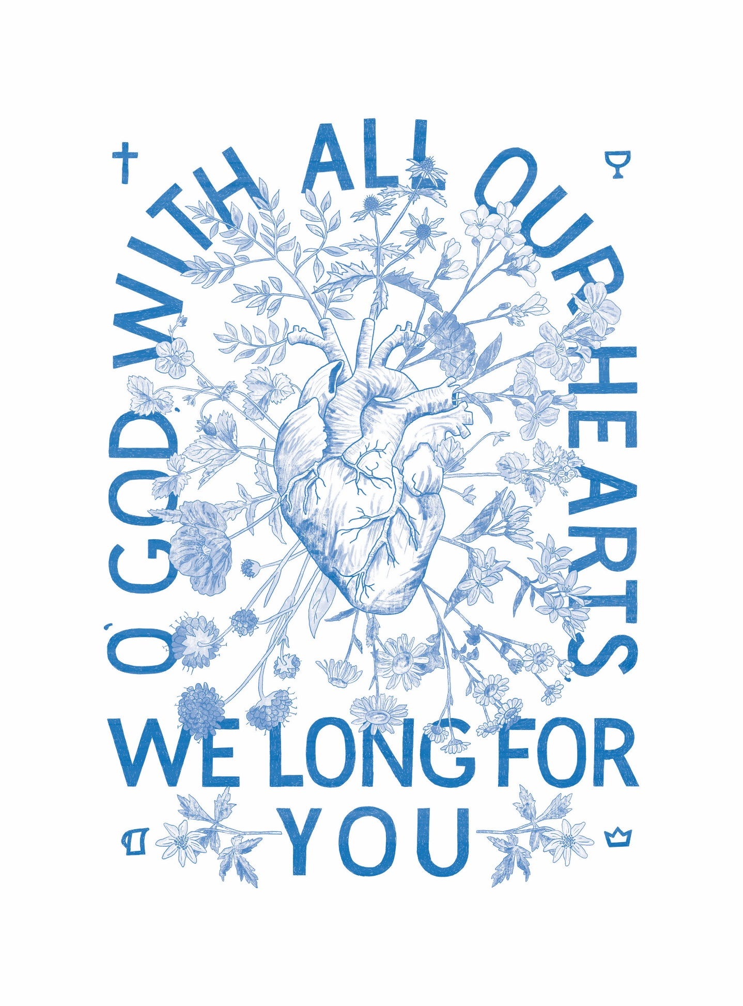
The Alliance Vision Prayer 宣道會異象禱告
The hand-lettering is the first half of the prayer.
and the illustration represents the second
half of the prayer: that our hearts would be
transformed and multiply life.
圖上的手刻字是禱文的前半部分，
插圖代表禱文的第二部分，意指：
願我們的心得到改變並去造就生命。

A Prayer Guide for Blessing the Nations

祝福列國的禱告指南

“In Blessing I will Bless You” (Genesis 12:2–3)
「論福，我必賜大福給你」 (創世記 12:2-3)
“I will make you a great nation; I will bless you and make your name great; and you shall be a blessing. I will bless those who bless you, and I will curse him who curses you; and in you all the families of the earth shall be blessed.” Genesis 12:2–3
「我必叫你成為大國。我必賜福給你，叫你的名為大；你也要叫別人得福。為你祝福的，我必賜福與他；那咒詛你的，我必咒詛他。地上的萬族都要因你得福。」(創世紀 12:2-3)
The blessings of Abraham extend to many generations and even to the ‘families of the earth’—the nations. We can proclaim the blessing of the Lord over our families, cities, and countries. We can make known His goodness and invoke His blessing over every sphere He has put in our lives. By blessing others, we give them honour and declare life for them—the life that comes through the relationship with the Giver of Life.
亞伯拉罕的祝福延伸到許多世代，甚至延伸到「地上的萬族」——列國。 我們可向我們的家人、城市和國家宣告主的祝福。 我們宣揚主的良善，並可在生活的每一個細節中尋求祂的祝福。 籍著賜福予人，我們為他們宣告從神得來的新生命，因祂是生命的泉源。
Every ethnos has a redemptive gift. Man, made in the image of God, demonstrates to greater or lesser extent aspects of the Creator. We can call out these dimensions of their nature and practice that we recognize in them and ask God to call it forth to focus on their Creator. In that, we bless the work done by the Creator in shaping each ethnicity so wonderfully.
每個民族都有一個救贖的禮物。上帝按照祂的形象造人，我們每人或多或少都展示了造物主的形象。我們應留意自己的本質和習慣，並祈求上帝幫助我們在多方面上都致力反映出造物主的形象。在此，我們感謝造物主，因祂為每個種族的塑造都是如此美妙。
Jesus became a curse by hanging on the cross and opened the way of blessing to those under the curse. “Christ has redeemed us from the curse of the law, having become a curse for us (for it is written, ‘Cursed is everyone who hangs on a tree’), that the blessing of Abraham might come to the Gentiles in Christ Jesus, that we might receive the promise of the Spirit through faith.” (Galatians 3:13, 14, NKJV)
耶穌被釘在十字架上為我們受了咒詛，為那些被詛咒的人打開了祝福的道路。 「基督既為我們受（原文是成）了咒詛，就贖出我們脫離律法的咒詛；因為經上記著：凡掛在木頭上都是被咒詛的。這便叫亞伯拉罕的福，因基督耶穌可以臨到外邦人，使我們因信得著所應許的聖靈 。」 （加拉太書 3:13, 14, NKJV）
The redeemed do not curse; we are people of blessing. This prayer guide comes with the hope that together, we can bless the nations to know the blessing of the Lord that ‘makes rich and adds no sorrow with it’ (Proverbs 10:22). The blessing of the Lord is the nearness of His presence. Come Lord Jesus to these beloved peoples. Bless them with the adoption as children of God, for they are wonderfully made by You.
被救贖的人不被咒詛；我們是得福的人。這份禱告指南是帶著同樣的盼望，盼望我們也能叫萬國得福，得以見證主的賜福，「耶和華所賜的福使人富足，並不加上憂慮。」（箴言 10:22）。主的賜福是祂同在的證據。主耶穌，來吧，來到袮心愛的民族。祝福他們成為神的兒女，因他們受造，奇妙可畏。
Please join us in speaking life over these people by proclaiming the prayer of blessing out loud each day for the people group we are praying for. “The tongue has the power of life and death” (Proverbs 18:21)
我們邀請你們加入我們，每天為我們代禱的人群大聲宣告祝福的禱告，為他們帶來生命的改變。 「生死在舌頭的權下」（箴言 18:21）。
Join us in singing a blessing over the nations:
與我們一起為萬國歌唱祝福：
https://www.youtube.com/watch?v=GjWI4CLmBbE

Amdo Tibetans安多藏族
About 1.2 million Ando Tibetan make up the six million Tibetans living in China. Most live and work as farmers and herders. About 10,000 Tibetans are living in Canada.
居住在中國的六百萬藏人中約有一百二十萬安多藏人(Amdo Tibetans)。 他們大多數以農民和牧民的身份工作和維生。 大約有一 萬名藏人正居於加拿大。
Their religion and culture are deeply integrated, and many believe: ‘I am Tibetan; therefore, I am a Tibetan Buddhist.’ Most Tibetans have a dedicated space in their homes with ritual objects they use daily.
他們的宗教和其文化深深地相互融合，許多人相信：「因為我是藏人, 所以我是一名藏傳佛教徒。」大多數藏人在家中都有一個特定的空間，裡面擺放著他們每天使用的宗教儀式物品。
Although few, Tibetan believers are growing in their faith, becoming bold, and caring for fellow believers in the countryside and neighbouring countries. Many Christian resources have been produced for Tibetan Buddhists. However, the long-hoped-for revival lags behind the effort. Enter the intercessors. Will you join us in praying for Tibetans?
雖然人數不多，但藏族信仰正在成長，他們變得愈來愈積極，並關心農村和周邊國家的信徒同胞。 近年，愈來愈多基督教的資源特定為藏傳佛教徒而設。 然而，即使在巨大努力中，人們期待已久的屬靈複興還未發生。 請加入我們為他們代禱。 你願意和我們一起為藏人祈禱嗎？

Pray with us: 讓我們一起同心祈禱：
Father, you have formed us in Your image so that creation might worship and adore You, our Creator. Would You bless Tibetans with the joy that comes from fellowship with the Eternal in worship? As they worship, will You let the emptiness of idolatry overcome them so that they will seek the God who loves them, with all their heart, soul, and mind?
父啊，袮是我們的造物者，袮按照袮的形象塑造了我們，讓受造物能夠敬拜和崇拜袮。 袮能祝福西藏人，讓他們領受在崇拜中與永生神相交所帶來的快樂嗎？ 當他們敬拜時，袮能從偶像崇拜的空虛中救贖他們，讓他們得以全心全意地尋求愛他們的神嗎？
Connect Tibetan Buddhists with Tibetan Christians who are serving You. Let the exuberant worship of Tibetans become unending praise to their Creator through salvation in Jesus. May their constant and passionate worship be turned toward You, Jesus. Amen.
祈求藏傳佛教徒能與藏傳基督徒聯繫起來。通過耶穌的救贖，讓藏人的崇拜成為他們對造物者宣告的無盡讚美。 願他們火熱的敬拜轉向袮，主耶穌。 阿門。

Arab Diaspora阿拉伯僑民
Canada has a substantial population of Arab diaspora. Approximately 1 million Arabs living in Canada are from Egypt, Syria, Jordan, Palestine, Lebanon, and Iraq. Many people from the Arab diaspora have left their passport countries for better career opportunities and political stability.
加拿大人口中有很多阿拉伯僑民(Arab Diaspora)。居於加拿大的大約一百萬阿拉伯人是來自埃及、敘利亞、約旦、巴勒斯坦、黎巴嫩和伊拉克。許多阿拉伯僑民為了更好的就業機會和政治穩定而離開了他們的國家。
Most Arabs are Muslim and deeply value hospitality, close family ties, and Islamic ideals. They are often resistant and can even be hostile towards gospel witnesses. Believers who convert from a Muslim background are often disowned by family and ostracized by their community. In many cases, even their lives are threatened. The exact number of Muslim background believers is not known but thought to be minimal.
大多數阿拉伯人是穆斯林，他們非常熱情好客、看重親密的家庭關係和伊斯蘭理想。他們經常對傳福音的人感到抗拒，甚至懷有敵意。從穆斯林背景歸信於基督的信徒經常被家人否認，並被他們的社區排斥。在許多情況下，他們的生命甚至受到威脅。有穆斯林背景的信徒之確切人數尚不清楚，但應不多。

Pray with us讓我們一起同心祈禱：
Father, we bless Arab Muslims with a pouring out of Your Spirit through dreams and visions.
天父，我們祝福阿拉伯穆斯林，求聖靈賜給他們異夢和異象，讓他們認識袮。
May they encounter faithful Christian witnesses. We bless them to understand the kind of peace. You offer. Through entering a relationship with You, we pray that they would experience the peace and freedom that comes from knowing that You have already paid the debt for all sin.
願他們遇到忠心的基督徒見證人。我們祝福他們能得到從主得來的平安，通過與您建立關係，我們祈求他們體驗到因袮擔當了我們的罪並賜給我們的平安與自由。
Flood them with Your perfect love that washes away all fear. We bless the believers among them with courage, boldness, and perseverance to bear witness to the Gospel—even through suffering and persecution. We bless their witness to bear fruit, resulting in an increased harvest of souls. Amen.
我們祈求上帝無盡完美的愛淹沒他們，洗去他們心中所有恐懼。我們祝福當地的信徒，即使經歷苦難和迫害，他們能有勇氣、膽量和毅力為福音作見證。我們祈求他們的見證能結出果子來，從而收取更多屬靈的莊稼。阿門。

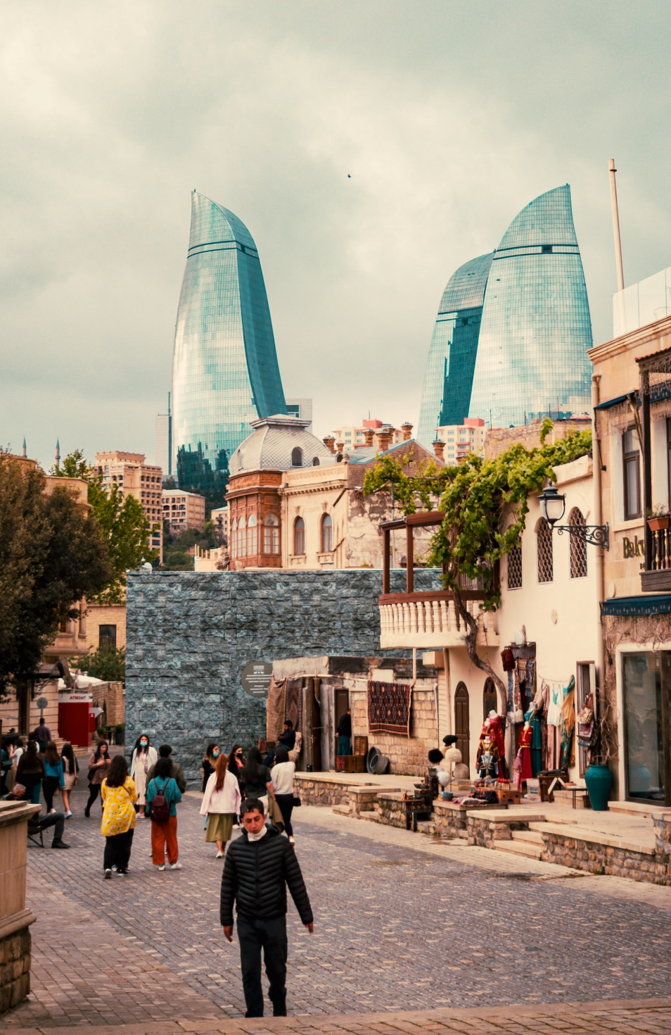
Azerbaijani阿塞拜疆
Zoroastrianism, most widely known for its element of fire worship, was commonly practiced in ancient times and originated in Azerbaijan. Evidence of this old religion is still prolific today. After the disciple Bartholomew preached in Azerbaijan, Christianity grew to be the official religion by the 4th century. After Islam spread in the 7th century, Azerbaijani culture shows little evidence of their Christian heritage. Today, 90% of Azerbaijani follow Islam.
瑣羅亞斯德教(Zoroastrianism)以其對火的崇拜而廣為人知，在古代很普遍，起源於阿塞拜疆。這種古老宗教的足跡今天仍然多處可見。在門徒巴塞洛繆在阿塞拜疆傳教後，基督教在公元四世紀成為官方宗教。不過，當伊斯蘭教在七世紀在當地傳播後，阿塞拜疆文化中的基督教傳統大多消失了。今天，90% 的阿塞拜疆人信奉伊斯蘭教。
Azerbaijani value loyalty and hospitality. Tea and bread are considered daily essentials. Azerbaijan is the wealthiest post-Soviet country due to oil and natural gas. However, corruption has slowed development and created economic hardship.
阿塞拜疆人重視對人忠誠和熱情好客。茶和麵包被認為是日常必需品。由於當地出產石油和天然氣，阿塞拜疆是後蘇聯時期最富有的國家。然而，社會貪污減緩了社會發展並造成了經濟困難。
There are 8.8 million Azerbaijani in Azerbaijan and over 20 million in Iran, of which less than 0.25% are believers. About 7,000 Azerbaijanis live in Canada, predominantly in the Toronto area.
阿塞拜疆本土住了880萬名阿塞拜疆人，伊朗則有超過2000萬名，其中基督徒不到0.25%。大約 7,000 名阿塞拜疆人現居於加拿大，並主要集中在多倫多地區。

Pray with us: 讓我們一起同心禱告
Father, rebuild ancient ruins that have been devastated; restore a temple of praise. Restore the Azerbaijani to their gospel roots! Open their eyes to see You and increase their longing to worship You. Bless believers with an increased knowledge of the Scriptures. Anoint them with Your Spirit, enabling them to be faithful and bold in witness, withstanding persecution. We call for more workers among the Azerbaijani and ask that a Bible school be established.
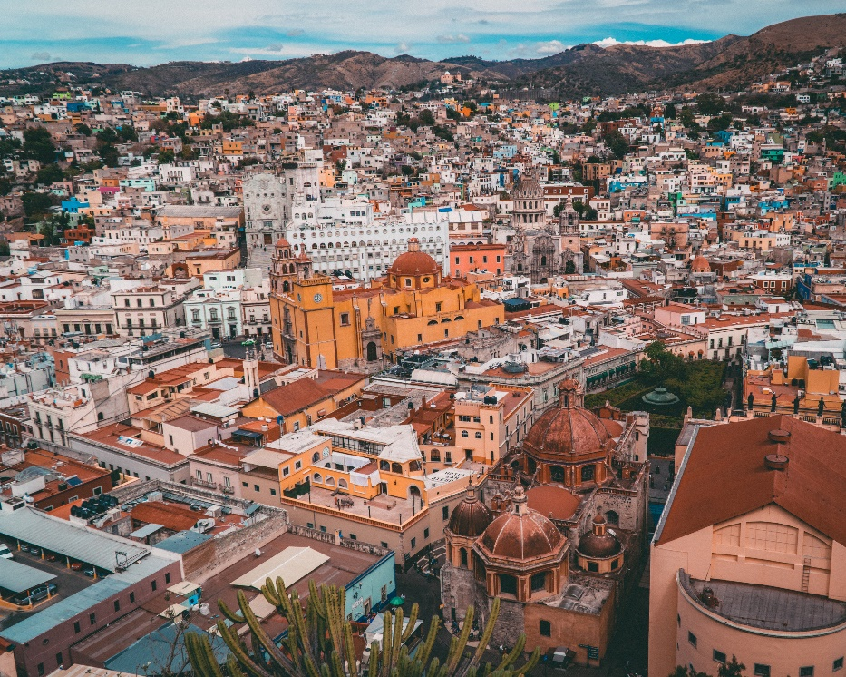
父啊，求袮重建被毀壞的遺址；重建萬民敬拜的聖殿。讓阿塞拜疆人恢復他們的福音根源！睜開他們的眼睛看到袮，並增加他們認識和敬拜袮的渴望。求袮祝福信徒對聖經的認識。用你的聖靈膏抹他們，使他們能夠忠實大膽地為袮作見證，抵擋逼迫。我們祈求袮興起更多工人在阿塞拜疆人中作工，並建立一所聖經學校。
Bless them with eternal satisfaction in You, Jesus, and we thank You that You are the bread of life. Whoever comes to You will never go hungry, and whoever believes in You will never be thirsty (John 6:35). Amen.
主耶穌，求袮祝福他們在袮裡面永遠富足，我們感謝袮，因袮是生命的糧。到袮這裡來的人，絕不飢餓；信袮的人，永不乾渴。（約翰福音6:35）。阿門。

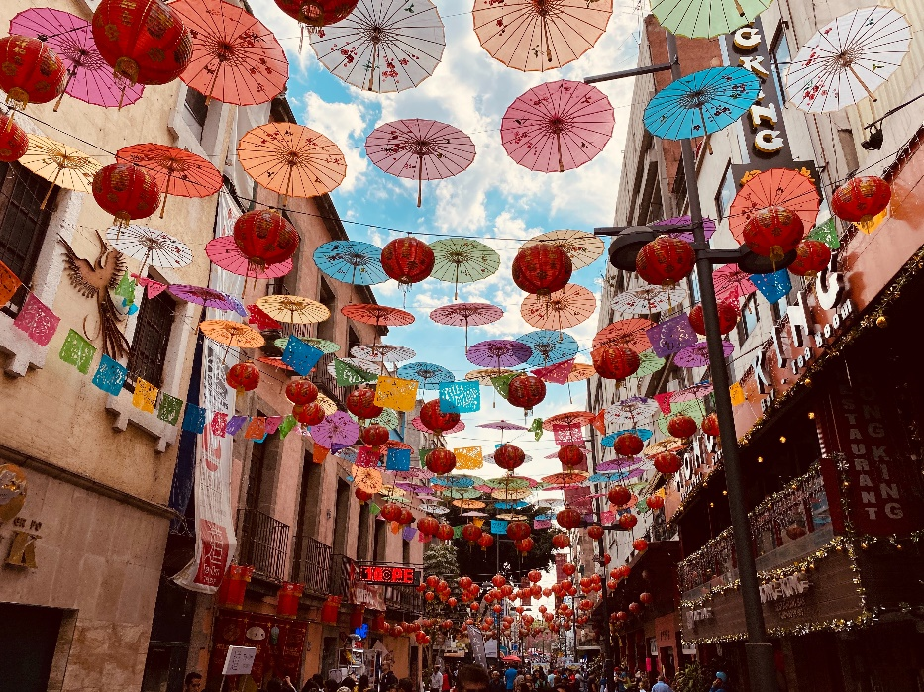
Chinese Diaspora in Mexico
僑居墨西哥的華人
The Han Chinese are the world's largest ethnic group, and although the majority live in mainland China, significant populations are reported in 62 countries worldwide. Less than 2% of the Chinese diaspora in Mexico are Christian.

漢族是世界上最大的民族，雖然大多數人生活在中國大陸，但據報導，全世界有 62 個國家有大量華人人口。不過，不到 2% 的墨西哥僑民是基督徒。

Thankfully there is some receptivity to the Gospel. The Joshua Project reports that there are about 1,268,000 Chinese that call Canada home, and about 8% of them are evangelical Christians. Most Chinese are either atheist or Buddhist.

值得慶幸的是，人們對福音有一定的接受度。約書亞計劃報告稱，約有 1,268,000 名中國人居於加拿大，其中約 8% 是福音派基督徒。大多數中國人要麼是無神論者，不然就是佛教徒。

Pray with us: 讓我們一起同心禱告
Jesus, we thank You that when You were on earth, You journeyed through all the towns and villages, teaching, proclaiming the good news, and healing people. Would You send Your Spirit to every village, town, and city the Chinese call home and draw them onto the narrow path towards You.
主耶穌，我們感謝袮，當袮在世上的時候，袮走遍了各城鎮和村莊，去教導、宣揚好消息、更去醫治人。袮願意把袮的靈送到中國人稱之為家的每一個村莊、城鎮和城市，並把他們帶到引到永生的窄門嗎？

We bless the Chinese to come to know You as saviour. We pray for the blessing of surrender for them on the journey towards You. Lord, bless them by sending workers to proclaim the good news to the Chinese wherever they live. Amen.

我們祝福中國人認識袮為救世主，我們祈求他們降服於袮。主啊，祝福他們，差遣工人向世界各地的中國人宣講好消息。阿門。

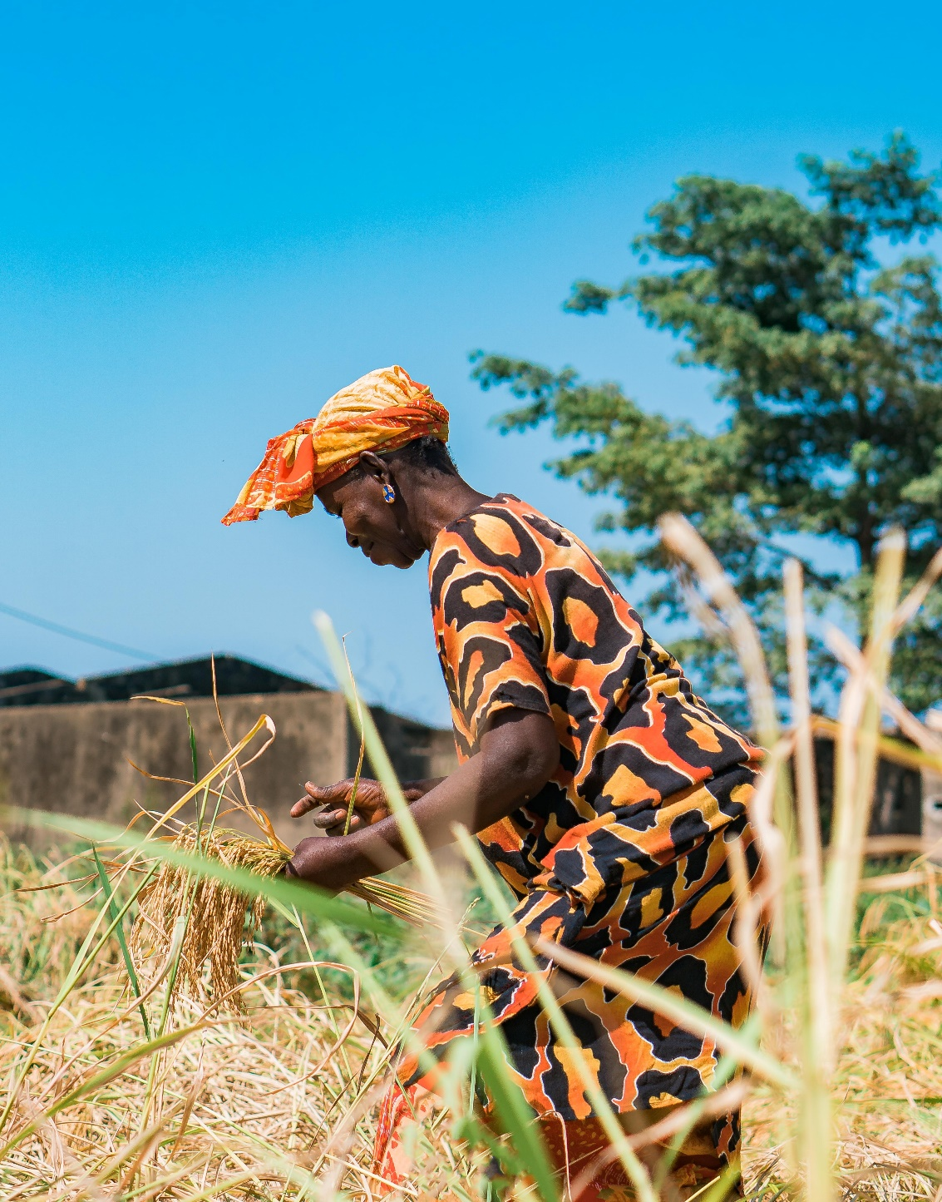
Fulani of Senegal塞內加爾的富拉尼
Fulani pride themselves on being the group that brought Islam across the Sahara to Western Africa.
從前，富拉尼人把伊斯蘭教穿越撒哈拉沙漠帶到西非，他們一直為此而感到自豪。
They are reluctant to leave this heritage behind and renounce Islam to follow Jesus. Senegalese are hospitable, polite, and open to dialogue, and they will quickly listen to the Gospel. However, turning from their own beliefs and practices to exclusively follow Jesus is very difficult. New believers often face persecution and rejection by their families.
他們不願捨棄此歷史作為所以難以放棄伊斯蘭教並跟隨耶穌。塞內加爾人熱情好客，彬彬有禮，喜歡和別人說話，他們願意聽福音。然而，從他們自己的信仰和種族文化轉向過來並跟隨主耶穌是非常困難的。初信者常常面臨家人的逼迫和拒絕。
Only 0.2% of the 3.9 million Fulani are believers, and there are only a couple of local fellowships among them. There are around 5000 Fulani that reside in Canada.
三百九十萬富拉尼人中只有0.2%是信徒，團契聚會的地方只有幾個。大約有五千名富拉尼人現居於加拿大。

Pray with us: 讓我們一起同心禱告：
Heavenly Father, we thank You for the love You have lavished on us! Please bless the Fulani people with a Your banner of love.
父啊，我們感謝袮對我們的愛！求神袮以愛為旗去祝福富拉尼人。

We long for the Fulani to come into Your family, and we call forth their destiny as children of God. Pour out Your love on entire families. Bless Fulani marriages to be made whole.

我們渴望富拉尼人加入袮的大家庭，願他們成為上帝的兒女。求袮將袮的愛傾注於每個家庭。祝福富拉尼人的婚姻能夠得以完全。

We call forth the new things. You are doing. Make a way in the wilderness and let the rivers flow in the desert. We bless Fulani believers who are being persecuted and rejected with great endurance. May they be faithful in sharing Your Word despite hardships. Bless the Fulani with a new name, Lord; may they be Your beloved, Your children! “To the one who overcomes... I will also give him a white stone inscribed with a new name, known only to the one who receives it” (Revelation 2:17). Amen.

我們盼望新的景象。我們知道袮正在作工，在曠野開道路，在沙漠開江河。我們會忍耐到底一直去祝福那些被迫害和拒絕的富拉尼信徒。願他們在患難中忠實地繼續分享袮的話語。主啊，願袮賜富拉尼一個新名字；願他們成為袮的摯愛，袮的孩子！ 「得勝的……並賜他一塊白石，石上寫著新名，除了那領受的以外，沒有人能認識。」（啟示錄 2:17）。阿門。

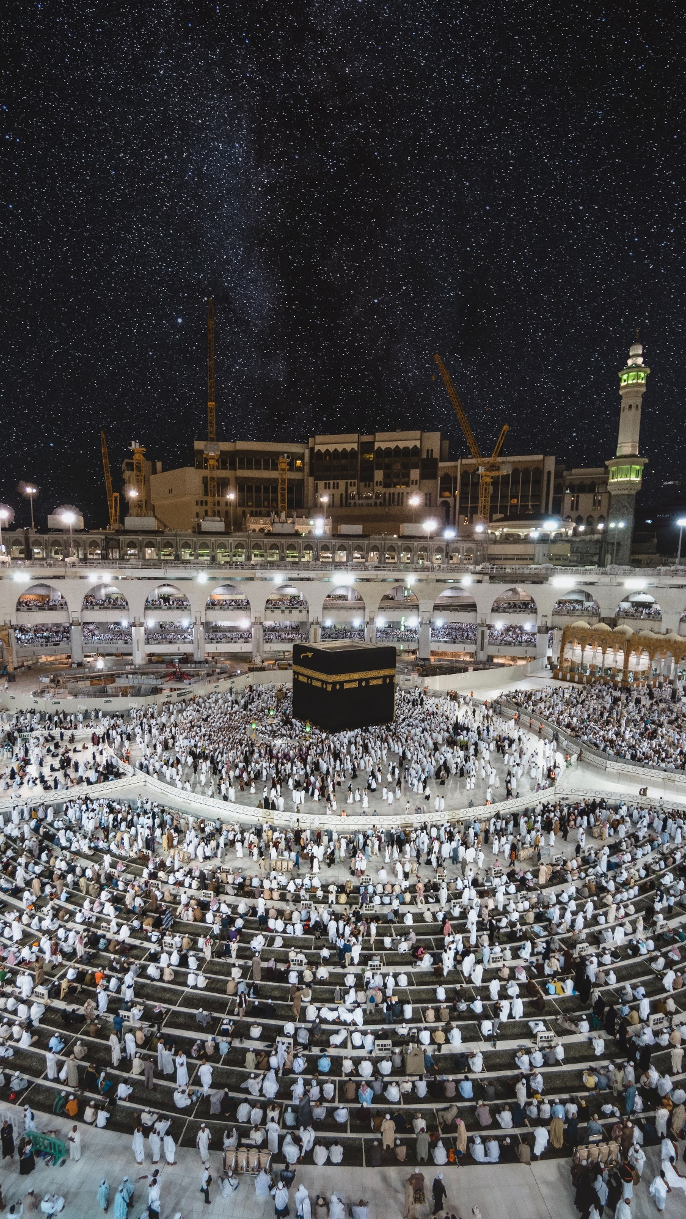
Gulf Arabs海灣阿拉伯人
Approximately 54 million Gulf Arabs from Bahrain, Kuwait, Oman, Saudi Arabia, and the UAE. Almost all are followers of Islam except for around 300 known believers. The Joshua Project states that 98.1% of the 78,000 Gulf Arabs living in Canada are Muslim. Many are international students who have travelled to Canada to receive higher education. University is a unique season for many Arab students because they can explore and discover opportunities otherwise unavailable to them back home. Would you consider reaching out to international students and inviting them into your home?
來自巴林、科威特、阿曼、沙特阿拉伯和阿聯酋大約5400萬的海灣阿拉伯人(Gulf Arabs)中，除了大約三百名已確認的基督徒外，幾乎所有人都是伊斯蘭教的追隨者。約書亞計劃 (Joshua Project) 指出，居住在加拿大的 78,000 名海灣阿拉伯人中有 98.1% 是穆斯林。許多人是前往加拿大接受高等教育的國際學生。能夠就讀大學對許多阿拉伯學生來說是很難得的，因為那能幫助他們探索和獲得更多就業機會，這些都是他們的家鄉無法給予的。你會嘗試接觸這些國際學生並邀請他們到你家作客嗎？

Pray with us: 讓我們一起同心禱告：
Father, we bless Gulf Arabs with a disciple-making movement! Bless the few Arab believers with continued favour and opportunities to make Your Name famous among the nations.
父啊，我們想興起一個造就門徒的運動去祝福海灣阿拉伯人！願袮保守那些少數的阿拉伯信徒繼續得到袮的恩惠，給予他們機會去傳講福音，讓袮的名字在萬國中享有盛名。
We pray that You would grant Your people influence, as You did with Joseph and Daniel. May Your people seize divine opportunities to show hospitality to international students. May Your love be poured out through Your people, into every sphere where they have influence. Bless Your disciples with boldness, courage, and the ability to disciple others. “One generation commends your works to another; they tell of your mighty acts” (Psalm 145:4). Amen.
我們祈求袮給予袮的子民能力去影響別人的生命，就像袮對約瑟和但以理所做的一樣。願袮的民抓住每一個機會，向每一位國際學生表示友好。籍著袮的子民，願袮的愛傾注到他們接觸的每一個人。願他們能有勇氣大膽地去建立和祝福門徒。「這代要對那代頌讚你的作為，也要傳揚你的大能。」（詩篇 145:4）。 阿門。

Huichol惠喬爾
Around 44,000 Huichol live in Mexico, and about 6,000 reside in the United States. Only 0.4% of the Huichol population is Christian. Most Huichol follow an ethnic religion that believes in many gods. Converts to Christianity are often persecuted by and expelled from their community.
大約 44,000 惠喬爾人(Huichoi)正居於墨西哥，大約 6,000 人現居於美國。惠科爾人口中只有 0.4% 是基督徒。大多數惠喬爾人信奉多神信仰的民族宗教。轉信基督教的人經常受到社區的迫害和驅逐。
Praise God that there are new opportunities through community development to build relationships and access other Huichol groups.
讚美上帝，通過社區發展，基督教團體有了新的機會去接觸其他 Huichol 團體，和他們建立關係。

Pray with us: 讓我們一起同心禱告：
Heavenly Father, please bless the Huichol with the revelation of who You are, the one true God.
父啊，求袮啟示惠喬爾，向他們顯明袮是誰──獨一真神。求袮賜福惠喬爾。
Bless them with pictures of Your loveliness: a merciful God who saves, a God who rejoices over His loved ones with gladness, and a God who sings over His people. Comfort them with Your love (Zephaniah 3:17). May their hearts and minds be receptive to You, Jesus.
求袮祝福他們，向他們顯示袮的榮美：「你是施行拯救、大有能力的主。他在你中間必因你歡欣喜樂，默然愛你，且因你喜樂而歡呼」(西番雅書 3:17），願袮的愛安慰他們。耶穌，願他們的心和靈接受袮。
We ask for Your mercy on those persecuting their people who believe in You. Bless the persecutors with a revelation of who You are and with Damascus Road experiences. Please enable them to see You.
我們祈求袮憐憫那些正迫害門徒的迫害者。求袮賜福給他們和向他們顯明袮是誰，求袮啟示他們大馬士革路的經歷，讓他們看到袮。
We bless Huichol believers to grow daily in their relationship with You. We pray that through them, You would draw others to Yourself—even to the ends of the earth. Amen.
我們祈求惠喬爾基督徒與袮的關係每天變得更親密。我們祈求，籍著惠喬爾信徒，袮會把更多人帶到袮自己身邊——直到地極。阿門。

Japanese日本人
Dominated by atheism, Buddhism, and Shintoism, evangelical Christianity represents only 0.5% of the Japanese population. Despite 500 years of Christian presence in Japan, Christianity is regarded as a foreign religion. Over 1,000 cities and half of all the villages have no church. With 126 million, Japan is the largest unevangelized country entirely open to missionaries.
日本人信奉無神論、佛教和神道教為主，福音派基督教僅佔日本人口的 0.5%。儘管基督教在日本已有 500 年的歷史，但基督教仍被當地人視為外國宗教。 日本有多於1000 個城市和一半的村莊還未有教會。日本有 1.26 億人口，是世界上最未聽聞福音的國家。
Japan faces many crises. Young people lack hope or confidence in the future; because of this, Japan has a suicide epidemic (over 30,000 per year). High suicide and divorce rates in all age groups confirm the crisis. Economic decline, social isolation, and the constant threats of earthquakes leave many people open to spiritual matters.
日本正面臨許多危機。年輕人對未來缺乏希望或信心；正因如此，日本出現了自殺流行病（每年超過 30,000 人）。每個年齡層都有高自殺率和離婚率，這些都證實了這場危機的存在。經濟衰退、社會孤立和地震的持續威脅使許多人飽受心靈和屬靈問題。

Pray with us: 讓我們一起同心禱告：
Heavenly Father, would You bless the Japanese with hearts that are open to Jesus. Soften their hearts and let the seeds of the Gospel begin to germinate. We speak life over the people and come against the spirit of death that robs them of hope and eternity with Jesus.
父啊，願袮祝福日本人，能得到一顆向耶穌敞開的心。求袮軟化他們的心，讓福音的種子發芽。我們渴望向他們宣講耶穌，並停止那死亡之靈去繼續剝奪他們從主可得的盼望和永生。
May they hear Your voice to them today, to “Come alive!” Penetrate every barrier raised against the knowledge of the Lord Jesus Christ. Increase Your Kingdom among Japanese and help them hear the ‘old message’ with new ears and renewed hope.
願他們今天聽到袮對他們說話的聲音，「活過來！」 求袮挪開每一個防止他們認識主耶穌基督的障礙。願袮的國度在日本人中間擴展，幫助他們以新的盼望接受耶穌的「好消息」。
“For the idols speak delusion; the diviners envision lies and tell false dreams; they comfort in vain. Therefore the people wend their way like sheep; they are in trouble because there is no shepherd” (Zechariah 10:2). Awaken the Japanese from idolatry and bless them with shepherds after Your own heart. Amen.
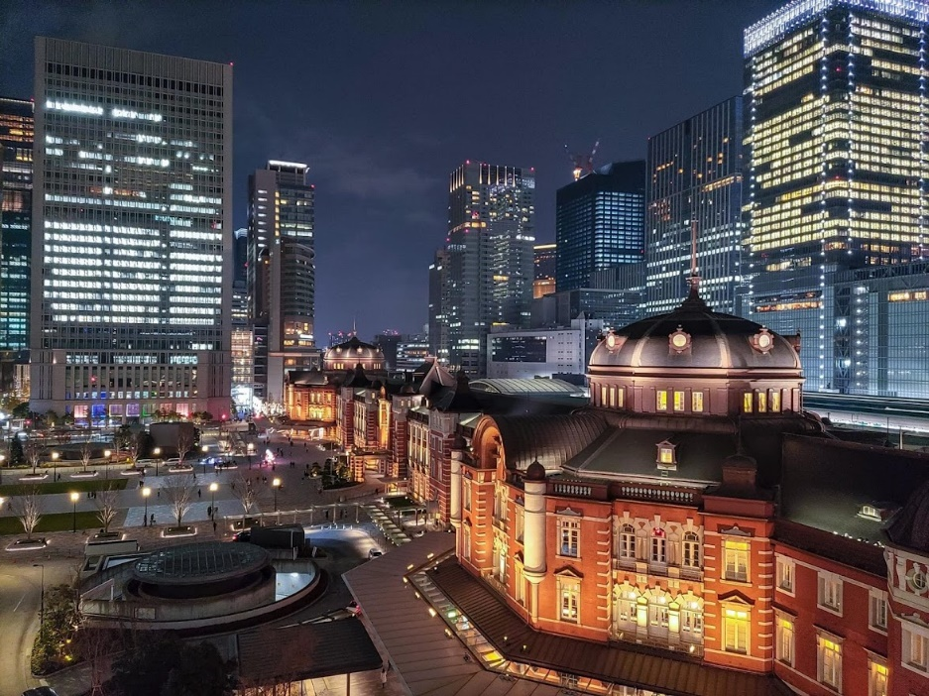
「因為，家神所言的是虛空；卜士所見的是虛假；做夢者所說的是假夢。他們白白地安慰人，所以眾人如羊流離，因無牧人就受苦。」（撒迦利亞書 10：2）。求神把日本人從偶像崇拜中喚醒，並賜給他們一個合袮心意的牧人。阿門。

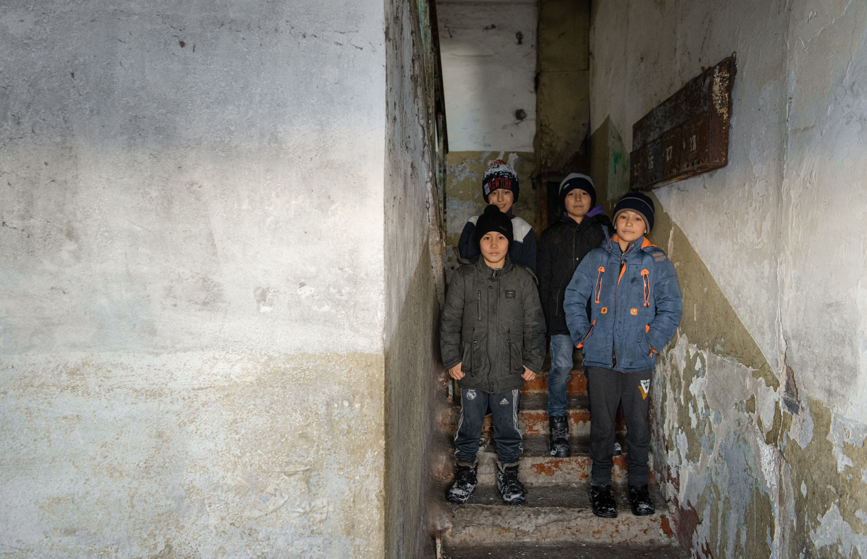
Kazakh哈薩克語
Most of the 12.2 million Kazakh live in Kazakhstan; however, many live in Mongolia, Ukraine, and Russia. About 3,300 Kazakhs call Canada home, according to The Joshua Project. Although many Kazakhs are culturally Muslim, their religion isn’t intensely practiced. Only 0.1% of Kazakhs are Christians.
1220 萬哈薩克人中大多數的人口都生活在哈薩克斯坦；亦有許多人生活在蒙古、烏克蘭和俄羅斯。據約書亞計劃 (The Joshua Project) 稱，約有 3,300 名哈薩克人在加拿大居住。儘管許多哈薩克人在文化上信奉穆斯林，但他們並不廣泛地實踐其宗教信仰。只有 0.1% 的哈薩克人是基督徒。
Kazakhs living in urban areas seem to be more open to hearing the gospel message than those in villages with stronger family bonds. Kazakhs are known for their warmth, friendliness, and hospitality.
相比住在村莊里著重家庭關係的哈薩克人，生活在城市地區的哈薩克人似乎比較願意聽到福音信息。哈薩克人非常熱情、友好和好客。

Pray with us: 讓我們一起同心禱告：
Heavenly Father, bless Kazakhs with a new song! May they sing a new song of praise to You that cannot be silenced! “You are worthy of taking the scroll and of opening its seals because You were slain, and with Your blood, You purchased for God persons from every tribe and language and people and nation" (Revelation 5:9).
天父，求袮祝福哈薩克人， 願他們唱新歌！願他們為袮唱新歌，無歇息地讚美袮！「他們唱新歌，說：你配拿書卷，配揭開七印；因為你曾被殺，用自己的血從各族、各方、各民、各國中買了人來，叫他們歸於神」（啟示錄 5：9）。
Pour out Your favour and blessing upon the few Kazakh believers to enable them to "each day proclaim the good news that He saves." May they sing of Your "glorious deeds among the nations" and "tell everyone about the amazing things" you do (Psalm 96:2-3).
求袮賜恩和賜福給那少數的哈薩克基督徒，使他們能夠「天天傳揚他的救恩」。願他們歌頌你「在列邦中述說他的榮耀」，並「在萬民中述說他的奇事」（詩篇 96:2-3）。
Bless the Kazakhs in these days of turmoil and unrest, with a peace that only comes from knowing the Prince of Peace. May their hearts be hungry for the truth of who You are, Jesus.
在這些動盪不安的日子裡，求袮祝福哈薩克人，只有認識和平的君才能得到真正的平安。願他們的心渴慕認識「袮是誰」，主耶穌。
Unveil their eyes to the truth of the Gospel, and may their ears begin to hear the whisper of heaven's song saying, "Worthy is the Lamb, who was slain" Revelation 5:12. Amen.
願他們睜開眼睛看到福音的真理，願他們聽到屬天的歌聲，「曾被殺的羔羊是配得頌讚的」 (啟示錄 5:12)。阿門。

Kazakh Uyghur哈薩克維吾爾語
The Kazakh Uyghurs live in the world’s largest landlocked country. They border on Russia, ‘the Stans,’ and the western edge of China.
哈薩克維吾爾人(Kazakh Uyghur)生活在世界上最大的內陸國家。他們居於俄羅斯、「斯坦斯」和中國的西部邊緣。
300,000 Uyghurs live in Kazakhstan—most can trace their roots to an immigration wave before the 1960s. They mainly speak Russian and practice Islam. Some may speak the Uyghur language to older family members. Only 0.01% are Christians. One factor that prevents the spread of Christianity is the perception that it is a religion for only the West. Praise God that there are six known Uyghur fellowships in Kazakhstan, ranging from 5 to 30 members.
300,000 維吾爾人生活在哈薩克斯坦——大多數人的背景可以追溯到 1960 年代前的移民潮。他們主要講俄語並信奉伊斯蘭教。有些人可能會對年長的家庭成員說維吾爾語。只有 0.01% 是基督徒。阻止基督教傳播的其一因素是他們廣泛地認為基督教只是一個西方的宗教。不過，讚美上帝，在哈薩克斯坦中巳有六個維吾爾基督教團契，成員從 5 到 30 人不等。
An estimated 2,000 Kazakh Uyghurs live in Canada.
估計有 2,000 名哈薩克維吾爾人正居於加拿大。

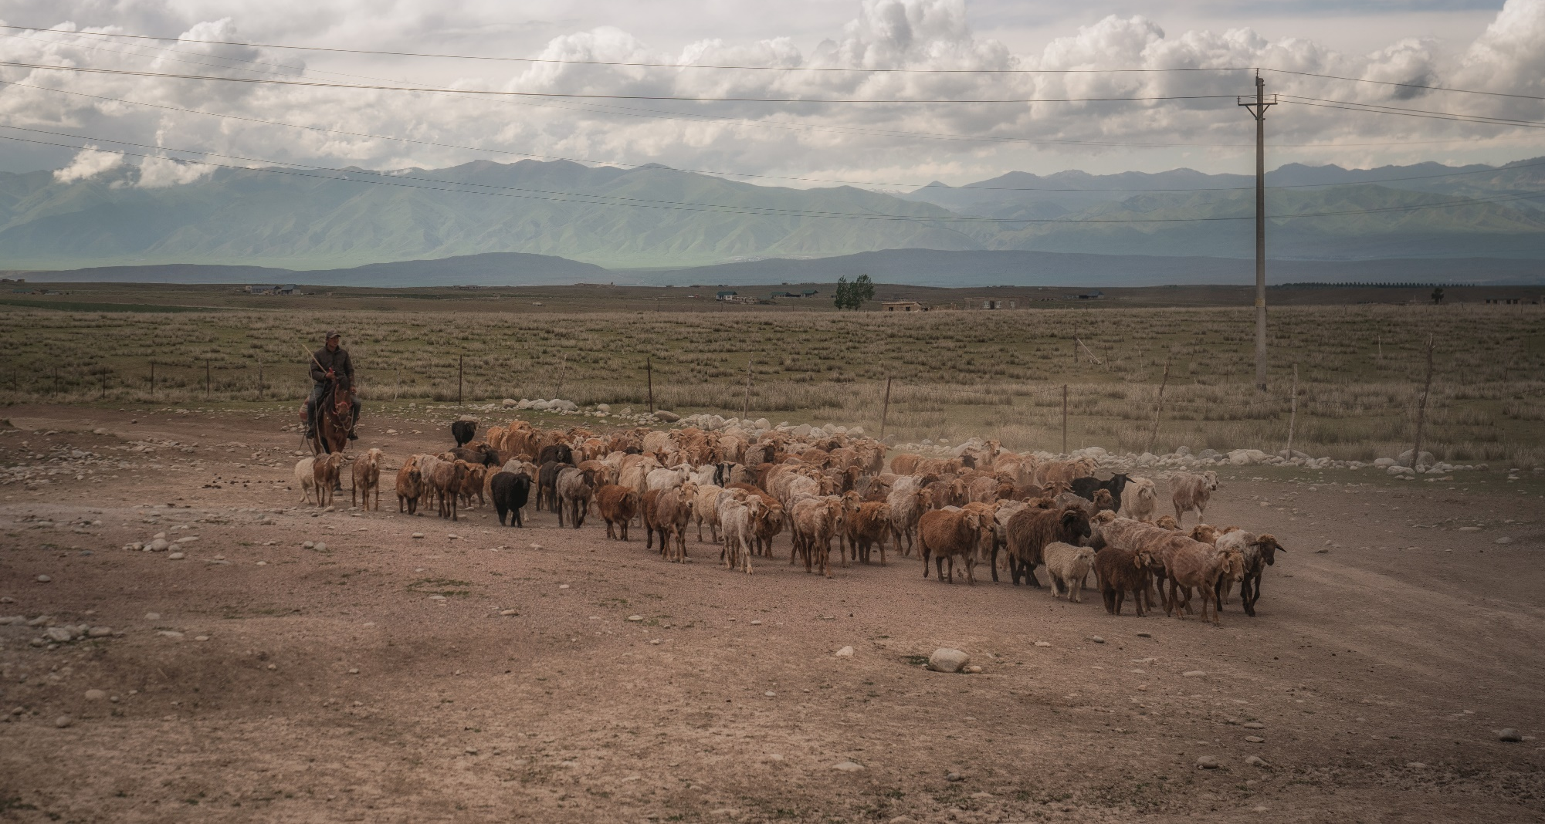
Pray with us: 讓我們一起同心禱告：
Lord, Will You come with Your light and illuminate the pathway to God. Lift the Kazakh Uyghurs from the thick darkness, covering the people. “And He will destroy on this mountain the surface of the covering cast over all people, and the veil that is spread over all nations” (Isaiah 25:7). Bless the Kazakh Uyghurs with open heavens and clarity that they might behold their God, Yahweh, the Creator of humanity. Amen
主啊，願袮帶著袮的光來照亮他們的道路去認識袮, 把被遮蓋了的哈薩克維吾爾人從深淵的黑暗中拯救出來。 「他又必在這山上，除滅遮蓋萬民之物和遮蔽萬國蒙臉的帕子。」（以賽亞書 25:7）。祝福哈薩克維吾爾人擁有一個開闊和清晰的視野，讓他們看到他們的上帝真神，耶和華，全地的造物者。阿門。

Kurds庫爾德人
The traditional homeland of Kurds spreads across Turkey, Syria, Iraq, and Iran. With a worldwide population estimated between 30 – 45 million people, the Kurds are the largest people group in the world without a state. They have a popular saying that “the Kurds have no friends but the mountains.”
庫爾德人(Kurds)的傳統家園位於土耳其、敘利亞、伊拉克和伊朗。庫爾德人的全球人口估計為 3000 至 4500 萬人之間，是世界上沒有國家的最大民族。他們有一句流行普及的說法：「庫爾德人沒朋友，只有山。」
Kurds are somewhat receptive to the Gospel, yet only about 1% are Christian; most are Muslim. They are known as being tremendously hospitable and friendly. They have vibrant traditions of telling stories through songs. Kurds are also known to be fiercely independent and patriotic. Their society is strongly communal and is arranged according to tribes.
庫爾德人在某程度上願意聽取福音信息，但只有大約 1% 的人是基督徒；大多數是穆斯林。他們非常好客和友好。他們喜歡用歌曲講故事，他們充滿活力。眾所周知，庫爾德人非常獨立和愛國。他們彼此有很強的聯繫，而社會是以部落形式發展下來。
Many Kurds seek a better life in western Europe, North America, and Australia. About 7,400 live in Canada.
許多庫爾德人在西歐、北美和澳大利亞尋求更好的生活。大約有 7,400 人居住在加拿大。

Pray with us: 讓我們一起同心禱告：
Heavenly Father, pray that Kurds would receive the friendship of God and know Jesus. Bless them by giving them faithful Christian friends and continue to grant them revelations of Jesus in miraculous ways. We pray Hosea 2:23 over them that you would call them Your people and be their God.
父啊，祈求庫爾德人得以認識袮和主耶穌。求袮祝福及賜給他們忠實的基督徒朋友，並繼續以奇妙的方式給他們啟示主耶穌的好消息。我們引用何西阿書 2:23為他們祈禱: 願袮成為他們的神，他們為你的子民。
Bless them to discern what is true and be dissatisfied with anything false.
祝福他們辨別什麼是真實的，拒絕任何虛假的東西。
May Kurds come to be Your people and spread Your fame. Bless them by meeting them in their needs, as they to call upon You for help. Amen.
願庫爾德人成為袮的子民，傳播袮的名。當他們呼求袮的幫助時，求袮祝福他們，滿足他們的需要。阿門。
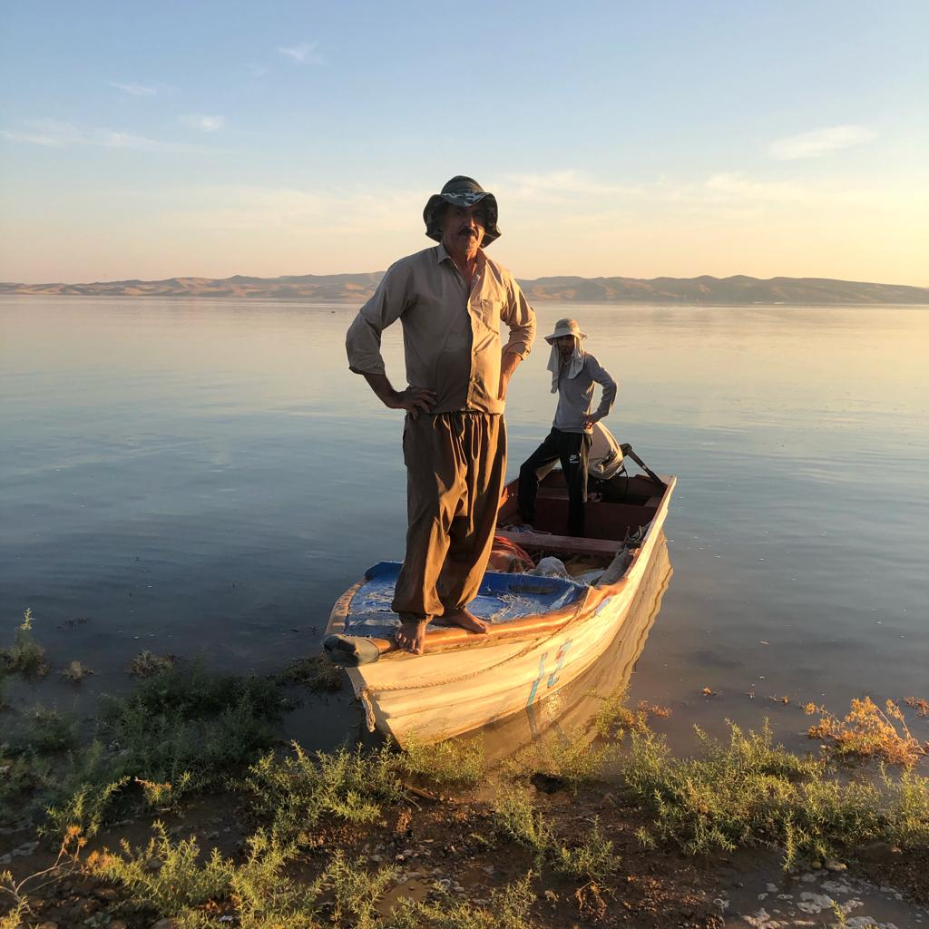

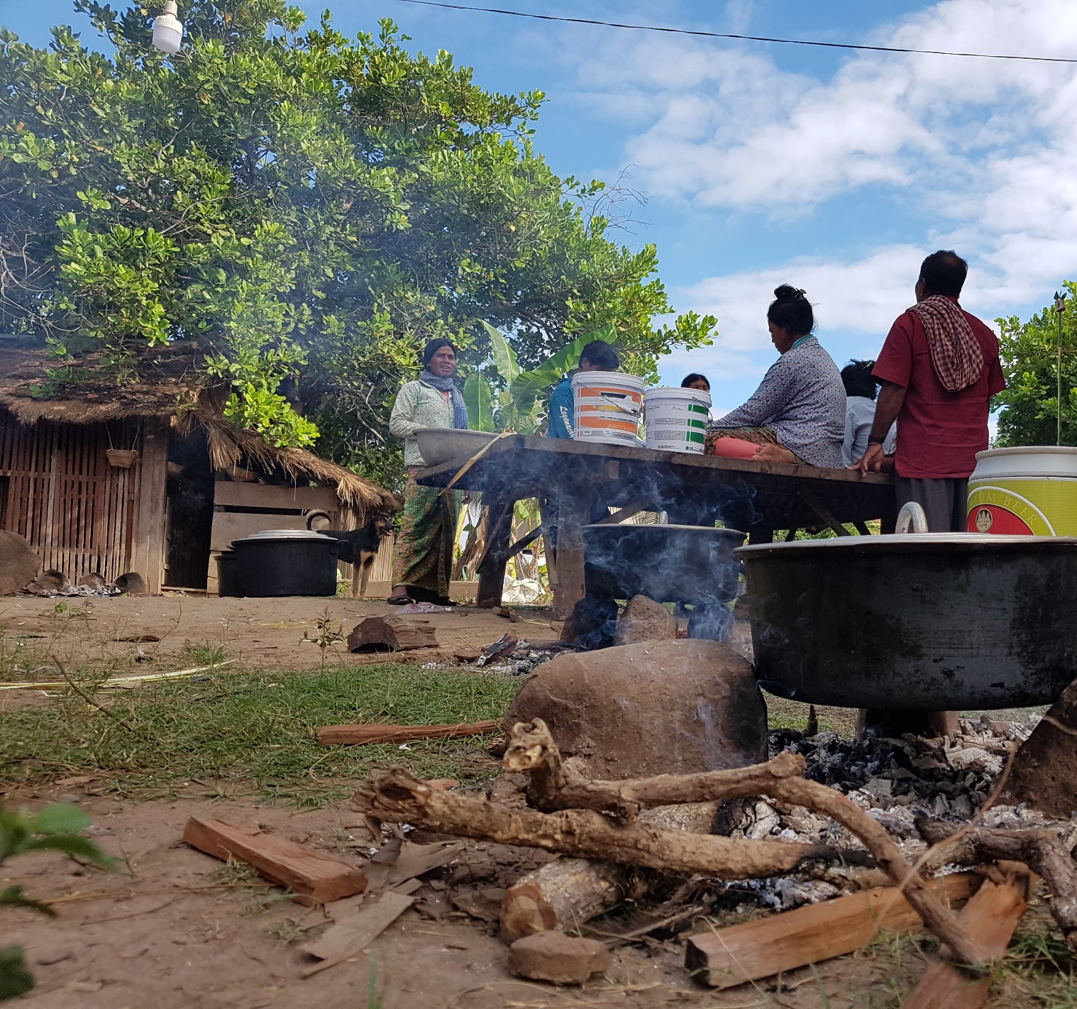
Kuy庫伊
The Kuy inhabit both sides of the Thai-Cambodia border, with about 35,000 living on the Cambodian side. They are predominately animist in their belief, with Buddhism mixed in. The Kuy are deeply steeped in their religion, but they are not entirely resistant to Christianity. Only 0.53% of the Kuy are considered Evangelical Christians, but several small Kuy churches in Cambodia.
庫伊(Kuy)族居住在泰柬邊境兩側，約有35,000人居住在柬埔寨一側。他們的信仰主要相奉萬物有靈論，佛教亦是普及的信仰。庫伊人深深地信奉他們的宗教信仰，但他們並不完全抵制基督教。只有 0.53% 的庫伊人是福音派基督徒，柬埔寨有幾個小教會。
The Bible has recently been translated into Kuy, and we trust that they will soon have a greater interest in reading it. May those who follow Christ boldly proclaim their faith!
聖經最近被翻譯成庫伊語言，我們相信他們漸漸地會有興趣去接觸和閱讀聖經。願那些跟隨基督的人勇敢地宣揚上帝的信息！

Pray with us: 讓我們一起同心禱告：
Lord, would You magnify the uniqueness of Jesus—the One who does not share His glory with another, the One who provides a sure and certain way to salvation, the One who has overcome all antagonistic spiritual forces and, as One with God, rules over the cosmos. May the Kuy see you for who You are!
主啊，願主耶穌基督的獨特和超越得以廣傳 — 耶穌是那一位獨享榮耀的神，那一位成就了可靠而唯一的救恩之路，那一位克服了所有敵對的屬靈力量，並與上帝原為一，是管理萬國宇宙的。願庫伊看到袮的大能！
Bless Kuys with a revelation of the uniqueness of Jesus and discernment to wade through their belief system, testing it against the purity of Your Word. Bless them with a hunger for truth. Would You favour them with a solid and growing confidence in Jesus? Come, and love these people into Your fellowship, Jesus. Amen.
求袮祝福庫伊，向他們揭示耶穌的獨特，賜予他們屬天的洞察力去看清他們的信仰，並用袮純淨的話語來測試它。幫助他們去渴望真理。我們祈求袮賜給他們一個堅定的和不斷成長的信心。來吧，主耶穌，求袮賜給他們袮的大愛，讓他們進入袮的團契。阿門。

Laotian老撾語
There are over 7 million Laos, and 60% identify as Buddhists. Animism, religion, and folklore are deeply rooted in the Lao culture. According to The Joshua Project, 2.52% of the population are Evangelical believers.
老撾(Laotian)有超過 700 萬人，其中 60% 是佛教徒。他們信奉萬物有靈論、他們的宗教和民間傳說深深植根於老撾文化。 根據約書亞計劃，2.52% 的人口是福音派信徒。

Pray with us: 與我們一起同心禱告：
Heavenly Father, would You help the Lao know the blessing of their God-created culture. Bless them to see where they have entangled and robbed of their freedom in Christ.
天父，祈求袮幫助老撾人了解袮為他們創造的文化祝福。 祝福他們，讓他們看到什麼正糾纏和剝奪他們在基督裡的自由。
Holy Spirit of God, hover over this nation. Give them a deluge of truth that will unseat tradition and bring release. Bless them with living water to refresh them and lead many to salvation.
神的靈啊，願袮運行在這地上。大大地為他們揭示真理，推翻他們的傳統並釋放他們。 求袮用活水祝福他們，使他們得到更新，帶領許多人得救。
Thank You that You will present the Lao before Yourself as a pure and spotless bride. We lift these prayers of blessing to the Eternal, whose love for the Lao is never failing. Amen
謝謝袮，我們期待見證袮把老撾人改變成一個毫無玷汙和沒有瑕疵的新娘。 我們將一切祈求和禱告交上，因我們深信永恆的主對老撾的愛是永不止息的。 阿門。

Minnan閩南語
Worldwide there are 58.2 million Minnan. 13.4 million Minnan call Taiwan home. The majority religion of Minnan is a mix of Taoism, Buddhism, folk religion, and ancestor worship.
全世界有5820萬名閩南人(Minnan)。 1340萬名閩南人扎根於台灣。閩南的主要信仰混合了道教、佛教、民間宗教和祖先崇拜。
Evangelical Christians make up 3.7%. Many Minnan believe that all religions are the same. They are reluctant to follow Jesus if it means forsaking ancestor worship because filial piety is central to Taiwanese culture.
福音派基督徒佔 3.7%。許多閩南人相信所有的宗教都是一樣的。不過，如果一個信仰需要放棄祖先崇拜，他們不會願意跟隨，所以他們不願意跟隨耶穌，因為孝道是台灣文化的核心。
The Taiwanese work very long hours. They prioritize education for their children, and most elementary school students go to cram schools after school.
台灣人工作時間很長。他們優先考慮的是孩子的教育，大多數小學生放學後都去補習班。
Approximately 14,000 Minnan Chinese live in Canada. Pray God would work in the hearts of the Minnan living both here and abroad!
大約有 14,000 名閩南華人居於加拿大。祈求神在身處國內和國外的閩南人的心中作工！

Pray with us: 與我們一起同心禱告：
Our Lord, You are the one who opened blind eyes. Would You bless Minnan people the awareness that what they long for in the depths of their being are You and Your salvation? Grant them sight to see You. Open their spiritual eyes to envision God’s plan for their lives and see themselves as worshipers of the One true God.
我們的主，袮是那位把瞎子眼看見的神。求袮祝福閩南人，讓他們知道他們內心深處的渴望應是袮和袮的救贖, 求袮讓他們看見袮。我們渴望袮打開他們屬靈的眼睛，去明白上帝對他們生命的計劃。我們祈求他們將自己視為獨一真神的敬拜者。
Show them the risen Jesus in all His glory. Light of the world, break through the darkness, causing every lie to fall, and bless them with visions and dreams of the Saviour of the world. May all praise, honour, and glory be to You! Amen.
求袮向他們展示復活耶穌的榮耀。耶穌是世界的光，衝破黑暗，傾倒每個謊言，求袮在異象和異夢中向他們顯示他們的救主。願一切頌讚、尊榮和榮耀全歸於袮！阿門。

North African Arabs北非阿拉伯人
Over 252 million North African Arabs live in seven different countries. Some North African countries have no fellowships, while others have local fellowships with a higher percentage of Christians. The evangelical population in this region ranges from 0% to 0.39%. Depending on the location, receptivity to the Gospel varies from low to hostile.
超過 2.52 億名北非阿拉伯人生活在七個不同的國家。一些北非國家未有團契聚會，一些擁有較高比例基督徒的地區則建立了當地團契。該地區的福音派人口從 0% 到 0.39% 不等。根據地點的不同，人們對福音的接受程度不等，偏向較低或懷有敵意。
Warm and hospitable, with a strong emphasis on family and relationships, many North African Arabs have also found themselves in Canada.
他們熱情好客，非常重視家庭和人際關係，許多北非阿拉伯人住在加拿大。

Pray with us: 讓我們一起同心禱告：
Father, we bless the communities of faith among North African Arabs with an anointing of Your Spirit. As they go out, fill them with boldness and courage. May they share Your love and truth. Father, thank You for how North African Arabs mirror the hospitality You have shown. We bless North African Arabs with hungry hearts, ready to receive the truth of Jesus Christ.
天父，我們以聖靈的恩膏祝福北非阿拉伯人的信仰團體。當他們出去傳福音時，求袮加添他們勇氣。願他們分享袮的愛和真理。天父，感謝北非阿拉伯人如袮一樣，都是熱情好客。我們渴望去祝福北非阿拉伯人，盼望他們接受耶穌基督的真理。
Come and speak to them through dreams, visions, media, and local believers. You stand at the door and knock. May they hear Your voice and open the door so that You can come in. May they eat the Living Bread, drink the Living Water, and be satisfied. We bless those currently searching for You to find more than they ever imagined. Amen.
求袮在異夢、異象、當地的媒體和信徒中親自地與他們交談。願袮站在門口敲門，願他們聽到你的聲音，打開門，讓袮進 來。願他們吃活餅，喝活水，得到滿足。我們祝福那些正尋找袮的人，能比他們想像的得的更豐盛，更豐富，並得到滿足。阿門。
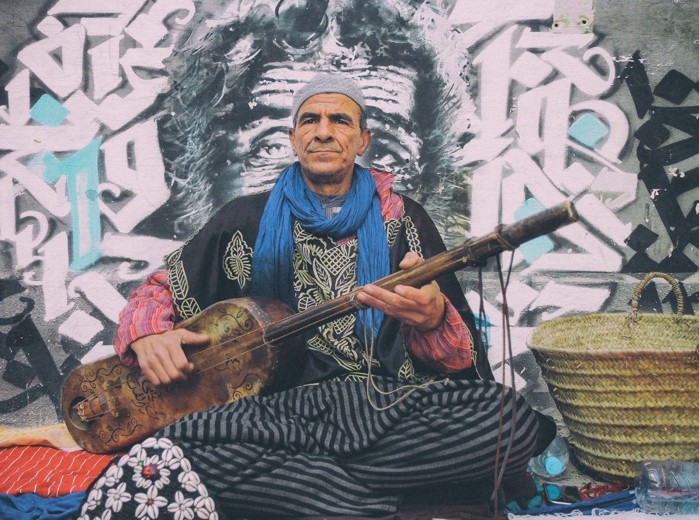

North Africans in Spain
在西班牙的北非人
Many North Africans have moved to Spain. The province of Barcelona has a large Muslim population of 135,000. In one international worker’s town, 10% of the population is from North Africa—of whom 1% are believers with no local fellowship.
許多北非人搬到了西班牙。巴塞羅那省的穆斯林人口總數約為 135,000。在一個有國際同工的小鎮裡，十分之一的人口來自北非——其中 1% 是未有團契生活的。
Our international workers in Spain regularly share gospel stories with them. Some have begun to join weekly prayer and worship meetings. In that town, the people are mainly Berbers and Arabs, who enjoy Chinese tea with mint and lots of sugar. They are incredibly hospitable people, and a visit can stretch over two or three meals.
我們在西班牙的國際同工巳定期地與他們分享福音故事。有些人亦已開始參加每週的祈禱和敬拜聚會。在那個小鎮，人口主要為柏柏爾人 (Berbers) 和阿拉伯人，他們喜歡喝放了薄荷和很多糖的中國茶。他們非常好客，一次的探訪代表了兩至三頓飯。
More than 325,000 North Africans live in Canada.
超過 325,000 名北非人現居於加拿大。

Pray with us: 讓我們一起同心禱告：
Father, we bless North Africans with hope and a future! We pray that many will know Your goodness. We declare Your sovereignty over the nations, and we bless them with the everlasting hope that changes everything.
父啊，我們祝福北非人末後有指望！我們祈求更多人知道袮的良善。我們宣告袮享有萬國的主權，我們祝福他們得到能夠改變一切的永恆盼望。
Thank You for marking out their appointed times in history so that they would find You. Father, as North Africans travel and meet people, would you set people who know You in their path. We pray that Your people would offer hope to North Africans. We ask that we feel Your tender heart and compassion for them. Amen.
感謝袮巳為他們定下了一個指定的時刻，讓他們尋見袮。父親，當北非人去旅行和結識他人時，求袮讓巳認識袮的人遇上他們，我們祈求袮的子民能給北非人帶來盼望。我們也祈求我們能更深刻地感受到袮對他們的憐憫和慈愛。阿門。

Pashtuns 普什圖人
Pashtuns have a reputation as independent and fearless people. They are also known for their love for children, close-knit families, and rich literary history of poetry and proverbs woven skillfully into daily discourse. They are lavish in their hospitality and generosity to guests. Their clothing and textiles are expressive and filled with brilliant, striking colours and patterns.
普什圖人(Pashtuns)是一個獨立無畏的民族。他們的文化非常著重對孩子的愛、組織親密的家庭。他們亦喜歡以豐富文學史的詩歌和諺語互相交談並融入在日常話語之中。他們對客人非常熱情好客和慷慨大方。他們的服裝和紡織品富有很多想像力，並充滿了絢麗奪目的色彩和圖案。
There are approximately 40-45 million Pashtuns, mainly in Afghanistan and Pakistan. The Joshua Project suggests about 47,000 Pashtuns call Canada home. Less than 0.1% of this people group are Christian. Typically, the Gospel is met with resistance and hostility by Pashtuns.
大約有 4至4.5 千萬普什圖人現居於阿富汗和巴基斯坦。約書亞計劃 (The Joshua Project) 稱，大約 47,000 名普什圖人居於加拿大。這個群體中只有不到 0.1% 是基督徒。福音現遭到普什圖人的抵制和反對。

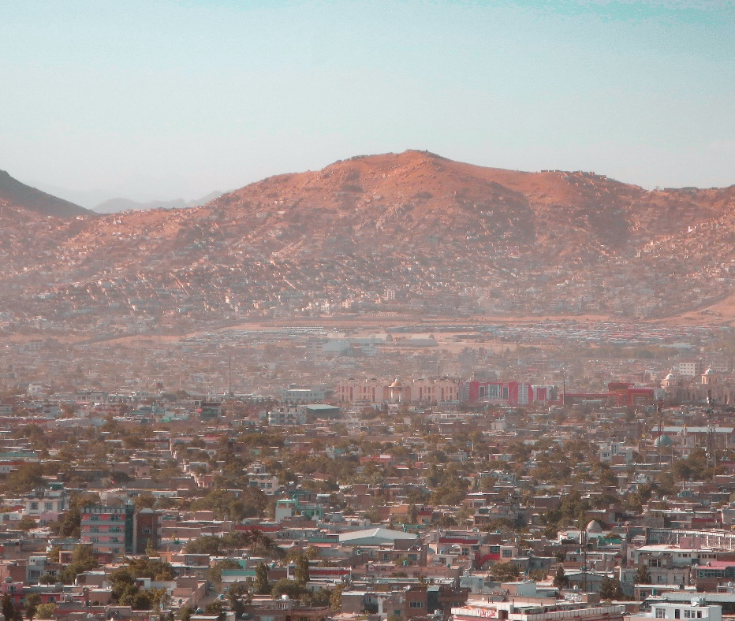
Pray with us: 讓我們一起同心禱告：
Lord Jesus, thank You for how warm and hospitable Pashtuns are. You welcome us with Your arms open wide, and we pray that You will bless many Pashtuns with that warm embrace.
主耶穌，感謝袮對普什圖人的熱情好客。袮張開雙臂歡迎我們，我們祈求袮用溫暖的擁抱祝福更多普什圖人。
We know that You are watching each of them and that You long for them to come home to You. Bless whole households and tribes with dreams and visions. Lead them to gospel witnesses who will introduce them to Your warm embrace.
我們深信袮正看顧著他們每一個人，袮渴望他們回到袮身邊。求袮用異夢和異象祝福他們每個家庭和村落，引導他們認識福音見證人，讓他們來到袮溫暖的懷抱。
Bless the few Pashtun believers to grow in faith and resilience despite persecution and suffering. Bless them with miraculous Kingdom breakthroughs among all the Pashtun tribes. Amen.
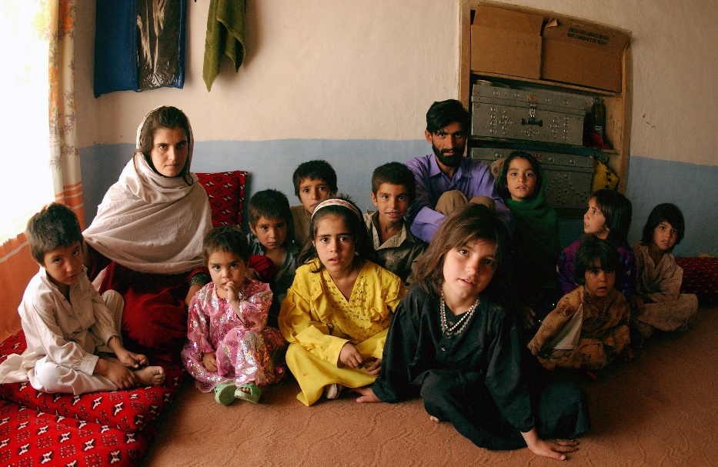
求袮祝福那少數的普什圖信徒，即使在遭受迫害和苦難的情況下，他們都能在信心和靈性韌性中成長。祝福他們在所有普什圖村落中取得奇蹟般的屬靈突破。阿門。

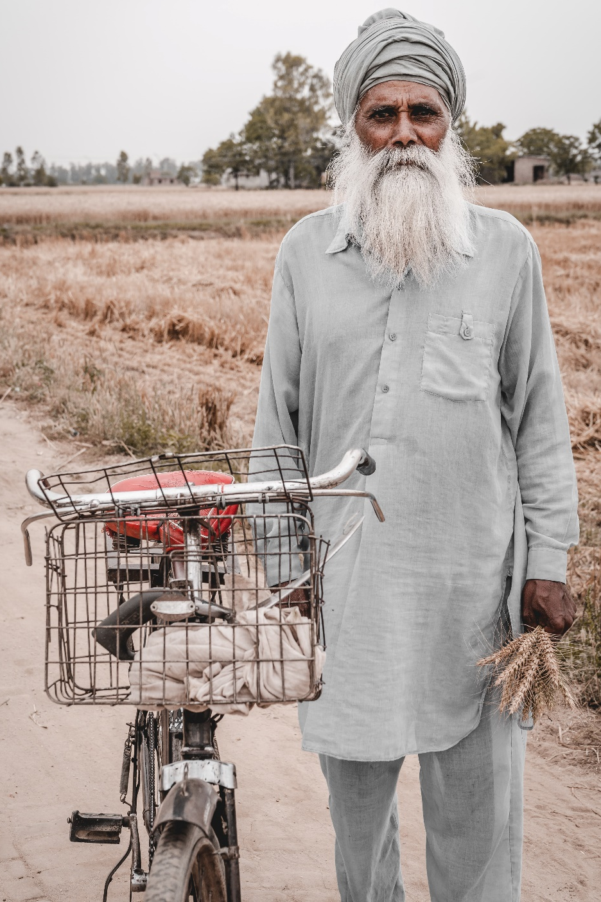

Punjabi Arain
旁遮普Arain
There are 0.0% Christians reported among the global population of 9.9 million Arain. The Punjabi-speaking Arain mainly live in the northern Indian state of Punjab. They are almost all Muslim.
據報導，在全球 990 萬Arain人口中，基督徒近乎佔零百分比。說旁遮普語的Arain人主要生活在印度北部的旁遮普邦。他們幾乎都是穆斯林。
Over 500,000 Punjabi people are living in Canada.
超過 500,000 旁遮普人現居於加拿大。

Pray with us: 讓我們一起同心禱告：
Father, we rejoice in the day when the Punjabi-speaking Arain will discover the face of their Creator. What a glorious day it will be when the hearts of the Arain are reunited with their Maker!
父啊，我們期待看到說旁遮普語的 Arain族人終認識造物主的面容，我們將為那一天而歡欣鼓舞。當 Arain 的心與他們的造物者重聚時，那將是多麼美好的一天！
Stir the hearts of Your people with a desire to reach the Arain. We ask that Arains would have a deep yearning to know You and be known by You. Pour out Your Spirit upon entire families. Holy Spirit, we ask that You continue to soften their hearts, prepare them to recognize You, and be reunited with the One who loves and cares for them.
求袮激起袮子民的心去接觸Arain, ，為他們作宣教事工。我們祈求 Arains 渴望深深地認識袮和被袮認識。求袮澆灌袮的靈於每個家庭。聖靈啊，我們祈求袮繼續軟化他們的心，讓他們準備他們的心去認清袮，並與那一位很愛和關心他們的神團聚。
As the seeds are planted, would You bless the soil of our friends’ hearts to receive their King? We bless the roots to grow deep and for the seeds to receive the nourishment and care they need so that a fruitful harvest may come. Amen.
當種子播下時，袮會祝福他們心中的土壤，讓他們接受袮成為他們的救主嗎？我們祈求他們的根長得深，他們的種子得到需要的養分和照顧，得以豐收。阿門。

Rohingya 羅興亞人
There are at least 2 to 2.5million people in the Rohingya—of which less than 20% still live inside Myanmar.
羅興亞人(Rohingya)的人口至少有 2 到 2.5 百萬人，其中不到 20% 仍居住在緬甸境內。
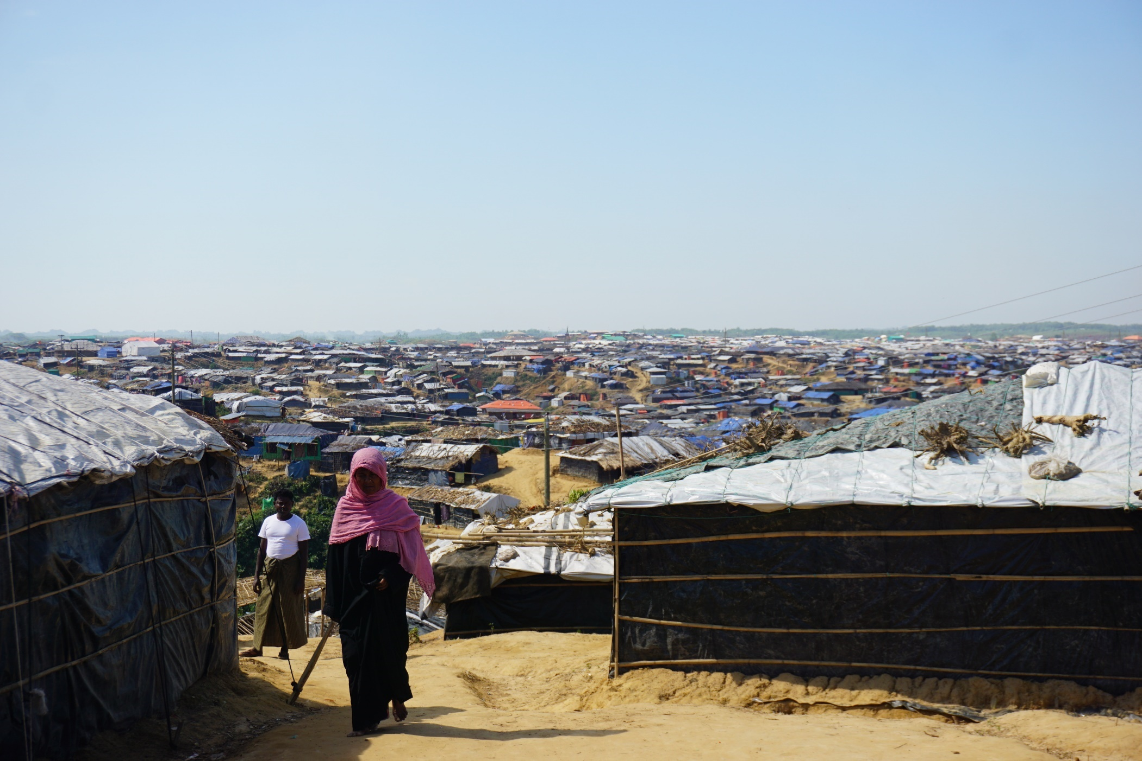
The rest have left the country and gone abroad. Over 700,000 Rohingya have settled in large refugee camps in Bangladesh.
其餘的人都出國了。超過 700,000 名羅興亞人已在孟加拉國的大型難民營中定居。
Even though most Rohingya are Muslims, there is growing receptivity to the Gospel. Rohingya Christians are still less than 1% of the population. Yet, it is encouraging to know that there is a small number of secret fellowships in the camps.
儘管大多數羅興亞人都是穆斯林，但人們對福音的接受程度越來越高。不過，羅興亞基督徒仍然不到人口的 1%。然而，令人鼓舞的是，營地中現有少數地下團契。
Approximately 2,000-3,000 Rohingya in Canada, many in the Kitchener-Waterloo, ON area.
加拿大約有 2,000至3,000 名羅興亞人，其中許多居於安大略省的基奇納和滑鐵盧地區。

Pray with us: 讓我們一起同心禱告：
Father, we pray that You would bless the Rohingya with a new name—their God-given identity.
天父，我們祈求袮賜福給羅興亞人，給他們一個新身份——是他們在袮裡面的身份。
They are no longer forsaken, forgotten, or rejected. They are made in Your image, and we declare that they are the beloved, seen by You, and chosen to know the Saviour.
他們不再被拋棄、遺忘或拒絕。他們是按照袮的形象而被造的，我們宣布, 他們是袮所愛的，被袮尋見的，並且被揀選的， 為認識救主的人。
We ask You to bless them with vigilant, vibrant, and caring Christian communities around them in Waterloo and everywhere You have sent them.
我們祈求袮在滑鐵盧和袮差遣他們的地方裡大大地祝福他們，在他們的周圍賜下充滿活力和施予關懷的基督徒社區。

As You have added to the number of believers, would You add to them the deepening love and understanding of Your ways? Amen.
當袮增加信徒的同時，我們祈求他們對袮的愛愈加深厚，他們對袮的認知更多。阿門。

Sasak薩薩克
Islam is the main religion of the 3.3 million Sasak who predominately live in Indonesia. Only 0.01% of Sasak follow Jesus.
居於印度尼西亞的 330 萬薩薩克人(Sasak)的主要宗教為伊斯蘭教。只有 0.01% 的薩薩克人跟隨耶穌。
Sasak typically work as farmers, fishers, and artisans. In Sasak culture, family life is fragile because of high divorce rates. When getting married, many Sasak follow the custom of eloping. The woman voluntarily allows herself to be “kidnapped” and “hides” while the “kidnapper” negotiates the wedding terms with her family. After the terms are set, the wedding ceremony follows.
Sasak 人大多是農民、漁民和工匠。在 Sasak 文化中，由於離婚率高，家庭生活很脆弱。結婚時，許多薩薩克人都遵循私奔的習俗。女人自願讓自己被「綁架」或「躲藏起來」，而「綁架者」則與她的家人協商婚禮條款。條款確定後，他們就會舉辦婚禮。
Many Sasak are traumatized by frequent earthquakes, floods, poverty, high maternal mortality rates, and child mortality.
許多薩薩克人因頻繁的地震、洪水、貧困、高孕產婦死亡率和兒童死亡率而受到心靈的創傷。

Pray with us: 讓我們一起同心禱告：
Father, we thank You for Your amazing love for the Sasak. Soften their hearts so that they would understand their need for You. Bless them to know you as their Savior, Sanctifier, Healer, and Coming King.
父啊，我們感謝袮對 Sasak 深深的愛。求袮軟化他們的心，讓他們明白他們有多需要袮。祝福他們認識到袮為他們的救主、聖潔者、醫治者和即將來臨的君王。
Beckon them to Yourself, Jesus, and draw them into the intimacy of relationship with You. We ask that they receive an invitation to the wedding supper of the Lamb. Bless them with eternal salvation, we pray. Amen.
主耶穌，求袮親自向他們招手，讓他們與袮有一個親密的關係。我們祈求他們被請赴羔羊之婚筵。我們祈求，祝福他們獲得永生的救贖。阿門。

South Asian Diaspora 南亞僑民
Highly collectivistic and communal, over 5 million South Asians work as labourers in the Arabian Gulf: Indians, Pakistanis, Nepalis, Bangladeshis, and Sri Lankans. The majority work and live in extremely demanding conditions while remitting up to 80% of their poverty-level earnings to their loved ones back home. Yet, they are hospitable and generous with guests, exemplifying a spirit of resilience. There are many Christian fellowships among Indians, with over 10% believers. However, less than 1% of the other countries represented are believers, with very few Christian fellowships. The Muslim host culture is not receptive to the Gospel to the point of rejection and hostility.
在南亞這個具高度集體主義和公共主義的國家裡，超過 500 萬南亞人在阿拉伯灣從事勞工，包括印度人、巴基斯坦人、尼泊爾人、孟加拉國人和斯里蘭卡人。大多數人在貧困線和極其苛刻的條件下工作和生活，但同時，他們會將高達 80%賺到的收入匯給家鄉的親人。儘管他們活在貧困線下，他們依然熱情好客，對客人大方，體現了堅韌不拔的精神。印度人中有很多基督徒團契，超過10%是信徒。然而，其他國家中只有不到 1% 是信徒，基督徒團契非常少有。穆斯林主導當地文化，令人們無法接受福音，更對其拒絕和懷有敵意。
Around 2 million South Asians live in Canada.
大約 200 萬南亞人現居於加拿大。

Pray with us: 讓我們一起同心禱告：
Father, we bless South Asians in the Arabian Gulf. We ask that they are treated justly and fairly in their workplaces. Satisfy them with Your rest. Give them a deep understanding of Your great love for them. We ask you to bless them with dreams and visions to show that You are a good Father.
天父，我們祝福阿拉伯灣的南亞人。我們祈求他們在工作場所中得到公正和公平的對待。求袮賜下安息，讓他們身心靈得到休息。讓他們深刻了解到袮對他們的大愛。我們求袮籍著異夢和異象來祝福他們，向他們顯明袮是他們的好父親。
We bless them with open hearts to the flood of Your mighty love. We pray Muslims would have open eyes to see Jesus as the ultimate expression of Your great love for them.
我們全心全意地祝福他們，祈求他們被袮大能的愛環繞。我們祈求穆斯林能睜開眼睛，明白到耶穌是袮向他們大愛的啟示。
May they come to understand that You deeply care for and desire them. Come Lord Jesus and soothe their wounded souls. Let love’s grip dissolve their reserve, woo them, and draw them into Your goodness. Amen.
願他們明白到袮是一直深深地關心和渴望他們的。主耶穌，來吧，撫慰他們受傷的靈魂。讓愛化解他們的疑惑，親近他們，並把他們帶到袮的良善中。阿門。

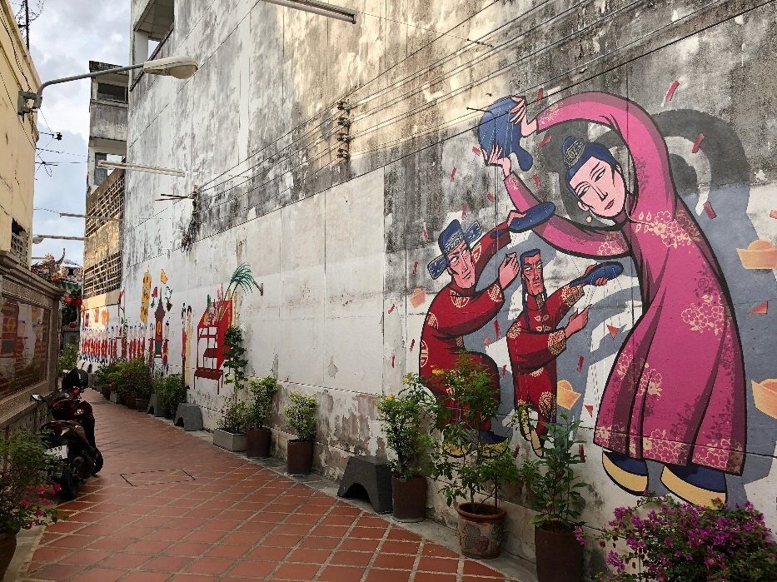
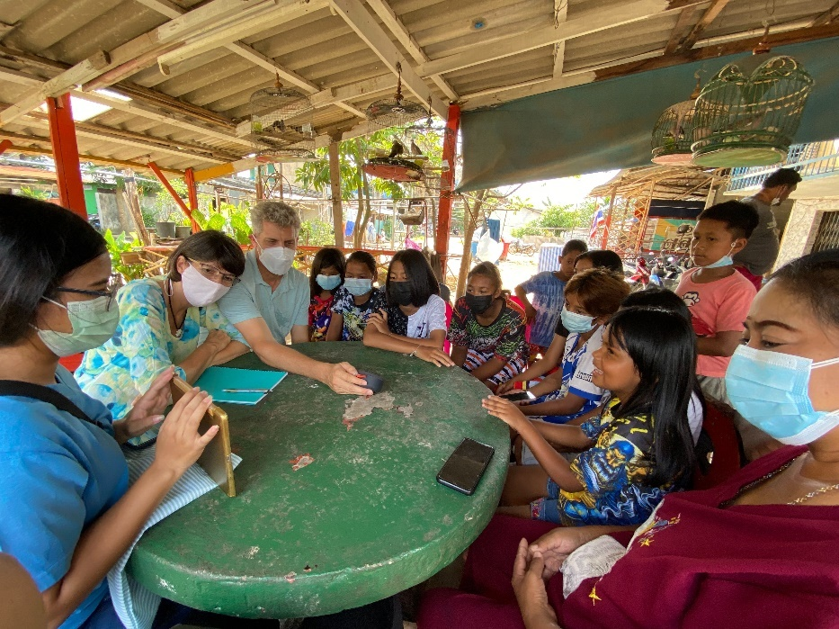
Southern Thai 泰國南部
Although the main religion of Thailand is Buddhism, Islam is the predominant religion in Southern Thailand. Most Southern Thai practice a folk Islam mixed with animism.
雖然泰國的主要宗教為佛教，但伊斯蘭教是泰國南部的主要宗教, 他們大多數同時奉行民間伊斯蘭教與萬物有靈論。
Many people in Southern Thailand are Malay by descent, who ended up in Thailand when Britain and France established the country’s borders in the early 1900s. Of the 10 million people who live in the south, less than 0.5% are believers, mainly from Buddhist backgrounds.
泰國南部許多人都是馬來人後裔，當英國和法國在 1900 年代初建立該國邊界時，他們最終來到了泰國。在南方的 1000 萬人口中，不到 0.5% 的人是基督徒，主要來自佛教背景。
Locals believe a particular city in this region has intense spirit activity. Many people travel there from other countries to make merit and appease the spirits. 當地人認為當地某些地區時常有靈界活動發生。所以，許多人從其他國家到那裡來做造福和沾靈氣。
About 20,000 Thai call Canada home and the vast majority are Buddhist. 大約 20,000 名泰國人居於加拿大，其中絕大多數是佛教徒。

Pray with us: 讓我們一起同心禱告：
Father, bless Thailand with a tremendous outpouring of Your Holy Spirit! Thank You for the workers You have already called there! Bless them with protection, courage, and wisdom as they follow You into the ripe harvest fields. Would You send even more labourers to Thailand? We pray for connections with people of peace who both receive and share the Gospel with their friends and neighbours.
父啊，求袮的聖靈大大地澆灌泰國！感謝袮在當地賜下同工們！求袮保護他們，給他們勇氣和智慧，進入成熟的莊稼地。願袮派遣更多同工到泰國。我們祈求袮賜下願意熱心地分享福音的平安之子，與他們的朋友和鄰居分享福音。
Bless many Thai with hearts that respond to Your Good News. May the nation of Thailand yield a harvest of righteousness for the glory of Your Name! Amen.
求袮祝福泰國人有一顆願意接受袮好消息的心。願泰國民族為榮耀袮的名而結出平安的果子，就是義！阿門。

Spaniards 西班牙人
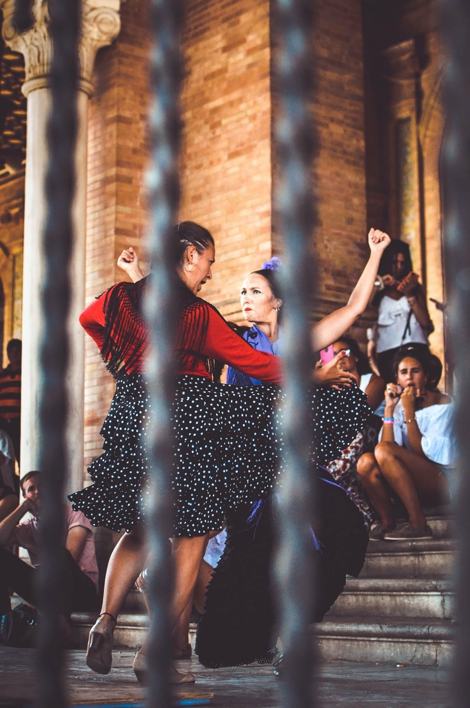
Roman Catholicism is the main religion of the over 47 million Spaniards, but there are rapidly rising levels of secularisation. Atheism and Islam are the fastest-growing belief systems. Receptivity to the Gospel has been very low, and less than 1% of Spaniards are Evangelical Christians. Ten million Spaniards live in towns without any evangelical presence.
羅馬天主教是超過 4700 萬西班牙人的主要宗教，但當地正迅速地日益世俗化。無神論和伊斯蘭教是發展最快的信仰體系。當地對福音的接受程度非常低，不到 1% 的西班牙人是福音派基督徒。有一千萬西班牙人生活在沒任何福音派團體的城鎮中。
Praise God there are 28 Alliance churches and fellowships in Spain. Two of them have between 100 and 200 members; the rest vary between 20 and 100. Most local fellowships meet in warehouse spaces, storefronts, and homes. Unlike much of Europe, the Protestant Reformation did not penetrate Spain due to the Inquisition. The Moors (Muslim inhabitants of the Iberian Peninsula) ruled Spain for 800 years, leaving a lasting impact on language, architecture, education, crops, and cuisine.
讚美上帝，西班牙有 28 個宣道會教會和團契，其中兩個教會有 100 到 200 名成員; 其餘的在 20 到 100 名之間不等。大多數當地的團契在倉庫、店面和家中聚會。由於宗教抵制，新教改革沒有滲透到西班牙，令他們與歐洲大部分地區不同。摩爾人（伊比利亞半島的穆斯林居民）統治西班牙巳有 800 年，對語言、建築、教育、農作物和本土食品帶來了深遠的影響。

Pray with us: 讓我們一起同心禱告：
Heavenly Father, bless Spain by increasing the number of faithful workers. As Your workers make disciples who disciple, would You add to the numbers of those being saved? We pray that the King of Glory would enter Spain.
天父，求袮增加忠實的同工祝福西班牙。幫助袮的僕人建立門徒成為宣教者，讓得救的人數增加。我們祈求榮耀的君王進入西班牙。
Open the gates of the cities, the businesses, the homes, and the hearts of Spaniards. King of Glory, come in, bless, and draw the people to You. We pray the people of Spain would recognize their King, The King of Glory, Jesus! Amen.
打開城市、企業、家庭和西班牙人心靈的大門。榮耀的君王啊，進來吧，祝福人們歸向你。我們祈求西班牙人能夠認識他們的君王，榮耀的君王，耶穌！阿門。

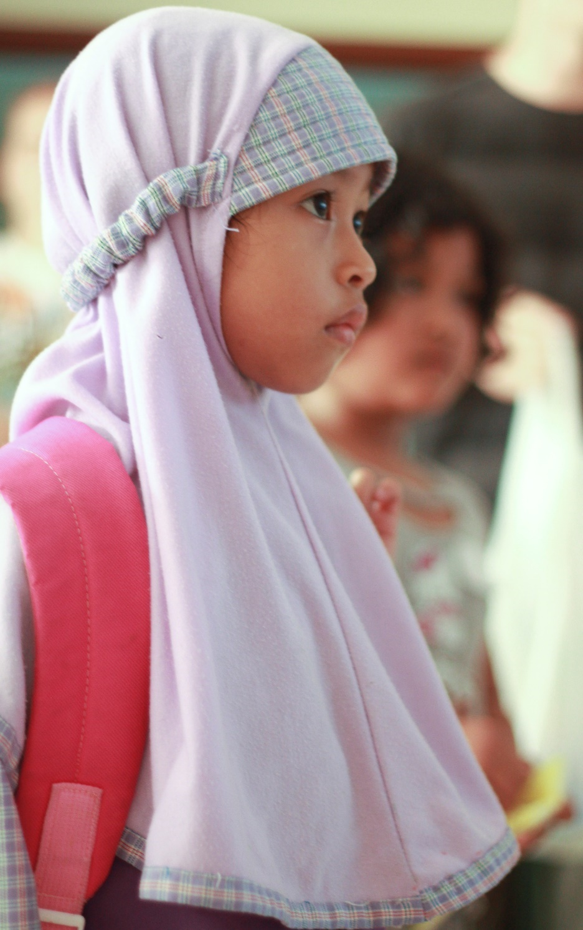
Sunda巽他
The majority of Sunda live in Indonesia, and their culture is rich with celebrations of life cycle ceremonies. They are the largest least-reached people group in Indonesia. Of the 38 million Sunda, only 0.05% are evangelical Christian. Most Sunda are devoted followers of Islam, with many added traditional customs. Historically, they have been unreceptive to the Gospel, though the Spirit is moving in new ways!
大多數巽他人(Sunda)生活在印度尼西亞，他們的文化豐富，喜歡慶祝生命週期。 他們是印度尼西亞中最未聽聞福音的人群。 在 3800 萬巽他人中，只有 0.05% 是福音派基督徒。 大多數巽他人是伊斯蘭教的忠實追隨者，他們亦奉行許多傳統習俗。 從歷史上看，儘管聖靈一直在作工，他們未有接受福音！

Pray with us: 讓我們一起同心禱告：
Holy Spirit, we ask that You breathe Your life into the hearts of our Sunda friends. We prophesy to the dry bones and call them to come alive!
聖靈啊，我們祈求袮將袮賜的新生命注入我們巽他朋友的心中。 我們向乾枯的骨骸發預言，呼喚他們活過來！
Thank You for these ripe harvest fields! Please bless them by sending out more workers. May the Sunda hear the Good News with soft hearts to receive Your message. Bless the believers among them with fellowship, and multiply Your work among these people. Lord, pour out Your Spirit! Amen.
我們為這些成熟的莊稼感謝！ 求袮差遣更多工人祝福他們。 願巽他有一顆軟化的心聽取好消息，去接受袮。 祝福他們當中的基督徒，在當地作袮的事工。 主啊，讓聖靈降臨充滿他們！ 阿門。

Tajik塔吉克
The Tajik make up 84% of Tajikistan's population, 25% of Afghanistan's, and 5% of Uzbekistan's. There are 18-25 million Tajiks globally. 98% of Tajiks are Muslim, and less than 0.01% are believers. There are only a few local fellowships and house churches among them.
塔吉克人(Tajik)佔塔吉克斯坦人口的 84%、阿富汗人口的 25% 和烏茲別克斯坦人口的 5%。全球有 18至25 百萬名塔吉克人。 98%的塔吉克人是穆斯林，不到0.01%是基督徒。其中只有少數地方有團契和家庭教會。
The international workers introduce Jesus to Tajiks by first sharing the stories that Islam and Christianity share: Creation, the Fall, Abraham, Noah, and Moses. Family roots are deep. Obedience and submission to the family keep people from following Jesus openly.
當國際同工介紹耶穌給塔吉克人時，他們首先向他們分享伊斯蘭教和基督教共同的故事，例如創造、墮落、亞伯拉罕、挪亞和摩西。塔吉克人對家庭文化根深蒂固。他們均要順服家庭文化，正因如此，他們大多都不願意跟隨耶穌。
Tajiks are renowned for their generous and welcoming hospitality. They seat their guests in places of honour, furthest away from the door, feeding their guests first and their children last. About 1 million Tajiks work abroad, primarily in Russia, to send remittances to families. Approximately 2,400 Tajiks call Canada home.
塔吉克人很熱情好客。他們常讓客人坐在離門最遠的地方，他們著緊先餵飽客人，最後才餵孩子。大約 100 萬塔吉克人在國外工作，主要在俄羅斯，並匯款給家人。大約 2,400 名塔吉克人現居於加拿大。

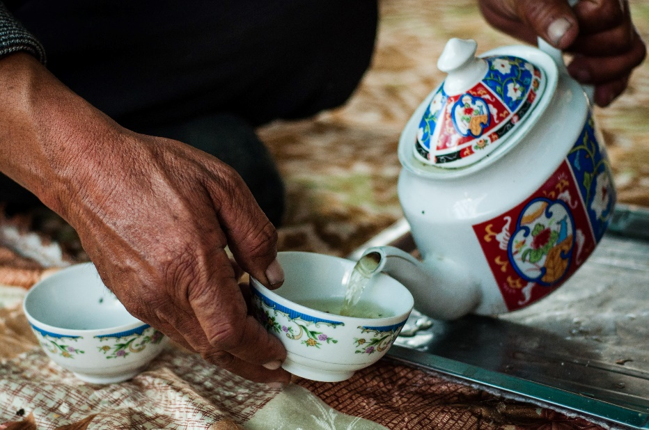
Pray with us: 讓我們一起同心禱告：
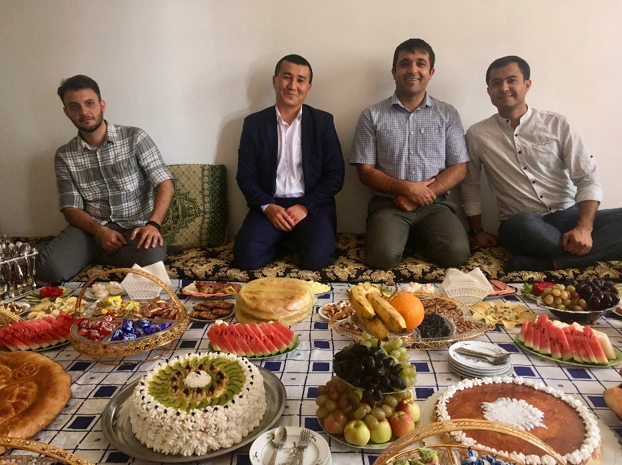
Jesus, we thank You that You are the way, the truth, and the life. We bless the Tajik to know the truth and for the truth to set them free. May they know freedom from all shame as they receive Your forgiveness. As they come to know You, Jesus, bless them with honesty and purity in their innermost being. Would You call them to the identity of children of God in harmony with the Creator? Would You satisfy their inborn desires for a love relationship with You? Revive their longings for all that is good and satisfy them with rest. We ask that You bless Tajiks with the peace of a secure identity in You. Amen.
主耶穌，我們感謝你，袮是道路、真理和生命。我們祝福塔吉克人認識真理，因真理必叫他們得自由。願他們在接受袮並得到寬恕時， 讓他們從所有羞恥中解脫出來。當他們認識袮時，耶穌，求袮祝福他們內心深處有誠實和純潔。袮願意稱他們為上帝兒女與袮同行嗎？祈求袮滿足他們的渴望，讓他們與袮建立愛的關係。喚醒他們對一切美好事物的渴望，並在袮賜下的安息中得以休息。我們祈求袮保守塔吉克人在袮裡面有一個永恆的身份。阿門。

Tibetan Refugee西藏難民
Most Tibetans live in Western China, India, Nepal, and Bhutan. In 1959, over 80,000 Tibetans fled their homeland for India and Nepal. Since then, over 150,000 Tibetans have moved abroad and created diaspora communities in North America, UK, Germany, France, Switzerland, and Australia. About 9,600 people of Tibetan descent live in Canada.
大多數藏人生活在中國西部、印度、尼泊爾和不丹。 1959年，超過80,000名藏人逃離家園前往印度和尼泊爾。從那時起，超過 150,000 名藏人移居國外，並在北美、英國、德國、法國、瑞士和澳大利亞建立了僑民社區。大約有 9,600 名藏族後裔現居於加拿大。
Most Tibetans practise Tibetan Buddhism (a mixture of Buddhism and the indigenous, shamanistic religion of Bon). Most Tibetans hold the belief that to be Tibetan is to be Buddhist. An estimated 0% of Tibetans are Evangelical Christians.
大多數藏人信奉藏傳佛教（佛教與當地的苯教薩滿教的合體）。大多數藏人認為，作為一個藏人， 他們順理成章應是一名佛教徒。據估計，福音派基督徒在藏人人口中的百分比近乎零。
Although receptivity of the Gospel has been very slow, around eight small fellowships meet online. Those who become Christian seem to develop into strong leaders who greatly desire to share Jesus with their community.
儘管福音的接受程度一直很慢，但大約他們當中有八個小型團契在網上聚會。而當中的基督徒正慢慢成長為熱衷的領袖，他們非常渴望與他們的社區分享耶穌。

Pray with us: 讓我們一起同心禱告：
Father, we commit ourselves to be the hands and feet of Jesus to Tibetans as they come to Canada. Grow our love for You so we may follow Your commands to love. Just as you have been generous to us, God gives us generous hearts towards Tibetans. Lord, you provide for the stranger, the fatherless, and the widow, and when we join you in it, You bless the work of our hands.
天父，我們願意成為主的手和腳去感染居於加拿大的藏人。求袮幫助我們更愛袮，幫助我們遵循袮的命令去愛他人。正如袮對我們慷慨一樣，上帝也給予我們對藏人有一顆慷慨的心。主啊，袮照顧和供給有需要的人， 包括客旅、孤兒和寡婦，當我們加入此大使命時，求袮祝福我們手所作的工。
Jesus, would You lead Tibetans to salvation and give them the joy of Your presence. Let the refugee diaspora find their solace in the salvation of the God who, alone, is our refuge. Amen.
主耶穌，袮會親自帶領西藏人獲得救贖，並讓他們因袮的臨在而得到喜樂嗎？求袮讓流散的難民在上帝的救贖中找到慰藉，上帝是我們的避難所。阿門。

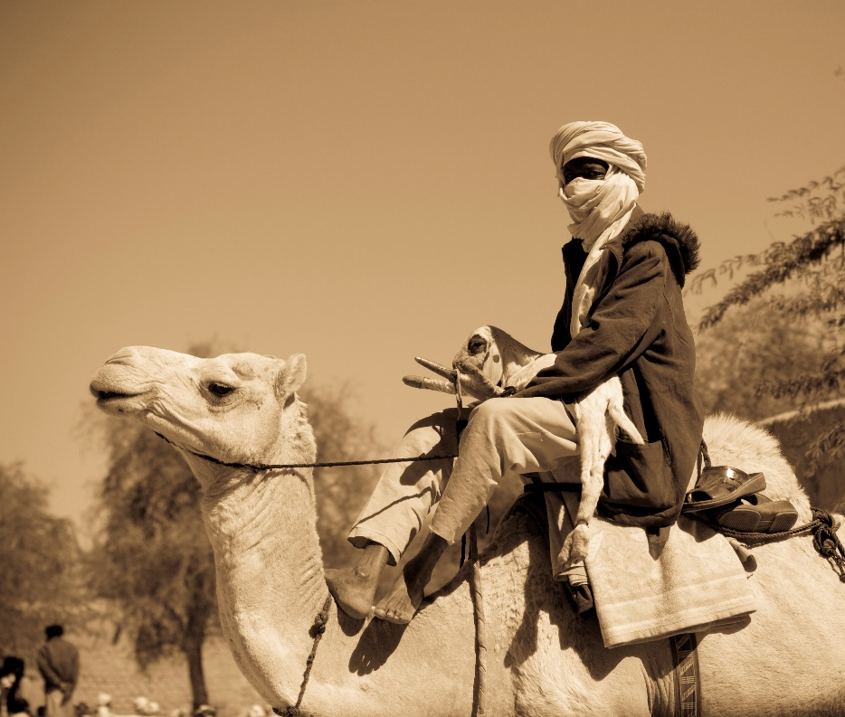
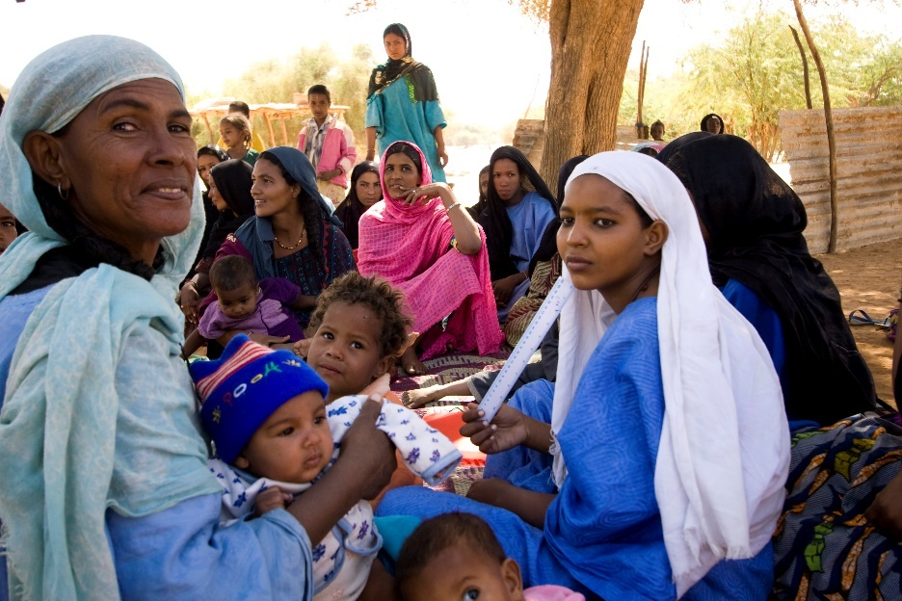
Tuareg圖阿雷格
Founded under Queen Tin Hinan, the Tuaregs are traditionally monogamous, semi-nomadic herders and warriors. Tuaregs are called the “blue people” of the desert due to their indigo-coloured clothing, which stains their skin. They are also known as the “veiled ones,” since men wear turbans. Tuaregs have their traditional script called Tifinagh, and different regions have their traditional crosses, used as a charm for protection against evil.
Queen Tin Hinan 是圖阿雷格(Tuareg)社會的創辦人，他們的傳統是實行一夫一妻制。圖阿雷格人大多善戰， 是半游牧牧民。由於深藍色面紗對於該民族的重要，圖阿雷格人被稱為「沙漠中的藍人」。他們也被稱為「蒙面者」，因基於傳統，男性會佩帶面紗。圖阿雷格人的傳統文字稱為Tifinagh，不同地區有他們傳統的十字架用作保護免受邪惡困擾的護身符。
In Niger, their population is 2.6 million, though there are possibly only a dozen Tuaregs in Canada. Islam is the main religion, and there are only a handful of scattered local fellowships among the Tuaregs. New believers face being ostracized from all family members, including forced divorce if married. Audio and oral Bible teachings play a vital role among the largely illiterate Tuaregs.
在尼日爾，圖阿雷格的人口為 260 萬，加拿大卻只有十幾個圖阿雷格人。伊斯蘭教是其主要宗教，圖阿雷格人中只有少數零星的當地團契。新信徒經常面對家庭成員的排斥，包括被迫離婚。對於大部分文盲的圖阿雷格人來說， 口頭傳授聖經教導是非常重要的。

Pray with us: 讓我們一起同心禱告：
Father, we praise You for the vibrant culture You have given Tuaregs. As seeds are sown through audio and oral Bible teachings, we bless them with open hearts to receive Your Gospel. Thank You for calling the Tuaregs to be free. We bless them with Holy Spirit’s presence. Bless them with complete freedom in Christ. We bless Tuareg believers with humble unity and a deeper life in Christ.
天父，我們讚美您為圖阿雷格人帶來了充滿活力的文化。當屬靈的種子籍著口頭的聖經教導播下時，我們全心全意地祈求，渴望他們接受袮的福音。感謝袮正呼召圖阿雷格人獲得永生的自由。我們祈求聖靈與他們同在，祝福他們在基督裡有完全的自由。我們祈求圖阿雷格信徒群體能謙卑地合一起來，在基督裡有更深的生命得著。
May Tuareg Christians be a witness to those around them that many would know of Your love. Amen
我們祈求圖阿雷格基督徒成為他們阿雷格人的見證，讓更多人知道袮的愛。阿門。

Turks in Germany在德國的土耳其人
5-7 million Turks reside in Germany. Many immigrated to Germany as labourers in the 1960s. Most Turkish communities live in urban industrial centres of West Germany. Although most originate from Turkey, there are also significant ethnic Turkish communities from all over the Middle East.
5至7百萬名土耳其人居住在德國。許多人在 1960 年代作為勞工移民到德國。大多數土耳其的社群生活在德國西部的城市工業中心裡。雖然他們大多數來自土耳其，但也有來自中東各地的重要土耳其族社區。
Culturally Sunni Muslims, the majority have become secularized. However, it is difficult for individuals to turn to Christ because they are perceived as forsaking their family, heritage, and culture. Conversion brings great shame to their families, and they face tremendous pressure to stay true to their families. Although there are very few Turkish Christians, 40 small fellowships are scattered across Germany.
他們在傳統文化上信奉遜尼派穆斯林，他們大多已世俗化了。然而，他們仍然不願意轉向基督，因為他們認為信基督是要背棄他們的家庭、歷史遺產和文化。成為基督徒會給他們的家人帶來極大的恥辱，因此信徒們面臨著家人的巨大壓力。雖然土耳其基督徒很少，但現正有 40 個小型團契分散在德國各地。
Around 64,000 people of Turkish origin live in Canada.
大約 64,000 名土耳其裔人現居於加拿大。

Pray with us: 讓我們一起同心禱告：
Heavenly Father, we thank You for the many Turks that You have brought to Germany for Your purposes. We speak an evangelistic blessing over the German Church to make disciples of all nations. We pray that the German Christians and the ex-pats would, in unity, bring the love of Christ to their Turkish neighbours.
天父，我們感謝袮將土耳其人帶到德國去成就袮的意旨。我們祝福德國教會去廣傳福音，使萬民作袮的門徒。我們祈求德國基督徒和當地的外籍人士團結一致，將基督的愛帶給他們的土耳其鄰居。
Jesus, bless the 40 Turkish fellowships with an outpouring of Your Spirit. Strengthen them to be apostolic, prophetic, and evangelistic disciples who train new believers to live missionally. Please bless Turkish believers with the boldness to share the Gospel, and we ask that You accompany the message of Christ with signs, wonders, and healings. We ask for a move of Your Spirit that would cause whole families and networks of families to turn to Christ. Amen.
主耶穌，求聖靈澆灌那40 個當地團契。求袮賜能力給他們，讓他們成為使徒、先知和宣教門徒，去建立新信徒延續當地的宣教工作。請賜福土耳其信徒有勇氣去分享福音，我們求袮幫助我們將基督的信息廣傳開去， 更親自地用神蹟、奇事和醫治感染他們。我們祈求聖靈的工作，讓每個家庭和每個人都轉向基督。阿門。

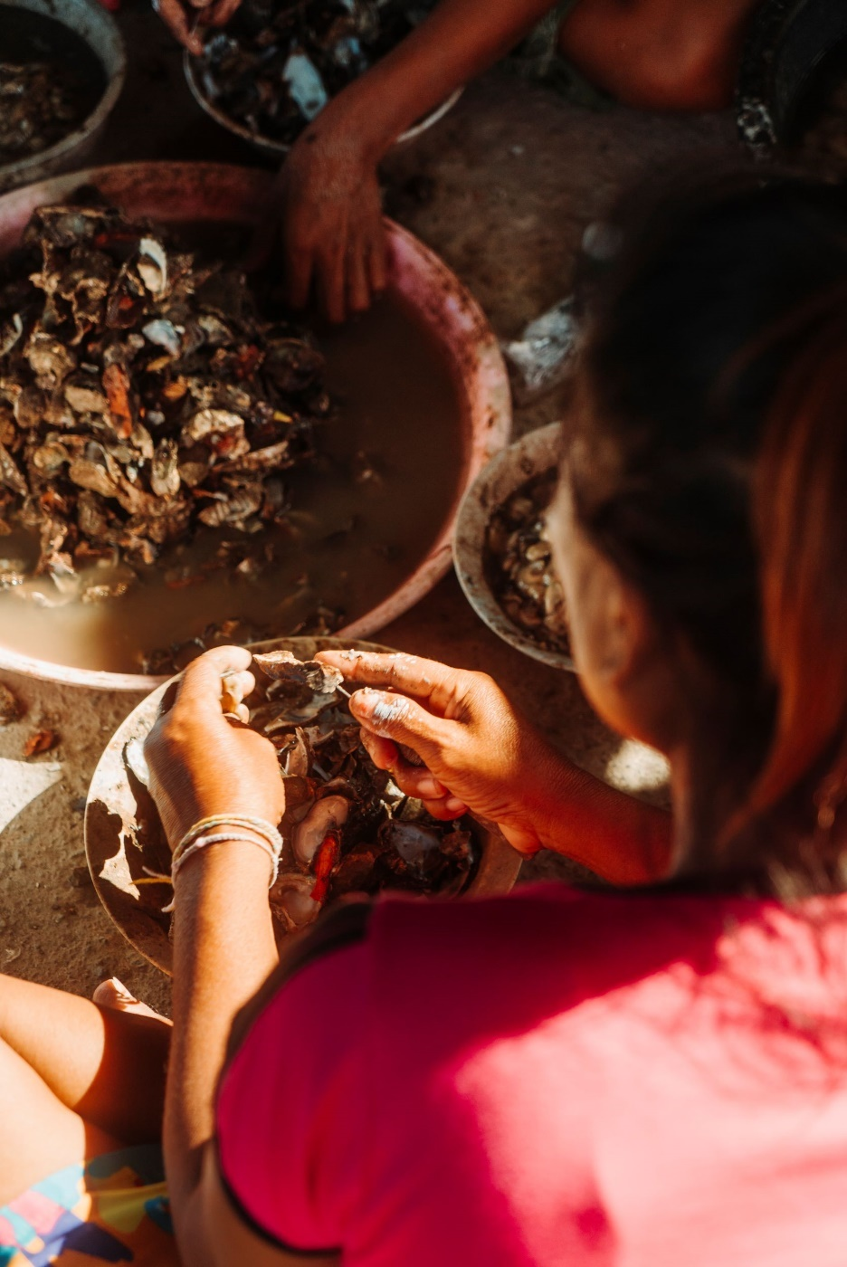
Urak Lawoi烏拉克·拉瓦伊
Urak Lawoi (pronounced: oo-rak lah-woi) means “Sea People,” Their way of life is genuinely linked to the ocean. Since migrating to Thailand from Malaysia by boat many generations ago, the Urak Lawoi communities have sustained themselves fishing. The men weave nets, build traps, and dive for fish, while the women collect shellfish in low tide. They are a family-oriented people concerned with preserving their traditional way of life amidst the threat of decreased fish populations (loss of traditional jobs) and increased globalization. Because of this, they hold tightly to their religion, a mixture of animism, ancestor worship, and Buddhism. They are open to the Gospel, but few decide to submit to Christ based on the customs of family and culture.
Urak Lawoi（發音: oo-rak lah-woi）的意思為「海洋人」，因為他們的生活方式與海洋息息相關。自從幾代人從馬來西亞乘船移居泰國以來，Urak Lawoi 社區一直以捕魚為生。男性會織網、設陷阱、潛水捕魚，而女性則在退潮時收集貝類。他們非常重視家庭觀念。近年，在海洋裡魚量減少（令他們失去他們的傳統工作）和全球化加劇的威脅下， 他們正努力維護他們的傳統生活方式。正因如此，他們堅持信奉自己的宗教，即萬物有靈論、祖先崇拜和佛教的合體。他們對福音持開放態度，但很少人會反對家庭和文化的習俗去跟隨基督。

There are no known Urak Lawoi outside Southern Thailand.
據知未有 Urak Lawoi居住在泰國南部以外。

Pray with us: 讓我們一起同心禱告：
Our Loving Lord, Would You bless these people with messengers of the Gospel who will live lovingly among them and share their lives, becoming part of their community. Immanuel, God with us, live through Your ambassadors in meaningful and powerful ways as they come alongside the Urak Lawoi. Let the song of the Lord arise from an ever-increasing community of faith. Bless them with a new song on their lips, with praise to their God. Amen.

我們慈愛的主啊，求袮賜予福音見證人給他們，用袮的愛去關心他們並生活在他們的中間，與他們一同生活，成為他們社區的一部分。以馬內利，神同在，求袮幫助他們作基督的使者， 與 Urak Lawoi 生活時，為他們帶來生命的影響。讓主的歌聲從不斷增長的信仰團體中升起，讓他們唱一首新歌，讚美他們的上帝，祝福他們。阿門。

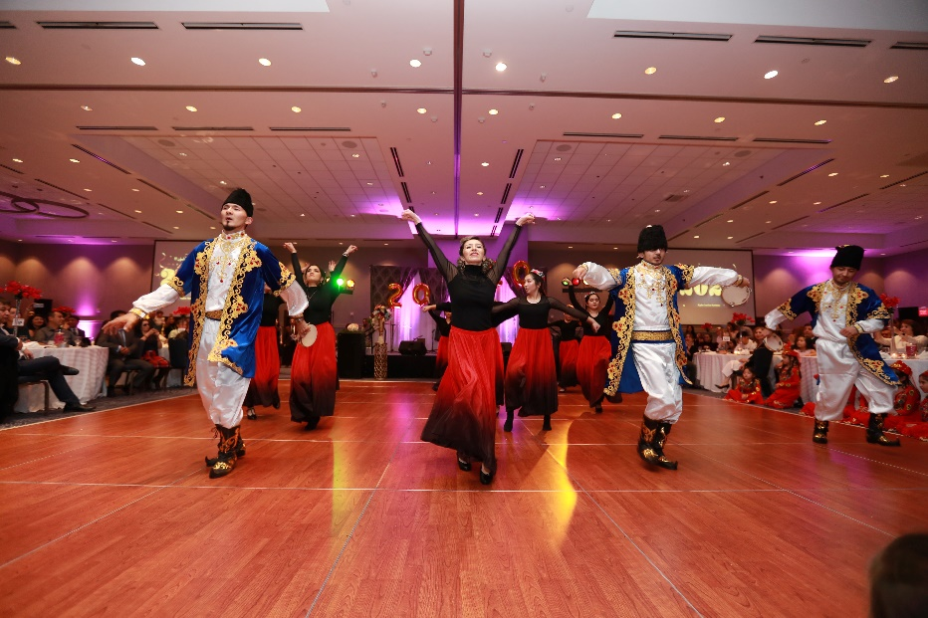
Uyghur 維吾爾族
Most Uyghurs, about 12 million, live in Northwest China. A small number live in the Central Asian republics with a combined 300,000. Of these populations, 0.01% are Christians. It is hard to know the extent of Christianity due to present persecution. Local fellowships are scattered and have gone underground. Most of the population is disinterested, resistant, and opposed to the Gospel as they struggle to hold on to their culture and religion.
大多數維吾爾人(Uyghur)（約 1200 萬）生活在中國西北地區。少數居住在中亞共和國，共有 300,000 人。在這些人口中，0.01% 是基督徒。由於目前遭受到的迫害，當地基督教的發展難以估計，當地的地下團契亦被分散。當地人一直堅持著自己的文化和宗教，所以一直抗拒和反對福音。
The Uyghur are a Turkic people group who are hospitable and love music and dance. Their community celebrations are always lively! These joys have been limited by the increasing restrictions on their religious and cultural practices.
維吾爾族是一個非常熱情好客、熱愛音樂和舞蹈的突厥民族。他們的社區慶祝活動總是很熱鬧！不過，他們的宗教和文化習俗受到越來越多的限制，所以這些快樂近來亦受到了限制。
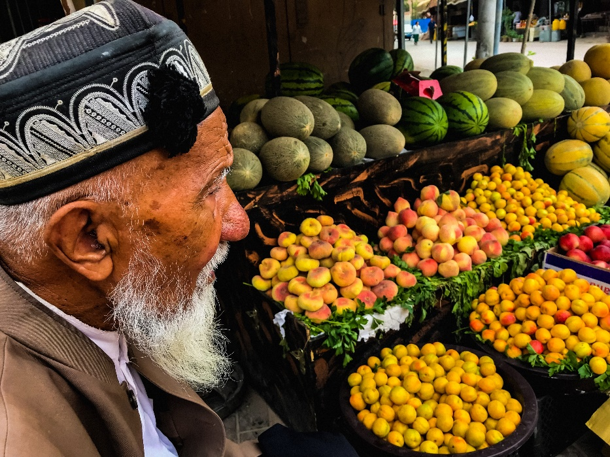
Canada is home to 2,000 Uyghurs.
加拿大現有2000名維吾爾人。

Pray with us: 讓我們一起同心禱告
Almighty God, Thank You for designing and creating the Uyghurs to express Your glory. Would You bless them with courage and tenacity to sustain them through present trials? We pray that the advance of the Gospel will not be impeded. May they call out to Yahweh during the current persecution. In their terror, would You meet them as the Eternal God of love? Bless them with justice, with opportunities to hear the Gospel, and scheduled encounters with Jesus during this time of suffering. May our Christian brothers and sisters remain firm in their faith and share Your hope to these struggling people. Hear the cries of Your creation and bless them with peace. Amen
全能的上帝，感謝袮親自創造了維吾爾人來彰顯袮的榮耀。求袮親自加添他們勇氣和堅韌，去幫助他們度過目前的考驗。我們祈求當地福音的傳播不被阻礙。願他們在當前的迫害中呼求耶和華。在他們的恐懼中，我們知道袮是慈愛永恆之神並會去迎接他們。求袮用公義祝福他們，讓他們有機會聽到福音，並在這段苦難的時期中認識到主耶穌。願我們的基督徒弟兄姐妹們堅守在主裡的信心，並將袮賜下的盼望分享給這些正在掙扎的人。求袮聽我們的呼求，側耳聽我們的禱告，祝福他們得到平安。阿門。

Vietnamese Diaspora in Cambodia在柬埔寨的越南僑民
Approximately 800,000 Vietnamese live in Cambodia—38.5% of whom are under 20. Most are undocumented migrants, materially poor, and many are illiterate or pre-literate.
大約 800,000 越南人生活在柬埔寨，其中 38.5% 的人的年齡界乎在 20 歲以下。大多數是無證移民，物質貧困，許多人是文盲或未識字。
As undocumented migrants, they face many struggles trying to find stable income and access to education. They experience hardship as an immigrant population embedded in an unwelcome society.
作為無證移民，他們沒有穩定收入， 正在教育方面面臨許多困難。作為不受歡迎的移民人口，他們經歷各種艱辛。
They practice a mix of Buddhism, animism, and ancestral worship. Only 0.17% of the Vietnamese in Cambodia are Evangelical Christians. There is a growing church presence in Phnom Penh and a few other areas, but there is little to no gospel access in most other regions of the country.

他們的信仰是由佛教、萬物有靈論和祖先崇拜組成的合體。柬埔寨只有 0.17% 的越南人是福音派基督徒。金邊和其他一些地區的教會人數不斷增加，但在該國大多數其他地區幾乎都未聽聞過福音。

There are over 240,000 Vietnamese who call Canada home!
有超過 240,000 名越南人現居於加拿大！

Pray with us: 讓我們一起同心禱告：
Father, thank You for those You have called and sent to work among the Vietnamese. Bless them with wisdom from above and encourage them daily. We pray that You would raise leaders from the local body of believers to serve. Bless and anoint those You have sent to preach among the Vietnamese. Would You remove every obstacle that stands in the way and bring down any strongholds rooted in religious traditions? Bless the Vietnamese with the ability to hear and believe so that many will call upon the Name of the Lord and be saved! Amen.

天父，感謝袮呼召並差遣工人到越南。求袮祝福他們憑著袮的智慧作工，並每天鼓勵他們。我們祈求袮為當地的信徒團體培養領袖。祝福和膏抹袮派往越南傳道的人。求袮亦清除所有阻擋福音的障礙，包括任何根植於宗教傳統的障礙。祝福越南人願意相信袮為他們的真神，讓更多人因呼求主的名而得救！阿門。

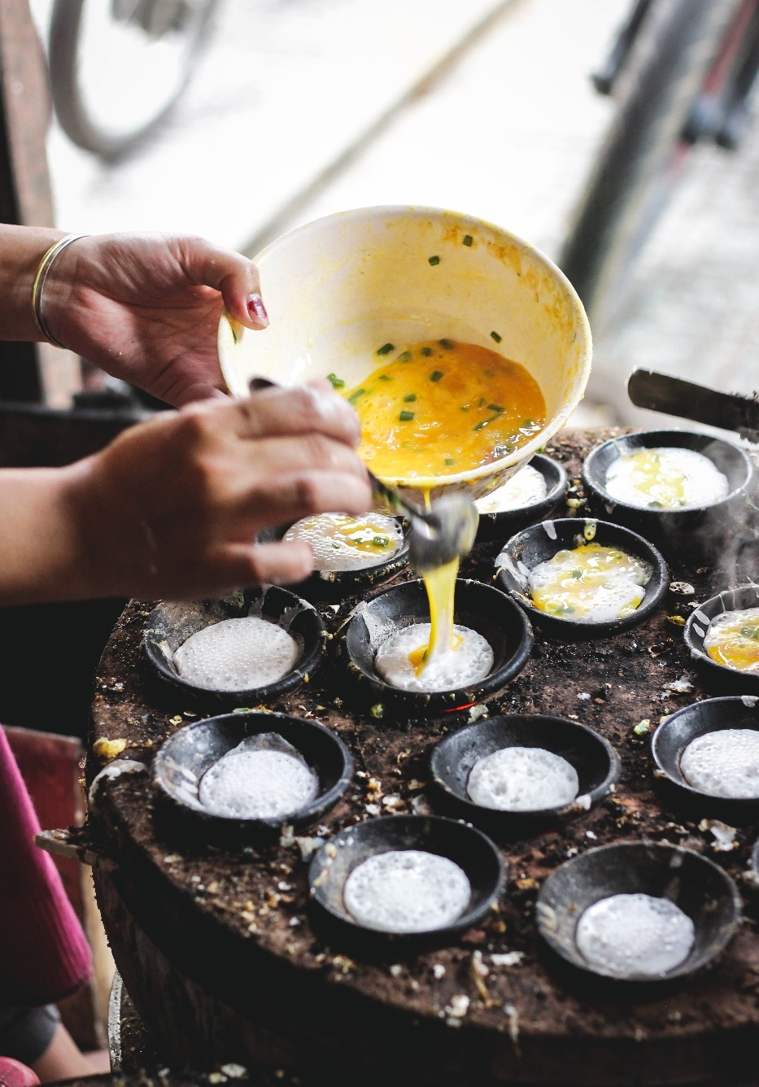

Western Fulani西富拉尼
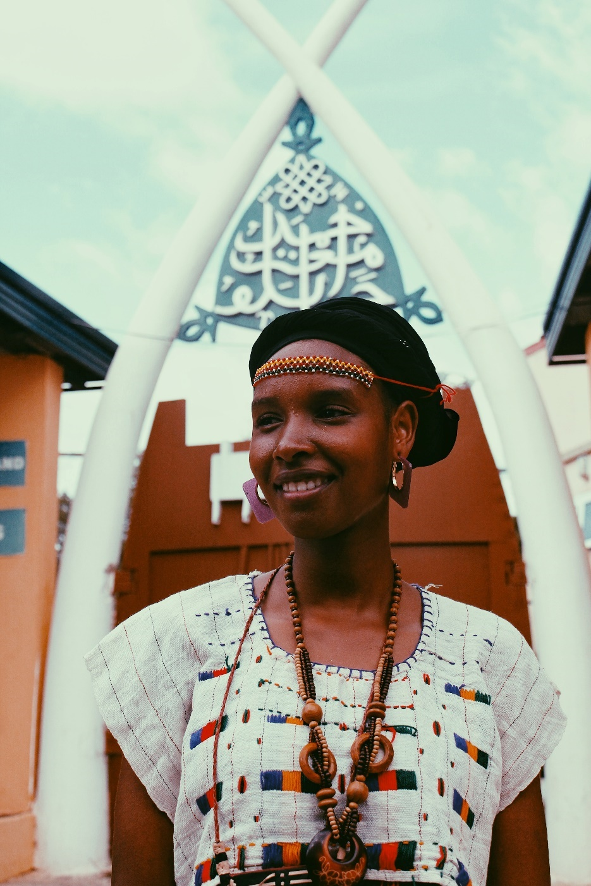
Most of Niger’s Western Fulani are poor, illiterate, rural animal herders marginalized by neighbouring people groups. While most Fulani are no longer nomadic, they still take pride in their cultural history. In some villages, the young men travel hundreds of kilometres on foot every year, leading their cattle to pasture and water.
尼日爾西部富拉尼人(Fulani)大多都是貧窮和文盲的農村牧民，正被鄰近的人邊緣化。雖然大多數富拉尼人不再是游牧民族，但他們仍然為自己的文化歷史感到自豪。在一些村莊，這些年輕人每年步行數百公里，帶著他們的牛群去牧場和水源。
Fulani values include hospitality, patience, reserve (stoicism), and respect. They practice folk Islam, and their life is guided by an unwritten but extensive system of rules that dictate family, social, and religious interactions.
富拉尼人的價值觀非常重視擁有一顆好客、耐心、堅忍和尊重的心。他們信奉民間伊斯蘭教，他們的生活受到不成文但廣泛被接受的規則體系所主導，這些規則斷定了他們的家庭、社會和宗教生活。
Of a population of 1.2 million Fulani in Western Niger and 2.5 million globally, the percentage of evangelical believers is only 0.01%. Some Western Fulani live in the city attend church. There are a few small fellowships that a national believer is leading. About 5,000 Fulani live in Canada, but they are primarily from other countries, not Niger.
在尼日爾西部的 120 萬富拉尼人和全球 250 萬人口中，福音派信徒的比例僅為 0.01%。一些住在城裡的西方富拉尼人會參加教會生活。有當地信徒正進行一些小型團契。大約 5,000 名富拉尼人生活在加拿大，但他們主要來自其他國家，而不是尼日爾。

Pray with us: 讓我們一起同心禱告：
Father, we bless the nomadic Fulani, those wandering in desert wastelands to be led by a straight way and be gathered in. We bless those living in bondage to fear and religion brought forth from darkness and the shadow of death.
父親，我們祝福游牧富拉尼人，那些在沙漠荒地中游蕩的人， 他們需要袮的引導回到袮的路。我們祝福那些生活在恐懼和宗教束縛中的人，願他們從黑暗和死亡的陰影中走出來。
Deliver them from the distress of their sinful ways and heal their afflictions. May they cry out to the Lord so that the thirsty ground of their hearts would be turned into pools of water. Bless them that they would be wise and attend to the Word of the Lord. Bless the Fulani to sing praises of Your steadfast love forever! Amen.
求袮將他們從罪惡的痛苦中解救出來，治愈他們的痛苦。願他們呼求主，使他們心中的曠野變為水潭， 叫旱地變為水泉。祝福他們，使他們有智慧，聽從主的話語。我們祈求富拉尼人永遠歌頌袮不變的愛！阿門。

Wolof沃洛夫
The Wolof have strong ties to their culture, heritage, and language. Despite colonization, modernization, and globalization pressures, the Wolof still maintain many traditional practices.
沃洛夫人(Wolof)與其文化、傳統和語言有著密切的聯繫。儘管面臨殖民化、現代化和全球化的壓力，沃洛夫人仍然保持著許多傳統習俗。
There are around 6,000 Wolof who call Canada home, and they have predominately settled into communities in Ottawa, Montreal, Quebec, and Winnipeg. Only 0.02% of the 6 million Wolof are Christian; the rest are followers of Islam. Most Wolof are not overtly antagonistic to the gospel message.
大約有 6,000 名沃洛夫人現居於加拿大，他們主要定居在渥太華、蒙特利爾、魁北克和溫尼伯的社區。 600 萬沃爾夫中只有 0.02% 是基督徒；其餘的都是伊斯蘭教徒。大多數沃洛夫人並沒有公然反對福音的信息。
They are usually polite and will “discuss” Christian views but are still resistant to follow Jesus wholeheartedly.
沃洛夫人大多都是彬彬有禮的，願意一起「討論」基督的教導，但仍然抗拒全心全意地跟隨主耶穌基督。

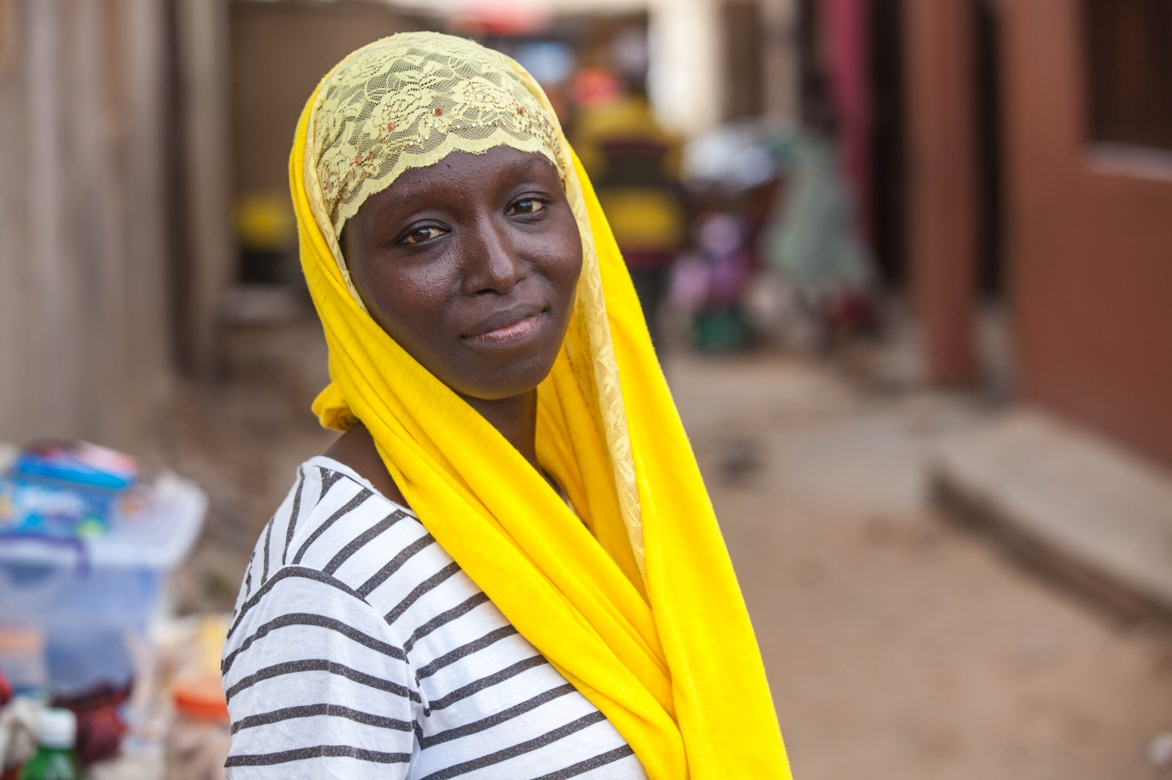
Pray with us: 讓我們一起同心禱告：
Lord Jesus, You are the Prince of Peace. You are peace to the heart amid fear. We thank You for Wolofs who have found You as their peace. For those who do not know You in this way, we pray that You will bless them with the peace that comes from a relationship with Jesus. Bless them with the assurance of eternal life. We ask that You uphold new Wolof believers and keep them faithful to Jesus and firm in their faith, despite persecution and rejection by their families. Enfold them in Your garments and speak the hope of peace to their understanding. Amen.
主耶穌，袮是和平的君。在恐懼中，袮是我們內心的平靜安穩。我們感謝你，因沃洛夫人認識袮為他們的和平的君。我們為那些不認識袮為和平的君的人，願袮賜福給他們，能得到來自與袮相交的那份平安。求袮賜給他們永生的禮物。我們求袮亦幫助新沃洛夫人基督徒，讓他們忠實於袮。儘管那些基督徒的家人正迫害和拒絕他們，求袮堅定他們的信心。求袮向他們訴說平安的盼望。阿門。

Yemeni Refugee Diaspora 也門難民僑民
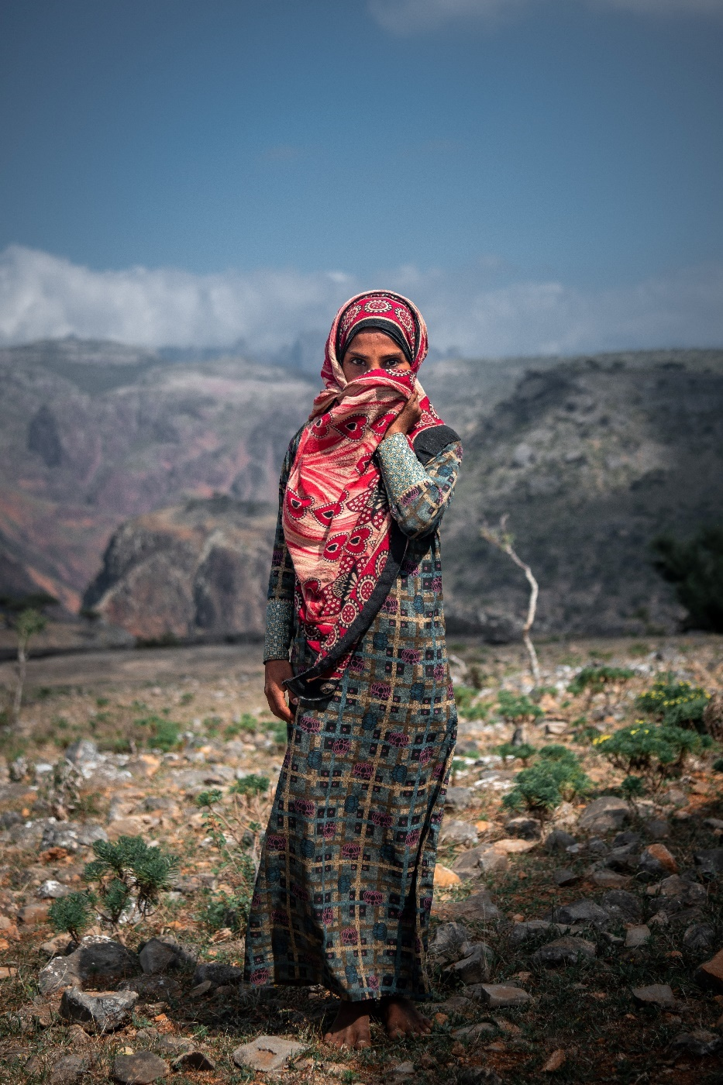
Over the years, the Yemeni diaspora has settled in Saudi Arabia, the UK, the USA, Egypt, Djibouti, Somalia, UAE, and other Gulf countries. More Yemenis have found refuge in places like Egypt, Djibouti, and Somalia, with a larger influx of those leaving in recent years.
多年來，也門(Yemeni)僑民先後在沙特阿拉伯、英國、美國、埃及、吉布提、索馬里、阿聯酋等海灣國家定居。近年，當中離開本土的也門人大多在埃及、吉布提和索馬里等地找到了避難所。
Away from the influence of their homeland, it is easier for the Yemeni diaspora to become followers of Christ, and there is a growing number of seekers.
因為遠離家鄉，也門僑民比較容易接受成為基督的追隨者，所以他們當中有越來越多尋求者。
However, there are very few intentional workers among them. Though less than 1% are believers, there are several informal house church groups. Some have also joined local churches in the countries where they are scattered.
但是，他們當中有很少同工，不到 1% 是信徒，現有幾個非正式的家庭教會團體。有些國外的人在他們居住的國家或城鎮裡參加教會聚會。

Pray with us: 讓我們一起同心禱告：

Father, You are the Shepherd of the Yemenis. As many have fled Yemen and settled in other nations, may they know the tender voice of the Shepherd who leads them beside green pastures and still waters. Where the enemy wants to steal, kill, and destroy, we bless them with the protection of their Shepherd God, who gives them abundant life. We bless Yemenis with knowing the voice of their Shepherd God, who leads them on the right paths.
天父，袮是也門人的牧者。正當許多人逃離也門並在其他國家定居時，我們祈求他們能聽到牧者的聲音，跟隨袮，因袮使他們躺臥在青草地上，領他們在可安歇的水邊。當敵人想要偷竊、殺害和毀壞，我們祈求他們的牧者保護他們，賜予他們豐盛的生命。我們祈求也門人聽到牧者的聲音，因衪會引導他們走義路。
Thank You for calling Yemeni believers to Yourself. We bless them as they grow in the knowledge of the Lord. May they also grow in perseverance as they follow You, Jesus. We bless them with the joy of the Lord as their strength. Father, would You enable them by Your Spirit to bear witness for Jesus Christ. Amen.
感謝袮正呼召也門信徒。我們祈求他們在主中的知識成長。願他們跟隨袮主耶穌的同時，也能在忍耐中成長。我們祈求他們靠著從耶和華得著的喜樂為他們的力量。父啊，袮願意賜袮的靈幫助他們成為耶穌基督的見證人嗎？阿門。

Yazidi 雅茲迪
Although most of the 700,000 Yazidis live in the Middle East, Canada hosts a small population of about 1,500. The Yazidi practice Yazidism, a monotheistic ethnic religion that includes elements common to other faiths, like baptism, fasting, a holy pilgrimage site, and a spring holiday where they decorate eggs. Less than 0.25% of the Yazidi people would consider themselves Christian; however, there is some openness to the Gospel among younger people.
700,000 名雅茲迪人(Yazidi)中的大多數人現居於中東，在加拿大的雅茲迪人人口約為 1,500 人。雅茲迪人信奉雅茲德教，這是一個一神論的民族宗教，此宗教信奉一些與其他信仰相似的儀式，如洗禮、齋戒、聖地朝聖和裝飾雞蛋的春假。不到 0.25% 的雅茲迪人會認為自己是基督徒；年輕人對福音持著一個開放的態度。
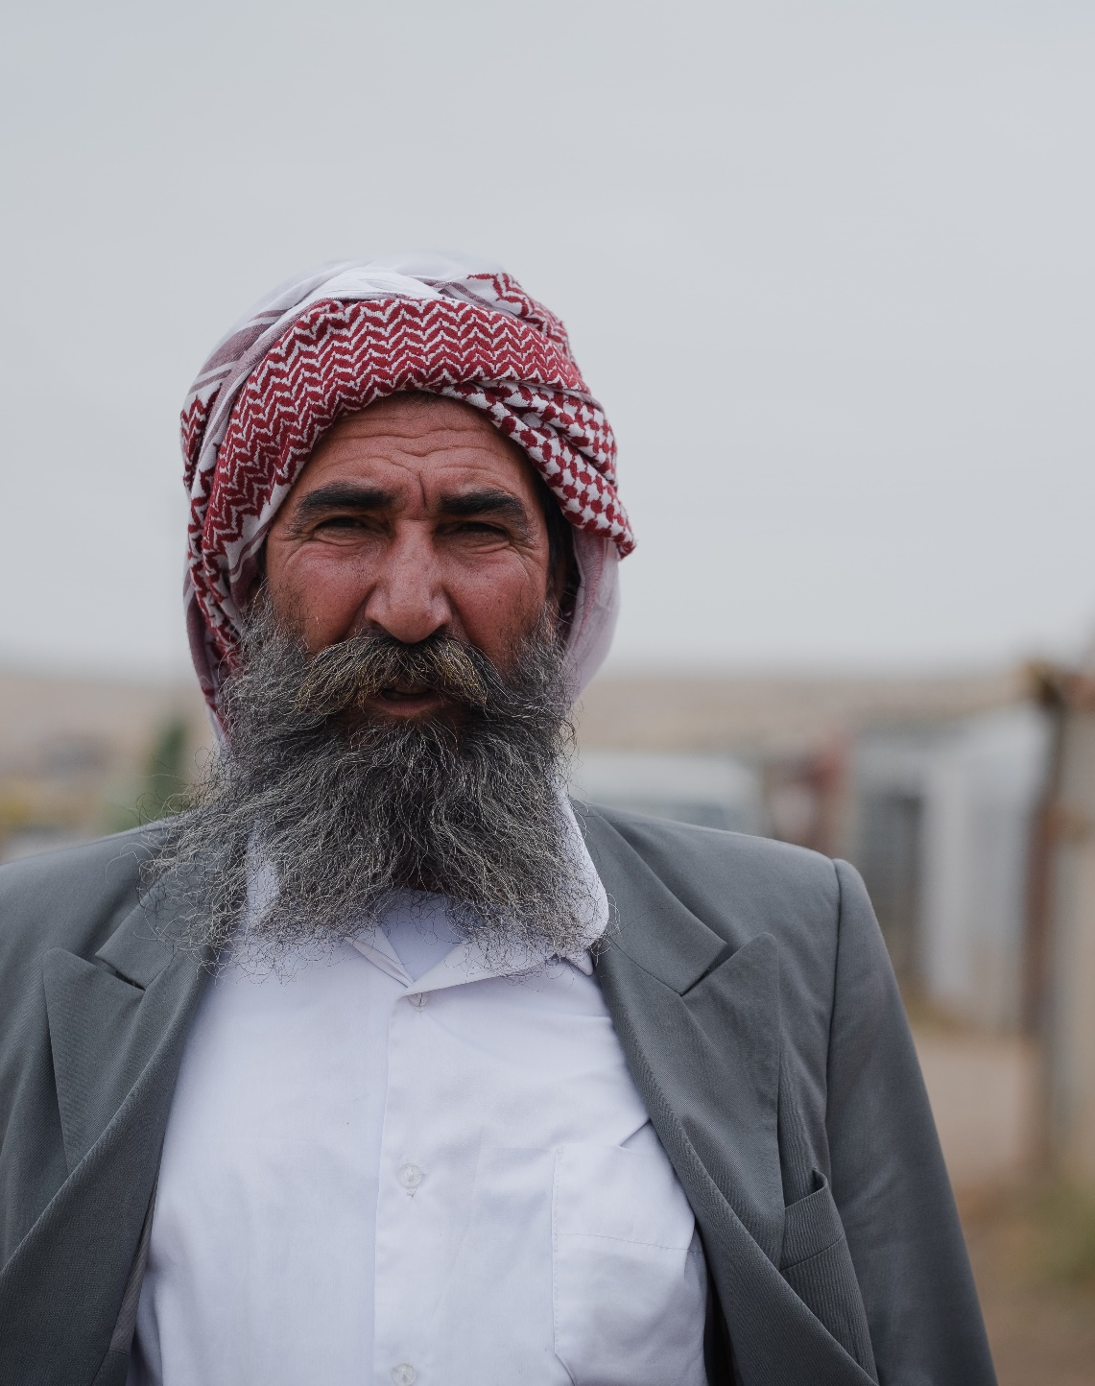
There is a three-level caste system in the Yazidi society, with many dialects across the locations and the castes. Marriages are usually arranged by their parents and kept within the same caste. However, a couple can secretly elope to get around this. Yazidis are incredibly hospitable. They have a unique style of music and dancing, and they love to dance!
雅茲迪社會實行三級種姓制度，各地和種姓之間有多種方言。婚姻通常由父母安排，並婚姻對象必要限制於同一種姓內。有夫婦偷偷私奔來解決此問題。雅茲迪人非常好客。他們有獨特的音樂和舞蹈風格，他們亦喜歡跳舞！

Pray with us: 讓我們一起同心禱告：
Living God, we were made for Your courts. Father, we bless the Yazidi people with souls that long for Your presence, with hearts and flesh that cry out for You, the only true God. We pray that their souls would long after You like the deer pants for water. Would Your Spirit awaken their hearts to their need for You? We pray that the Yazidi people would discover that You are the only One who can fully satisfy their hunger and give them the fullness of life. Please grant them a deep desire to know You more. We bless them with the discovery that You are close to them and accessible. Amen.
永生的神，我們受造原是為了敬拜袮。天父，我們祝福雅茲迪人擁有渴望袮同在的心，以一顆渴想唯一真神的心去呼求袮。我們祈求他們的心切慕你，如鹿切慕溪水。我們祈求聖靈喚醒他們對袮的需要。我們祈求雅茲迪人會發現，袮是唯一能完全滿足他們的切慕並給予他們充實生活的神。請賜予他們更多認識袮的深切渴望。我們祝福他們，讓他們知道袮是那位親近他們和能被接近的神。阿門。

v

cmacan.org

